

Love Where You Live Fund
Large Projects £1,500 - £20,000

Application Guidance
For NHG Sponsors
Please note: the following guidance is to help sponsors work with partners to create a comprehensive project idea and application together. The guidance below is general guidance on applying for community and wellbeing grants.
Please email lwylf@nhg.org.uk with any questions.
Date last updated: April 2025
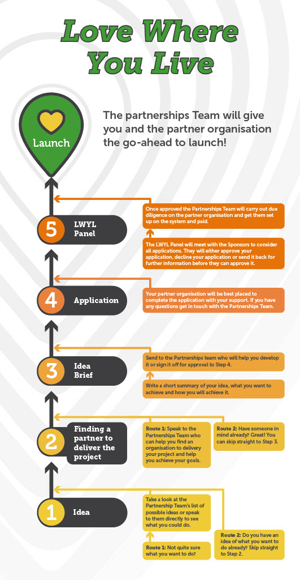

Checklist
Please note: this list is an aid to creating a project and you may or may not find it useful. It is not required to submit.

Be prepared –
Your partner organisation will need to have the following for their application:
- Organisation’s aims and objectives, annual accounts, bank details, constitution
- Organisation track record, insurance, policies, and procedures
- Staff and volunteer profiles, how the organisation is managed

Be clear
Your partner organisation should use your Idea Brief to guide them with completing the application and consider:
- Purpose and goals, activities, target audience/participants, project duration
- Delivery staff, any key volunteers
- The need the project addresses, the difference the project will make
- Project milestones (major moments such as workshops or sessions, any celebrations, etc.)
- Sustainability or maintenance plan – will the project spark further projects or outcomes? If so consider this.
- Total costs

Evidence the need
Gather any evidence that reinforces the need for the project. This could be:

- Consultation reports, letters of support from tenants and community groups
- Quotes from community questionnaires
- Expert testimonial (eg advocates for play, wildlife etc)
- Demographic/statistical data, ward information, Government reports about your
neighbourhood

Leave enough time
- Review the application form and the application process, assess whether you
need further information and speak to the Tenancy Sustainment Team if you have any questions.
- Proofread and edit, make sure every question has been answered
- Double check the budget

How to write a great application for community and wellbeing grant funding

Preparing to write your application for community grant funding
Writing funding applications is much easier, and you are more likely to be successful, if you have prepared well with your group. Funders require very specific information about what you want their money for, how it will be spent, and what this will help you to achieve.
Different funders fund different things. Having a good idea about what you need funding for will help you apply to funders that are more likely to give you funding.
Below is a list of planning activities that will maximise your chances of a fundraising bid being successful.

Do you have all the documents you need?
Most funders of community grant schemes will want to see evidence that your group has:
- A committee
- A bank account
- A statement of your accounts for the last financial year (unless you are a new group).
- A governing document (e.g. constitution, trust deed, memos and articles)

Some funders will also ask for evidence of:
- Insurance
- A health and safety policy and/or risk assessment
- An equal opportunities policy
- A child protection or safeguarding policy if you work with children or vulnerable adults

Do you know exactly what you want money for?
Plan your work carefully so you know what you need money for. Before you start to write an application, you should be able to answer these key questions:
- What do you want to do?
- How much will it cost?
- Why is your work important?
- How will you know if you are doing a good job?

LWYLF has their own priorities. Key things to think about are:

- Does the project meet the fund’s criteria?
- Will the project meet an identified need or address a gap in service provision?
- Can you deliver the outcomes – do you have access to the right specialisms or expertise?
- Do you have robust financial and project management systems?
- Is the budget realistic, cost effective and good value for money
- How will the project benefits be sustained? Who will maintain the project?

Before you can apply for money for an event or activity, you need to know exactly what the activity is going to be.

- How often will it take place, what will it involve and how long will it last?
- Who is the activity for? Families? Children? Unemployed people? People who share a particular identity or experience?
- Who will organise and run the activity?
- Where will the activity take place and how will it be promoted?

How much money do you need?
Funders will want to know exactly what you want to spend their grant money on. Make a budget for your project or activities. Include:

- A list of everything you will have to pay for, and how much each item will cost. This might include, for example, venue hire, equipment, transport, paying workers, volunteer expenses, publicity, and insurance.
- A list of any income you are already expecting (for example, from membership fees, donations, grants you’ve already received etc.).

Budget tips:
- Be accurate. Get quotes for each item in your budget. Funders may come back and ask you what you have based your budget on, and you need to be able to show them that you have found out how much everything will really cost.
- Don’t underestimate. Trying to make the budget look less than you really need could lead to financial problems that affect the other activities your group is involved in, and funders will be concerned if they think you are not being realistic.
- Prepare a budget for your whole organisation for a year. It’s useful to do this, even if you are only applying for funding for a few things or a specific project. It will help you work out whether there is anything you need that you haven’t already thought of.

Why is your work important?
Funders want to know that the money they give to groups and projects will make a difference to people’s lives. They want to know what change will happen because of your activities if they give you a grant. Many funders refer to this as the outcomes of your project.
Ask people who are involved in your group what the group means to them, what they get out of it, and why it is important in their lives. This could help you show that you are meeting people’s needs.
You could also use statistical information to show the needs of the communities you are supporting. Contact your local authority, police and health authority, or look on their websites, to try to find information about deprivation, crime and health problems in your community. They may have this from the national census survey, or from their own local surveys. You can also use the Index of Multiple Deprivation, which provides detailed information about a range of problems faced by different neighbourhoods.
Be sure to source information from reputable sources e.g. office of national statistics, council websites, Government reports etc.

There are several ways that you can evidence community need, which can be included in your funding application, such as:
- A community consultation report
- Letters of support from voluntary and community groups, local Councillors, Police, local schools, youth groups etc.
- Research on the geographical location, population, project theme
- Quotes from the community or intended beneficiaries of the project
- Links with local and regional government strategies and initiatives
- Statements from recognised professional institutions e.g. University research on the benefits your project will make to your target group.

How will a funder know that you will do a good job?

Funders will want you to demonstrate you will be able to make your project a success. There are several ways that you can evidence your track record and organisational sustainability such as:
- A profile of the qualified and experienced people within your organisation and level of volunteer support
- Case studies of similar projects delivered by your group and what they achieved
- Evidence of long-term support from local institutions such as the local authority.

Top tips for writing a good application
- Have a clear outline of the project –know exactly what you want to do
- Assume the funder knows nothing about your organisation or the subject matter.
- Do not use jargon, use plain, succinct and simple language.
- Pick out key words in questions which the funder wants to see in each answer – use the funder’s language.
- Stick to the question, do not deviate.
- Use positive statements, not weak / negative words (‘We will try …’ is weak, ‘We will…’is strong).
- Think of your audience – use headlines, bullet points etc to make it easy for the funder to read.
- Use visual aids –photographs which will pull on the emotions and show a difference.
- Don’t waffle -remove any redundant words.
- Draft a detailed budget based on real figures and do not apply for the maximum amount if you do not need to.
- Read it aloud to someone else to see if they understand what you are asking for.
- Allow time to proofread – attention to detail is important.

