

Your Home User Guide
Your Home User Guide
Contents
Welcome to Lampton Parkside 4
Notting Hill Genesis 5
NHBC 6
NHG online portal- My account 5
Residents association 8
Estate management 9
Post and deliveries 9
Parking 9
Cycle storage 10
Security/ Access 10
Communal Cleaning 10
Refuse disposal 10
Estate regulations 12
Service charge 13
Communal and Landscaped areas 13
Defects 15
Repairs 18
Preparing for the repair 19
Household pests 20
Utilities 21
Mains water/ drainage 21
Utility Cupboard and Stop Cocks 21
Electricity 23
Heating and hot water 28
Television / Telephone / Internet 29
Underfloor Heating and Thermostats 29
Mechanical ventilation 30
Looking after your new home 31

Lubrication 31
Door seals 31
Ironmongery 31
DIY 31
Redecorating 32
Alterations 32
Reducing condensation 33
Bathroom & kitchen care 34
Sanitaryware 34
Kitchen sink 34
Units & doors 35
Worktops 35
Finishes 36
Appliances 37
Windows, Door & Internal Security 38
Maintenance 38
Doors Locks 38
Burglar Alarm Wiring 38
Fire Safety 39
Smoke and Heat alarm operation 39
Contents Insurance 42
Local Information 43

Welcome to Lampton Parkside

In this Home user guide, you will find useful information to help you get settled in. The purpose of this guide is to help you to familiarize yourself with your home and Lampton Parkside. It is important that you review the contents of this manual to ensure that the features installed within your home are utilised fully.

Lampton Parkside is a redevelopment of the former Hounslow Civic Centre site it includes 3 mixed-use blocks, ranging in height from 2 - 9 storeys. The combined scheme comprises of 780 residential units, providing a flexible range of uses. The scheme provides 291 car parking spaces, 1,322 cycle spaces, amenity space, landscaping and associated public realm.



Notting Hill Genesis
Notting Hill Genesis was formed in April 2018 from Notting Hill Housing and Genesis Housing Association, but our roots reach back to the 1960s when our legacy organisations were established by local people who shared a similar vision – to house west London’s working poor, providing them with a home from which to build themselves and their families a secure future.
We have more than 2,000 colleagues, most of whom work at the heart of our communities, building relationships with residents that go beyond bricks and mortar. We strive to be the best we can, and are committed to working with our residents to ensure that everyone has a safe, secure and good quality home, and access to high standard services delivered in the way that suits them best – whether that’s online or face-to-face.

Property Manager
Name:
Email:
Contact Number (Concierge):
Contact Number (Head Office):

Estate Operations Manager
Name: Mihaly Vantara
Email: Mihaly.vantara@nhg.org.uk
Contact Number: 020 3815 0000

Lease/Tenancy Details
Start date:
End date:

NHBC

Your home has the benefit of cover under the NHBC Buildmark warranty scheme. This is a warranty under which the developer, during the first year, and the NHBC during years 2-10 following legal completion, has defined responsibilities with regards to defects in materials or workmanship in your new home.
Please note the defect period begins from the date the development was completed and handed over to Notting Hill Genesis. Any defects occurring during the first year should be reported via My Account or to your Housing officer/Property management officer who will pass them on to the developer who is responsible for resolving any issues in line with Buildmark policy. Following this period, NHBC will provide cover for latent defects for the lifetime of the warranty policy, in accordance with the policy terms.
NHBC advice centre Tel: 0844 633 1000 / www.nhbc.co.uk

NHG online portal- My account
We strongly recommend registering your account with NHG, this is where you can get information to your tenancy and rent details. You can also raise your own home repairs, pay your rent and seek any extra support that you may need to manage your tenancy.
Installing My account: https://www.nhhg.org.uk/residents/my-account/

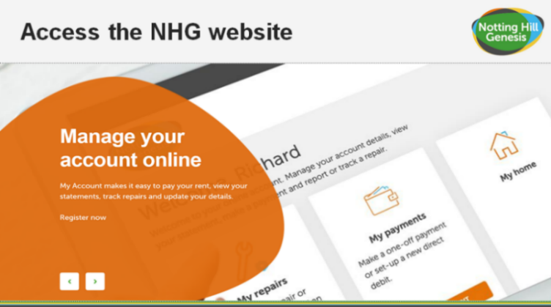
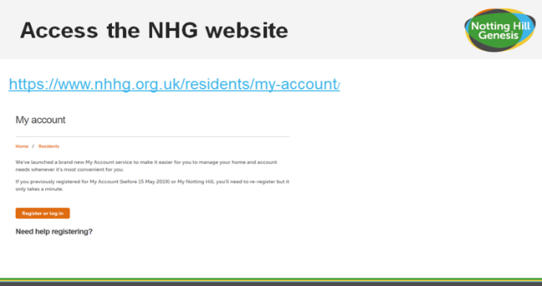
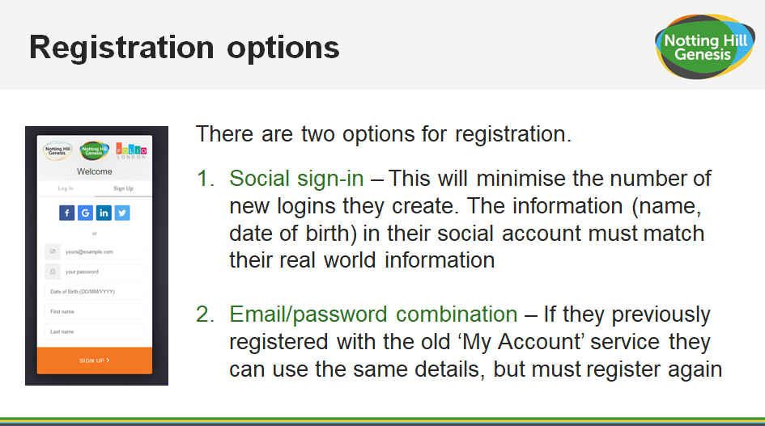
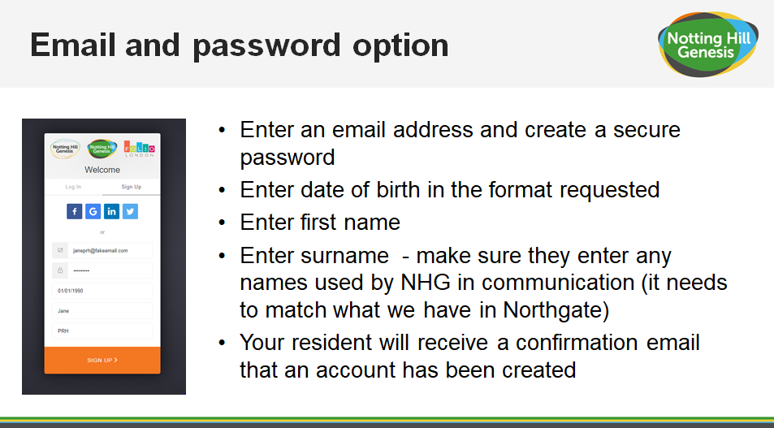
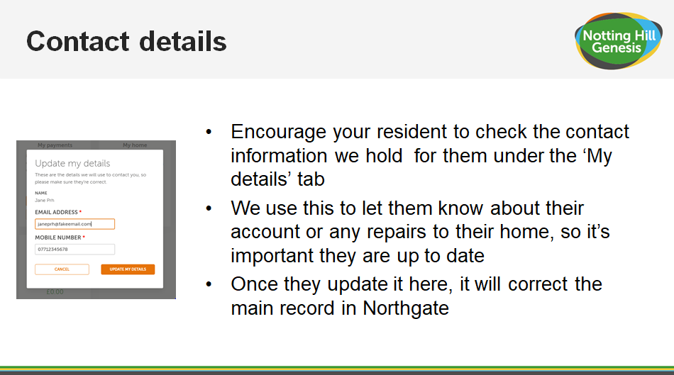
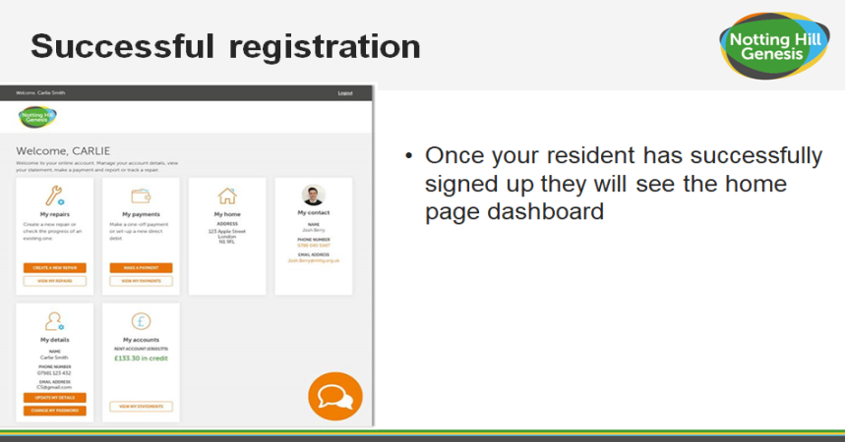
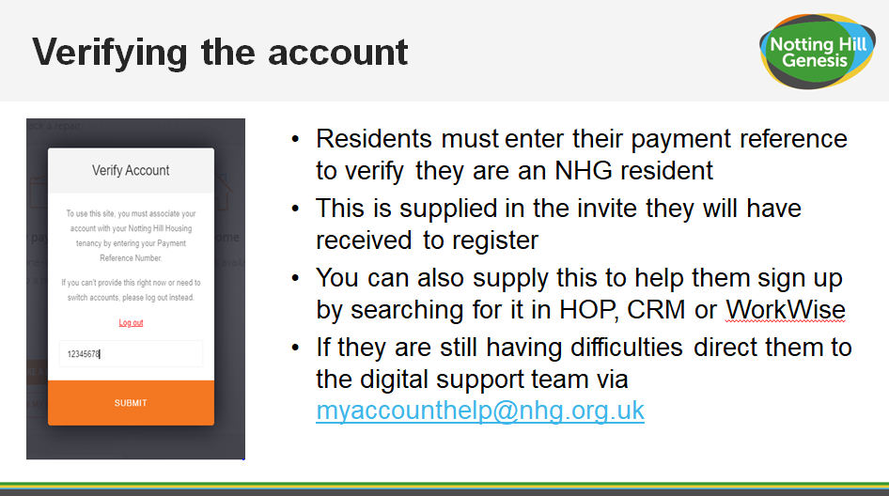
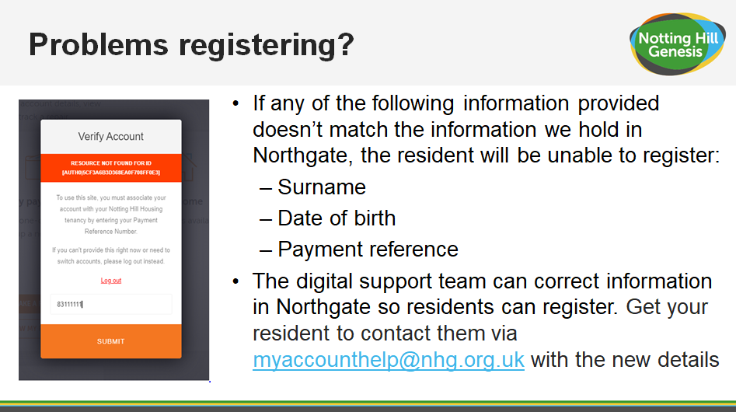

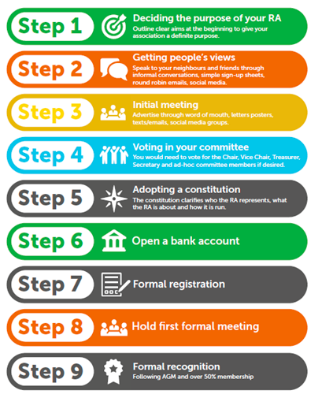

Residents Association
As a responsible landlord, we want to ensure we support and actively engage with all our residents from the moment they move in. We believe that we are a better landlord if we are challenged, and we will support residents if they wish to set up a Tenant and Residents Association (TRA), ensuring it is representative of all those living at Lampton Parkside and that they are independent of us, feel empowered and able to make strong decisions that are for the majority.

Estate management
Estate Operations Manager
The Estate Operations Manager’s office is the point of contact for residents if you have any questions or queries regarding any other aspects of site.
The Estate Operations Manager will initially be based within the Concierge and if you have any questions regarding the site they will be able to point you in the right direction.
The Estate Operations Manager will also be carrying out inspections of the communal areas from time to time to ensure the site is clean and tidy.

Post and deliveries
The post boxes are accessible via the letterbox of your front entrance door.
Royal mail postal service delivers once a day, Monday to Saturday excluding bank holidays.
Any parcels for residents will be taken at the Estate Operations Manager desk and kept for your collection unless you have requested for the courier to contact you directly so you can take personal collection. We advise you to do this if a parcel is particularly important or valuable. We take all parcels on your behalf and in good faith. We do not take any responsibility for any items in our storage.
Please note we do not hold grocery or take-away deliveries.
For grocery deliveries you will need to arrange directly to meet them outside your block.
For take-aways you will need to meet them outside the entrance to site as they will not be permitted past the entrance until the site is fully open.

Parking
Lampton Park Side has onsite parking and is located on the road and under the podium blocks area however allocations are strictly limited. If you have been allocated a parking space, you will be made aware by the Estates Operation Manager.
The car park will be patrolled regularly, and parking enforcement will be in operation for any unauthorised vehicles.
Please note that all vehicles must be registered with Lampton Park Side management before a parking permit can be issued. All parking permits are required to be placed in the front windscreen of the vehicle and visible.

Cycle storage
Cycle racks will be provided across the development, with cycle stores dedicated to each block. Your own cycle store is on the ground floor.
All cycles are stored at the owner’s risk.

Security/ Access
Lampton Park Side has extensive CCTV coverage around site. For any security matters please contact your Estate Operations Manager.
The blocks are accessed with an access fob that each resident is given. The access fob will permit you to enter the block bin store and cycle store.

Communal and Window cleaning
Cleaners managed by the Lampton Park Side estates team will be responsible for the cleaning of the landscaped areas, shared surfaces and pedestrian routes. As well as communal corridors/entrance lobbies and lifts all cores throughout normal working hours. Please contact your Estate Operations Manager for further details.
As part of the estate management your external communal windows will be professionally cleaned at least once a year by mobile platform or extendable pole. You are responsible for cleaning the windows within your home. You will be notified in advance of when these works will take place. If you have any queries regarding this, please contact the Lampton Park Side management team.

Refuse disposal
We ask that residents kindly remove any household waste and dispose of it in their designated bin store. The refuse store for each unit is located at ground floor level in your building, it can be accessed through the courtyard. These stores will require fob access.

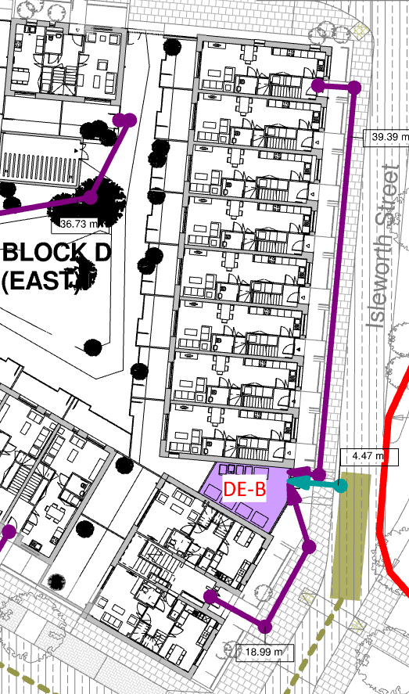

Refuse is removed on a weekly basis from the communal bin stores, please contact Lampton Park Side Estate Operations Manager if the bin stores are overflowing-
When recycling, please ensure you follow the guidelines below:
- Cardboard - please flatten or tear into smaller pieces - card sleeves, cereal boxes, egg boxes, cards, etc.
- Mixed paper
- Plastic bottles - empty, rinsed and squashed
- Tins and cans - empty and rinsed
Do not put black sacks into the recycling bin as these cannot be recycled. For further information please visit the London Borough of Hounslow website:
https://www.hounslow.gov.uk/info/20002/recycling_and_rubbish

Estate regulations
If the street lighting is out or for any pavement issues, please contact Estate Operations Manager.
It is essential that estate regulations are set, implemented and appropriately managed in the event of non-compliance by any occupier. A copy of the proposed estate regulations is below and is intended to enhance the quiet enjoyment of Lampton Park Side for the benefit and convenience of all. The estate regulations will form part of the leases and tenancy agreements.

Noise - Noise levels are to be kept at a minimum as so not to disturb your neighbours. No loud noise is permitted between 11pm and 8am. Any noise allegations will be investigated by the management team.

Balcony - No items should be stored on the balcony. This includes washing and bicycles.

Window Dressings - Windows should not be covered in any material other than the window dressings provided. Residents are not authorised to change the window dressings.

Barbecues/Fires - No barbecues or fires will be allowed at any time at Lampton Park Side, including on private or shared balconies, terraces or podium gardens.

Satellite - All blocks have a communal satellite. No resident will be permitted to have a satellite on display at any time. Any satellite located will be removed immediately.

Podiums, gardens, shrubbery and Estate Areas - These areas are provided for the enjoyment of all residents at Lampton Park Side. No ball games are permitted within these areas, except within designated facilities. The interfering or removal of any plants is not permitted, and the interfering of any water features is not permitted.

Pets - All pets are to be registered and authorised by the landlord. Authorisation requests can be obtained from the management office.

Bicycles - All bicycles are parked at the owner’s risk.
Parking - There is limited provision for residents parking on the estate. Cars may be parked in designated bays as long as they are displaying valid permits. Any abandoned vehicle will be removed and disposed of.

Common parts - Do not obstruct any of the access ways i.e. fire exits. Smoking is not permitted within any communal area or lifts.

Property - Any act that may interfere with the safety, comfort or convenience or cause nuisance or danger to any person or property is prohibited.

Disposal of waste - All waste is to be disposed of in the correct manner.

Advertising - No advertising by Estate agents will be allowed to be displayed within Lampton Park Side. Window stickers, advertisements or notices will be removed immediately.

Immoral use - No apartment or area within Lampton Park Side is to be used for any illegal, immoral or improper activity.

Fire equipment - Residents are not to remove, dispose or interfere with any equipment or sign that is provided for their safety and the safety of others.

Road closures - The landlord is permitted at any time to authorise the closure of any road so that building work may be carried out.

Service charge
Please see your tenancy agreement for list of payable service charge details.

Communal and Landscaped areas
There are communal and landscaped areas at Lampton Park Side for resident’s enjoyment. You have access to the courtyard for residents. Please note these areas are for all residents to share and therefore the following rules must be adhered to:

Ground floor landscaped areas
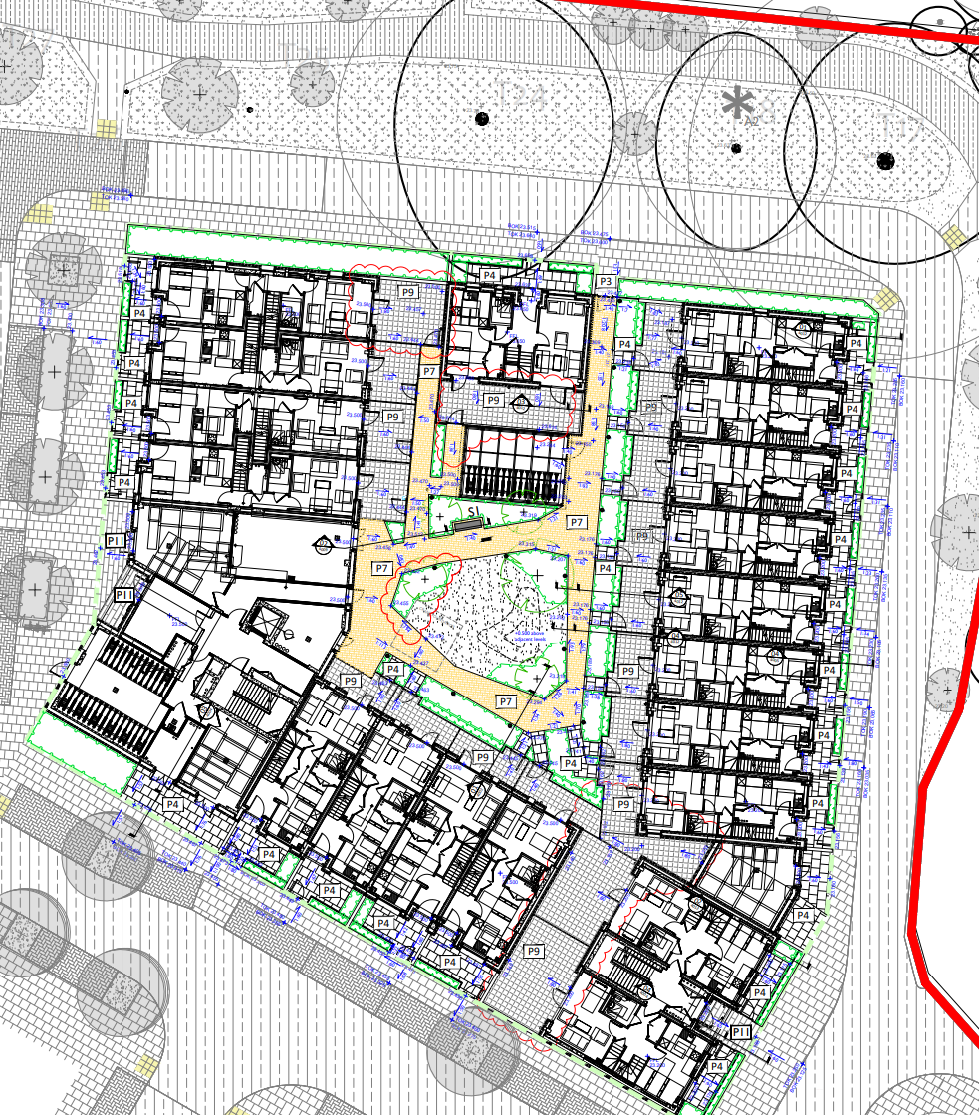
Whilst enjoying these spaces please use in a considerate manner and in respect of your neighbours keep noise to a minimum
- CCTV in operation
- No Loitering or Noise after 10pm
- No Barbeques or Fires
- No Littering
- No Dog Fowling
- Children must be supervised at all times

Please report any damage in this Area to the Estate Operations Manager.

Defects
Defect liability period
Your home is covered under a 12‐month defects warranty, known as the defect’s liability period. This period started when Notting Hill Genesis took possession of your home from the contractor. The contractor is responsible for the rectification of defects and faults that occur during this period. All you need to do is report any genuine defects you find via your online MyAccount. A photo/video must be attached to the defect ticket (if at all possible) and a detailed description of the problem including the location within the property. Once raised this will be sent across to the contractor who will contact you to arrange an appointment.
Further information and contact details can be found in the accompanying guide, presented to you at handover.
Defect response times
The Defects Team will take a decision as to whether the fault is a repair, a defect, or your responsibility. Please make sure that the information you provide – when raising your defect via your online MyAccount is correct. Incorrect information which results in the contractor attending your home will be charged to you.
Defects categories
Emergency- 24 Hours
- Gas leaks – to be reported immediately to Transco.
- Dangerous electrical works that are a risk to life or property.
- Failure of electric lighting.
- Burst water pipes or other ingress of water that causes/is causing damage.
- No water supply to a property
- Failure of front entrance doors
- Failure of lifts (where all residential lifts are affected)
- Loss of heating and hot water supply (Vulnerable residents)
- Defects that may cause injury or danger to any person f not immediately attended to.

7 days
- Defective Front Door Lock
- Ease & Adjust External Door
- Ease and Adjust windows to Open/Shut
- Re-Fix Loose Staircase Nosing/Tread
- Door Entry System Not Working
- Power Point not Working
- Cooker Point not Working

- Defect Heating Programmer
- Defective Thermostat
- Leaking Radiator
- Leaking Waste Pipe
- Leaking W/C
- Inoperative Radiator
- Discharging Overflow
- Poor Water Pressure
- Shower Inoperative
- W/S Will Not Flush
- CCTV System not Working
- Air Conditioning not Working
- Adjust Garage Door to Shut
- Adjust Gate to Shut
- Ease and Adjust Internal Door
- Leak to Window/Door Pane
- Re-Fix Loose Window Door/Furniture
- Leak to Door Threshold
- Re-Fix Loose Balustrade Re-Fix Newel Post
- Re-Fix Loose/Defective Floor Finishes
- Re-Fix Loose/Defective Floorboards
- Relay Defective Block Paving Slabs
- Extractor Fan not Working
- Poor Television Reception
- Leaking Gutter/Down Pipe
- Dripping Taps

28 days
- Defective Double-Glazed Units
- Draught to Front Entrance Door
- Draught to Window
- Re-Fix Loose Fence Panel
- Re-fix/Adjust Loose Kitchen Cupboard Door
- Make Good Holes in Wall

At the end of defects liability period a final joint inspection is carried out in each home and the communal areas. The inspection party consists of the building contractor, the development project manager, Notting hill Genesis’ employer’s agent, site inspector and HO/PMO. The purpose of the end of defects inspection is to check for any defects which need to be put right by the building contractor.

It is important that access is gained to all homes and the external and internal communal areas. This is the last opportunity to report defects for repair by the building contractor.
Following the inspection, the building contractor will arrange appointments directly with you to carry out final defect rectification works. You will be required to give access at this appointment time.
After the end of the defect’s liability period, general defects inside the home are the responsibility of the homeowner or Contractor. Communal areas will be the responsibility of NHG.
If a repair arises out of misuse of or damage to the property, then the cost of the repair will be borne by the resident.
Don’t forget, the defects period starts from practical completion of the project, so will have already commenced at the date that you move in.

Repairs

Repairs are reported via MY ACCOUNT and / or directly to your Estate Operations Manager:
We are responsible for repairs to:

- The structure of your home including the roof, outside walls, doors, windows and windowsills.
- Gutters, down pipes and drains.
- Garden walls, fences, and steps used to access and exit the property (except where they are the neighbouring property’s responsibility).
- Existing central heating, water heaters and fires (where provided by us).
- Electrical repairs (not including electrical appliances)
- Repairs to the gas installations such as boiler and pipework (not including appliances)
- Inside walls, floors and ceilings.
- Doors, door frames, door hinges, letter boxes and skirting boards, window catches, sash cords and window frames.
- Chimney stacks and flues.
- Banisters.
- Kitchen units, wall tiling, air vents and extractor fans.
- Showers (where provided by us), sinks, toilets and baths.
- Pest control in communal areas.
- Bathroom flooring and wall tiles.
- Persistent issues with drainage/removal of wastewater.

- Repairs to gas installations such as cookers or gas fires should be carried out by a certified Gas Safe engineer.
- Garden sheds
- Door handles
- Sink/toilet blockages in the first instance. The resident should attempt to unblock these with drain unblocker/plunger where appropriate.

We are not responsible for repairs to:

We are responsible for emergency repairs to:
- A heavy leak in your property where it is not possible to contain the water, or it is leaking between floors or properties.
- An electrical fault in your property where it is not possible to contain the water, or it is leaking between floors or properties.
- An electrical fault in your property which endangers health or life.
- Complete electrical failure, or electrical failure in a kitchen/ bathroom

What is an Emergency repair?

- Any repair that will threaten the health or safety of our residents or the wider public if it is not carried out immediately is an emergency.
- Any repair that will seriously damage the property if it is not carried out immediately is an emergency.

How long will I have to wait to have a repair carried out?
- We aim to have someone attend your property within 24 hours if you report an emergency repair.
- We aim to complete non-emergency repairs within 28 working days.
Please be aware that our contractors cannot always fix a problem on the first visit. If they cannot fix something, they will arrange a date and time to come back and finish the job.

Preparing for the repair
When waiting for a repair, it is important to clear space or move furniture so that the repair is accessible for the contractors. This will help them to carry out the works more quickly and minimise the risk of any accidental damage to possessions.
If you have any concerns or think you may have difficulty clearing space for the contractor, please let your housing officer know as soon as possible.

Household pests
You are responsible for dealing with household pests such as ants, bees, bedbugs, wasps, cockroaches, rats and mice within your property. Contact the environmental health department at your local council for advice. Go to www.gov.uk/report-pest-problem for more information.
If you cannot deal with the pest issue, or if you have a pest problem in a communal area then contact your housing officer and Estate Operations Manager.

Utilities

Mains water/ drainage

Thames water supply the incoming mains water through an underground service pipe fitted with a stop valve at the boundary to the development for use by the water company in an emergency.
As water enters your home, its flow is controlled by the stopcock, which allows you to turn off the supply in an emergency or for maintenance.
Mains water and drainage supplier: Thames Water
www.thameswater.co.uk
Telephone 0800 316 9800/ Billing and account enquiries/ Telephone 0800 980 8800

Utility Cupboard and Stop Cocks
Your water meter is located within the communal riser cupboards.

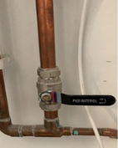 | The dwelling stopcock is located in the Utility Cupboard of your property.
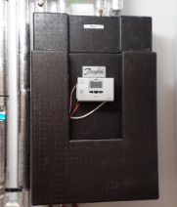  . | The dwelling stopcock is located in the Utility Cupboard of your property adjacent to the HIU.
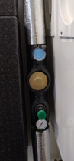 | There is an isolation valve outside the front entrance door. The water supply for the whole apartment can be closed off from there. The stop cock within the Utility Cupboard will also perform the same function
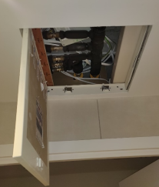 | Isolation valves within the bathrooms above the access hatch can shut off water supply for these rooms.
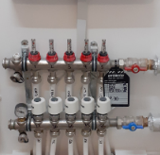 | Underfloor Heataing Manifolds are located within the Utility Cupboard and should only be used by qualified professionals to make adjustments.
Your water meter is located externally in the footpath.

Trouble Shooting

Kitchen Wastepipes: If a blockage occurs and the sink is full of water try to remove the blockage by pushing a flexible drain rod down the plughole or by using a suction cup plunger to move water up and down the wastepipe. The risk of blockages can be reduced if you remember to put fat (which solidifies when cold) into an empty container rather than down the sink or drain.

Bath, Shower and Basins: Blockages here are normally caused by the build‐up of hair and soap in the plug hole and become noticeable when the bath or basin starts to drain away more slowly. Clear bath or basin wastes with a ‘Sani snake’ (available from hardware stores) or by using a proprietary chemical cleaner (please read instructions carefully). You can purchase a small filter to put over the bath/ water outlet to collect hair, etc. and prevent blockages.

Electricity

Electrical supplier details: British Gas

Telephone: 0333 202 9802

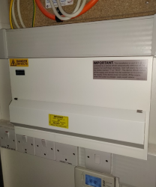 | Location of meter: Utility Cupboard
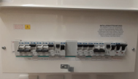 | Location of Consumer unit: Utility Cupboard

Energy tips
Light
The light fittings in your property use energy efficient light bulbs. Although these lights may cost more, the cost saving in reduced energy bills will ensure money saving in the longer term. See the Finishes section for electrical light fittings installed in your property.
For replacement bulbs contact your local electrical store.
To change light bulbs, the light switch must be in the off position. It is advisable to replace the bulb with the same type of bulb that was removed.
For further information on energy saving lighting visit: www.energysavingtrust.org.uk/electricity/lighting
Electrical alterations, including replacing light fixtures and fittings should only be carried out by a qualified electrician.
Cables may run in any position above a ceiling or under a floor. Before fixing to walls, floors and ceilings always check for buried pipes and cables using a detector available from diy stores.
Do not interfere with earth bonding cables connected to pipework and main earth connection.
For further information on electric safety in the home visit the electrical safety council website www.esc.org.uk

Loss of power and troubleshooting
If your electricity goes off, start by checking to see if it is a power cut or a fault in your home. The easiest way to do this is to see if your neighbour’s have electricity. If they do not have power either then it is a power cut and you should contact 105. It isn’t possible to predict a power cut however here are some precautions you can take in case a power cut occurs:
  - Make sure you have multiple torches along with extra batteries
  - Keep a plug‐in telephone that does not require electricity – remember that with cordless phones you may not be able to make phone calls once the batteries are dead

  - Keep important documents safe and handy
  - If your neighbours have power, then it could be a fault in your home.
  - Your trip switch may have turned itself off. If it has, try turning it back on. If it switches off again then one of your electrical appliances may be faulty. Your trip switch turns itself off to make sure you do not get injured by a faulty appliance. Once you have found the faulty appliance and turned it off, your power should stay on.
  - If you have only lost power in part of your home you may have a fault with your electrical wiring somewhere, in which case you should call a qualified electrician as soon as possible.

Energy and water efficiency
Tips for saving energy and money around your home:
Washing machines
  - Wash at the lowest temperature that will give efficient results.
  - Wait until you have a full load or use the ‘half load’ setting to reduce water.
  - Use short wash cycles for lightly soiled items.
  - Consider buying a shower wash type of washing machine.
  - If you are planning to use a tumble dryer, choose a washing machine with a high spin to save on drying time.
Washer dryers
  - Washer dryers save space and often cost less than two separate machines. They usually hold less than a dedicated built tumble dryer – you can’t wash a second load until the first load has finished drying, and they usually use an air/water heat exchanger, which means that heat extracted in the condenser is lost to the drain. Washer dryers can give a
perfectly satisfactory service.
  - Wait until you have a full load before using the washer and/or tumble dryer.
  - If the machine has an energy saving load setting use it whenever possible.
  - Use low temperature settings for lightly soiled items
Fridges and freezers
  - Try to keep your freezer at least three quarters full.
  - Do not put warm food into the fridge.

  - Defrost your fridge or freezer regularly and avoid leaving the door open longer than necessary.
  - Check that the door seal on your fridge is working effectively by closing on a piece of paper to see if it is held tight. If your fridge builds up frost too quickly the door seal could be faulty.
Cooking
  - Match pan sizes to ring and use pans that are appropriate for your type of hob.
  - Where a long cooking time is needed use a conventional oven. However, a microwave oven is more economical for short cooking times, particularly for smaller quantities of food.
  - When cooking with a microwave always follow the manufacturer’s instructions and ensure that there are no “cool spots” left in the food.
  - For toasting use a toaster rather than the grill.
Dishwashers
  - Always wait until the machine is full before running it.
  - For lightly soiled items some dishwashers have economy programmes that reduce the washing temperature and /or shorten the washing time.
Television sets
  - When you choose your tv consider buying a model that uses less electricity.
  - Do not leave the tv switched ‘on’ if nobody is watching it.
  - Do not leave the tv in ‘stand‐by’ mode for long periods.
Irons
  - Do not leave an iron switched ‘on’ if you are not going to use it within 5 minutes.
Kettles
  - When you choose your kettle consider buying a jug‐style model or an energy efficient one.
  - Remove lime scale from your kettle regularly.
  - When boiling water use a kettle – not a pan.
  - Only heat as much water as you need in the kettle but remember to always cover the element.
Computers
  - Switch your computer off when it is not in use.

Mobile phones
  - Unplug phone chargers when not in use.

In the bathroom
  - When brushing your teeth using a tumbler, instead of running the tap water for rinsing, can save nine litres of water per minute.
  - Taking a shower instead of a bath can save up to 40% of the water that you use.
  - Reducing the time you spend in the shower will save water and energy.
  - Put the plug in the basin when washing hands or shaving, rather than leaving the tap running.

Heating and hot water

Heating and hot water is distributed in your home via the heat interface unit (HIU), which is located in your Utility Cupboard.

Hot water is produced by the HIU on demand.

Heating and hot water consumption is measured by a heat meter, which is visible on your HIU and is read during your handover appointment with your customer liaison.

The Kamstrup Metering System has been chosen for your home. This is a smart energy meter and heating and hot water controller, all in one.

Any queries with regards to meters and billing for heating and hot water should be addressed to your supplier, please refer to the separate EON information for further details.

Television / Telephone / Internet

The TV signal in your apartment is supplied via a communal satellite dish and aerial; also known as Fibre Integrated Reception System (FIRS), which is managed by OFNL. You do not need a dish or aerial installed to receive TV.
FIRS delivers entertainment services, including satellite and terrestrial TV to your apartment. There is a Gateway Terminal Unit (GTU) installed within your property which is connected via the installed aerial sockets to enable you to connect satellite (Sky or Freesat) or terrestrial (Freeview) set top boxes, TVs or DAB radios.
For any questions or issues with your TV system, please contact OFNL on the contact details below.
When calling, please advise of the status of the lights on the GTU.
Call: 02921 678 550
Contact form: www.ofnl.co.uk/getintouch
Email: support@ofnl.co.uk
You will find an Optical Network Terminal (ONT) pre-installed within your home. This is the main fibre box where the fibre connects into your home.
To set up broadband, please refer to the OFNL Welcome Letter at the Literature section and contact one of the residential service providers which are available in your area. They will send you a router which will be plug and play.

Underfloor Heating and Thermostats
The pipework runs back to a manifold in your services cupboard which is connected to the heat interface unit (HIU).
Room thermostats sense the temperature in each room and open or close valves on the manifold to allow the hot water to run through the pipes until the room is warm enough. When the stat senses the room is warm enough it closes the valve to stop the flow of water.

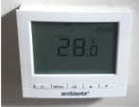 | HIU Control Unit

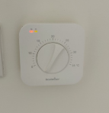 | Each room has its own thermostat.

Electrically heated towel rails with thermostatic valves are fitted in your bathroom.

Mechanical ventilation

Ventilation in your home is supplied by mechanical ventilation with heat recovery unit (MVHR).
The ventilation unit installed in your home will not only ensure that your property has a good level of indoor air quality, it will protect the fabric of your home from condensation and remove odours and indoor pollutants, resulting in a healthier living environment for you.
The ventilation system extracts warm, damp air from the home and draws in fresh air from the outside via ducted ceiling mounted terminals. The warm, extracted air is passed through a heat exchanger to recover the heat before being expelled outside. The cool, fresh air from outside is also passed through the heat exchanger, without coming into direct contact with the extracted air where it is pre‐warmed before being pumped into your home. The unit also has a summer bypass mode. This ensures that in the summer, fresh air is not passed over the heat exchanger and as such reduces the risk of overheating.
The ventilation system to your kitchen and bathroom where excessive moisture can be generated while cooking or using the bathroom is boosted. This is done automatically when the lights are turned on in the bathrooms, and there is an MVHR Boost Switch for the kitchen above the worktop.

Looking after your new home

Lubrication

There are many areas within your new property that will benefit from regular lubrication. In particular, we recommend that window hinges and door mechanisms are regularly lubricated to keep them in good working order.

Door seals

The condition of all door seals should be examined at six-monthly intervals. If the seal is missing, in part or completely, it should be replaced immediately. It is necessary to replace like with like and the use of any seal, other than that originally installed, may jeopardise the performance of the door. Seals should be fitted in accordance with the manufacturer’s instructions.

Ironmongery

Stainless steel and chrome finishes should be cleaned at least every six months with a dry cloth or duster and washed periodically with a soft cloth and soapy water and dried with a clean cloth. Do not use abrasive materials for regular cleaning. Acetones or solvents can be used to remove grease marks or paint from stainless steel finishes if needed. There are also special products available for removing scratches or rust from stainless steel. Always follow the manufacturer’s instructions when using cleaning products.

DIY
When hanging pictures care must be taken to not disturb or damage any pipes or electric cabling that may lie beneath the surface of the wall. It is strongly recommended that you use a cable/ pipe detector, which can be bought from most major DIY stores.
Plasterboard should be able to take a weight of approximately 10kg using appropriate plasterboard fixings.
Due to this weight limitation it is not advised that you fix heavy objects to plasterboard walls e.g. Flat screen tv unless the relevant provisions have been allowed for.

Redecorating
If you plan to redecorate your home, we recommend that you wait for the drying out process is complete, which usually takes between 6 and 18 months. Paint that is applied too soon may crack as the moisture in the construction evaporates. Unfortunately, NHG cannot be held responsible for damage to decorations that have been applied too soon. We recommend using emulsion paint to assist in drying out process.

Alterations
Please note that structural or material alterations are not permitted. Please contact your Housing Officer for further guidance.

Reducing condensation

Condensation is caused by steam or water vapour when it comes into contact with cold surfaces (in the same way that steam in the bathroom condenses on the window).
Once materials have dried out, you should no longer experience significant condensation. However, normal daily activities produce a great deal of water vapour, which may cause condensation if allowed to spread around the home.
Measures you can take to control condensation:
  - Cover pans when cooking and do not leave kettles boiling
  - Put washing outdoors to dry if you can. If you use a tumble dryer, make sure that it is vented to the outside air (unless it is a self‐condensing type). DIY vent kits are available.
  - Use the cooker hood and/or extractor fans and keep the doors closed when cooking, washing and bathing.
  - Do not switch off the main isolator switch to the extractors in the bathroom or kitchen at any time, as they are needed to ventilate these rooms.
  - Regularly open windows to encourage air changes.
Ventilation is needed to get rid of the moisture that is naturally produced every day in your home. Your home will only maintain a healthy internal environment when ventilation systems are running. You risk damage to your health and home if you turn these off or block outlets.
Homes where the heating is off all day, because the occupants are out, are more likely to suffer condensation problems than those heated more continuously. This is because, when normal activities such as washing and cooking are carried out in the evening, the home has been unheated for long periods and the surfaces are cold.
Make sure the heating timer is set so that your home is warm by the time you return home. During very cold weather it is better to leave the heating on during the day to maintain an even temperature. The temperature can be set a few degrees lower and turned up when you return.
Most heating systems operate inefficiently if turned completely on and off. Use your thermostat to control heating operation. This will be more efficient and help to reduce fuel bills.
Remember that condensation is not normally a building fault. Learning to control moisture levels is a vital part of living in modern, well insulated, home.

Bathroom & kitchen care

Sanitaryware

To prevent a build-up of dirt and limescale, acrylic and ceramic sanitaryware should be wiped down immediately after use with a soft cloth and thoroughly cleaned with warm soapy water, a cream cleaner or multi-purpose surface cleaner on a weekly basis.

Many household chemicals such as paint stripper, nail varnish remover, household bleach, abrasive cleaning agents, perfume, aftershave or strong disinfectants can cause damage and should not be allowed to come into contact with your sanitaryware.

If such chemicals do accidentally come into contact with your sanitaryware then it is advised that you rinse the affected area with sufficient water to completely remove the chemical.

In hard water areas mild lime-scale remover may be used from time to time.

Never leave strong bleach or cleaners in the wc bowl for extended periods of time or overnight. Never mix different cleaners in the wc bowl as this may give off poisonous or volatile gases.

To avoid damaging internal fittings do not put bleach products in the cistern.

When cleaning your sanitaryware the manufacturer’s instructions take precedent over the above recommendations and should be followed at all times. The item should be rinsed and dried with a soft cloth after cleaning to provide the best finish.

Kitchen sink

Your stainless-steel kitchen sink is generally resistant to most household items and is very hard wearing, however the following substances should not be allowed to come into contact with the stainless-steel surface; mortar, cement, plaster, concrete, tile cement, grout, undiluted bleach, acids, silver dip.

Daily cleaning of your sink should be carried out using cream-based cleaners on a soft cloth. This should be adequate to remove such marks as tea stains and grease. More abrasive cleaners such as scouring powders, should not be used. The everyday film of limescale, which in hard-water areas, can be quickly removed using a standard cream cleaner but, should a thicker limescale layer form, then this will require treatment with a proprietary limescale remover and a soft brush.

It is likely that during its use the stainless-steel surface will scratch, you can reduce the appearance of scratches by using a stainless-steel cleaner.

Units & doors

It is important that you treat all cupboards with care in order maintain their appearance and functionality. Units and doors can be cleaned by using a soft damp cloth with warm water and a mild detergent, ensure to wipe excess water off immediately to ensure water is not left ‘standing’ on the surfaces.

Worktops

Your kitchen worktop has a laminated finish. Due to their resistant and hygienic, dense surface, Wilsonart work surfaces do not require any special form of care. The surfaces are generally easy to clean. As a general rule, dirt and spilled substances such as tea, coffee, wine etc. should be cleaned immediately as the cleaning effort increases if they are left to dry. When necessary, cleaning should be done with non-aggressive agents.

Please refer to the manufacturer’s recommendations for further information.

Finishes

Surface Finishes

Apartment Wall Finishes | Dulux Trade Super Matt - White
Ceiling Finishes | Dulux Painted in white matt emulsion
Woodwork Finishes | Dulux Satinwood - Pure Brilliant White
Skirtings and Architraves | Square Edged - Skirtings MDF 15mm x 119 Architrave 15mm x 58
Window Boards | Square Edged - MDF 25mm
Front Entrance Doors | Nordan Homeguard Door RAL 7006 30% Gloss
Apartment Internal Doors | Primed for Site Finish
Floor Finishes

Bathrooms & WCs | Slip-resistant vinyl sheet flooring: Safetred Natural (4677 009 Steel), 2 mm thickness
Kitchen, Living, Dining Room,  Hallway | Timber Vinyl Flooring - Warm Elegant Oak
Staircases, Upper Landings, bedroom | Carpet: contract range carpet: cut pile 1/8-gauge 80% wool mix: Elford Twist Standard 'Grey' by Joseph Hamilton & Seaton.
Recessed Entrance Matting to  Communal Entrance Hall | Battleship Hippo - Anthracite - width of entrance hall x 750mm min

Appliances

Product Description | Care & Maintenance
Washer - dryer | The outer parts and rubber components of the appliance can be cleaned using a soft cloth soaked in lukewarm soapy water.
Detergent dispenser drawer | Remove the dispenser by raising it and pulling it out. Wash under it under running water, this operation should be repeated frequently.
Hob | Always clean the hob after cooking to prevent a build-up of dirt. Clean the hob with a damp dish cloth and dry it with a cloth or towel to prevent limescale buildup. Only clean the hob once the heat indicator has gone out. For stubborn dirt is best removed with a glass scraper.
Fridge/freezer | Remove the layer of frost regularly. Never clean the shelves or containers in the dishwasher. Wipe door seal with clear water and dry thoroughly with a cloth. Clean the appliance with a soft cloth, lukewarm water and a little ph neutral washing up liquid.
Extractor hood | Clean the metal filter after 8 to 10 weeks, this can be cleaned in a dishwasher, this can cause slight discoloration. Clean off any grease from all accessible parts of the housing, this reduces fire hazards. Clean the extractor hood with a hot detergent solution or a mild window cleaning agent.
Dishwasher | Fill detergent dispenser with detergent. Start applicant without utensils in the program with the highest rinsing temperature.

Windows, Door & Internal Security
Your home has been fitted with Senior Architectural Systems double glazed windows and balcony doors. Operating and maintenance instructions are included separately.

Maintenance

Maintaining your windows couldn’t be simpler. All you have to do is check them carefully at least once a year for the following signs:
- Look for (and remove) any airborne debris that might be trapped in between the frame and sash. To do this, open the window in the cleaning position.
- Wipe or brush clean all surfaces and check the weather seal is clean, dry, continuous and undamaged. Never get any paint on the weather seal as this will reduce the window’s performance.
- Check that the handle moves freely and smoothly. If they are stiff, carefully use a recommended lubricant on the locking tongues/bolts while in their extended position
- Check the glass does not have any water vapour inside the sealed unit or that the glass is damaged.
- Check all timber surfaces for damage and note if the finishing (paint etc.) needs refreshing.
- Check all handle and ventilator controls are not loose. If they are then tighten them with an appropriate screwdriver. Tighten enough so the handles and controls work freely without being too loose. Do not overtighten.
See additional information on how to use your windows in your handover pack and labels on windows. If you need help with anything to do with maintenance refer to Operation Manual.

Doors Locks
Your doors are fitted with unique key locks. Entry into your home is gained by the use of this lock. The door and lock mechanism are constructed to resist unauthorised entry in line with Secured By Design guidelines and UK security regulations. When leaving your home, ensure that all windows and doors are locked.

Burglar Alarm Wiring
There is a power supply for a future alarm within the Utility Cupboard if required, however installation of a wireless intruder alarm is recommended.

Fire Safety

The fire strategy in each residential block has been developed on the presumption that there will be a low probability of fire spread beyond the apartment of fire origin due to the high degree of compartmentation. This ‘defend in place’ approach is the conventional method used in the UK and it means that you should not evacuate your apartment unless the fire alarm in your property is triggered or you are directed otherwise by attending Fire Rescue Service.
Alterations or modifications to any part of your home could affect its ability to stop a fire spreading. Therefore, before any such work is carried out, we strongly advise that you seek professional advice and the permission of the freeholder via the managing agent.

Smoke and Heat alarm operation
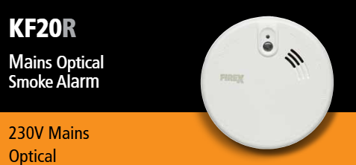
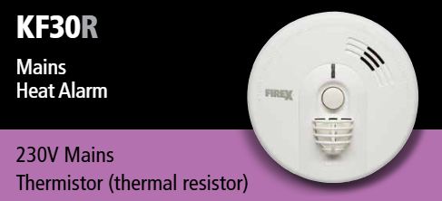

Do not paint your alarm, or allow water or dust to contaminate your alarm:
- Regularly check that the green mains indicator light on the cover is on
- Test weekly – press and hold the Test/Hush button on the alarm for 10 seconds. The alarm will sound loudly and the red light on the cover should flash rapidly
- If the alarm beeps and the red-light flashes at the same time the battery is depleted – ensure green mains power light is on

- Check the red light on the cover flashes every 40 seconds, to ensure that the detector has performed an automatic self-test.
- The red indicator will flash rapidly to show an alarm condition for the smoke detector
- In ‘Test’ mode the alarm will perform a self-test and emit the alarm sound
- When in ‘hush’ mode the alarm enters a ten-minute period instead of the normal 40 seconds to indicate the sensitivity is reduced, and will then automatically reset itself
- When interconnected to other mains powered alarms, an alarm on one detector will trigger all other interconnected alarms within one second (only the triggered alarm will flash a red indicator)
- Aim to replace the batteries once a year to avoid them going flat.

Fire Evacuation Alarm Sounder
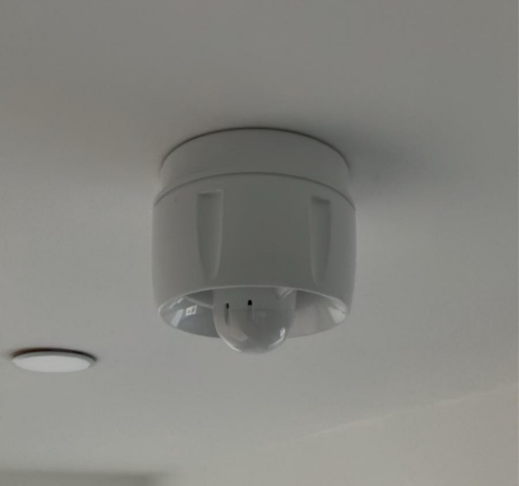

Fire evacuation alarm sounder located in ceilings

The fire alarm sounder is a critical safety device designed to alert occupants in case of a fire emergency. When activated, it emits a loud and continuous alarm to ensure everyone is aware of the danger and can evacuate promptly.
- Stay calm and follow the evacuation procedures.
- Do not ignore or assume it is a false alarm—always treat it as an emergency.
- Use designated escape routes and avoid using elevators.
Regular fire drills and maintenance checks ensure the sounders function correctly. If you notice any issues with a fire alarm sounder, please report them immediately to the Lampton Park Side management team.

Fire doors
The front doors throughout the development are fire rated. The stairs are a protected area and internal doors onto the stairs are fire rated.

Sprinkler system

 | Sprinkler Head located in ceilings

A sprinkler system has been installed within each dwelling.. When a sprinkler head is activated (by a high temperature) the sprinkler will activate and water will begin to flow.
The sprinkler system is maintained by the Lampton Park Side management team. Any damage to the sprinkler head must be immediately reported to Concierge immediately. Do not decorate over the sprinkler head.

Contents Insurance
We recommend that residents purchase Contents Insurance but we are unable to provide an Insurer.

Local Information
Doctors

Hounslow Family Practice  77 Lampton Park Side, Hounslow,  TW3 4JX  020 8572 1497  240 yards | FirstCare Practice  Blenheim Centre  Prince Regent Roadd, Hounslow,  TW3 1NL  020 8630 1111  480 yards | The Medical Centre  5 Cecil Road,  Hounslow,  TW3 1NU  020 8572 2536  0.5 miles

Dentists

Vicarage Farm Dental Centre  238 Vicarage Farm Road, Heston,  Hounslow,  TW5 0DP  020 8570 2297  0.9 miles | Mrs K Sodhi - Family Dental Practice  61 Lampton Park Side, Hounslow,  TW3 4JX  020 8572 2076  400 yard | B.S Panesar BDS (Wales)  61 Lampton Park Side, Hounslow,  TW3 4JX  020 8572 2076  400 yards

Opticians

Specsavers Hearing Centre  160 High Street,  Hounslow,  TW3 1LR  020 8577 9234  760 yards | Boots Opticians  193-199 High Street Hounslow,  TW3 1BL  0345 125 3776  0.5 miles | The Opticians  134 High Street,  Hounslow,  TW3  020 8570 8476  760 yards

Pharmacies

Asda Pharmacy  Alexandra Road,  Hounslow,  TW3 1NL  020 8607 1020  520 yards | Hounslow Central Pharmacy  38 Lampton Park Side, Hounslow,  TW3 1JH  020 8570 3178  600 yards | Bath Road Pharmacy  115-117 Bath Road, Hounslow,  TW3 3BT  020 8570 6445  0.5 miles

Accident and Emergency Hospitals

West Middlesex University Hospital  NEAREST A & E  Twickenham Road  Isleworth  Middlesex  TW7 6AF  020 8560 2121  1.8 miles | Ealing Hospital  NEAREST WALK IN  Uxbridge Road  Southall  Middlesex  UB1 3HW  020 8967 5000  2.4 miles

Library

Hounslow Library
24 Treaty Centre High Street,
Hounslow,
TW3 1ES
0845 456 2800
200 yards

Places of Worship

St Philip & St James C Of E Church  205 Kneller Road, Twickenham,  TW2 7DY  020 8898 2694  1.3 miles | St Vincent De Paul Roman Catholic Church  2 Witham Road,  Osterley,  Isleworth,  TW7 4AJ  020 8560 4737  0.8 miles | Hounslow Methodist Church  Bell Road,  Hounslow,  TW3 3PB  020 8570 0200  0.6 miles
Southall Baptist Church  Western Road,  Southall,  UB2 5DS  020 8574 4456  2 miles | Ram Mandil Hindu Temple  27 Hogarth Gardens, Hounslow,  Middlesex,  TW5 0QS  0208574 5276  0.6 miles | Islamic Integration Community Centre  Phoenix Court  531 Staines Road, Hounslow,  TW4 5DP  020 8570 7978  0.5 miles
Richmond Synagogue  Lichfield Gardens, Richmond,  TW9 1AP  020 8940 3526  3 miles | Hounslow Evangelical Church  186 Hanworth Road, Hounslow,  TW3 3TR  020 8572 9724  0.6 miles | Redeemed Christian Church of God  25 Spring Grove Road, Hounslow,  Middlesex,  TW3 4BE  020 8577 2111  360 yards

Post Office

Hounslow Post Office
201-205 High Street, Hounslow,
TW3 1BL
020 8570 3727
0.5 miles

Leisure Activities

Lampton Sports Centre  Lampton Avenue, Hounslow,  Middlesex,  TW3 4EP  0845 4566675  280 yards | Heston Pool  New Heston Road, Hounslow,  TW5 0LW  0845 456 6675  0.8 miles | Swift Road Outdoor Sports Centre  Swift Road,  Southall,  UB2 4RP  020 8843 5042  1.9 miles
Wycombe House Cricket & Tennis Club  Jersey Road,  Isleworth,  TW7 5PJ  020 8560 8124  1.3 miles | Hounslow Indoor Bowls Club  50 Sutton Lane,  Hounslow,  TW3 3BD  020 8570 2530  0.6 miles | Tenpin Bowling  Leisure West Complex, Browells Lane,  Feltham,  TW13 7EQ  0871 222 3675  2.7 miles

Police Stations

Metropolitan Police Service  5 Montague Road, Hounslow,  TW3 1LB | In an Emergency  Call 999 if:  •a serious offence is in progress or has just been committed  •someone is in immediate danger or harm  •property is in danger of being damaged  •a serious disruption to the public is likely  Non-emergency call 101  Call 101 for non-emergency enquiries

Veterinary Surgeons

Young Veterinary Partnership  57 Lampton Park Side, Hounslow,  TW3 4DH  020 8570 0489  320 yards | Alcombe Veterinary Surgery  154 Thornbury Road, Isleworth,  TW7 4QE  020 8758 0400  0.9 miles | Medivet  1 Green Parade,  Whitton Road,  Hounslow,  TW3 2EN  020 8898 0008  1.9 miles

Schools

Beavers Lodge Playgroup  Beavers Lodge  Salisbury Road,  Hounslow,  TW4 6BE  020 8577 3112  1.5 miles | Alexandra Primary School  Denbigh Road,  Hounslow,  TW3 4DU  020 8570 6826  280 yards |  | Wellington Primary School  Sutton Lane,  Hounslow,  TW3 4LB  020 8570 6130  0.5 mil3s
Kingsley Academy  Prince Regent Road, Hounslow,  TW3 1NE  020 8572 4461  760 yards |  | Adult Education  Community Centre  Bath Road,  Hounslow,  TW5 9TL  020 8583 6050  1.7 miles

Banks

Natwest  275-277 High Street, Hounslow,  TW3 1ZA  0345 788 8444  0.5 miles | Barclays  210 High Street,  Hounslow,  TW3 1DL  0345 734 5345  720 yards | Lloyds Bank  Units 8-9 Treaty Centre  High Street,  Hounslow,  TW3 1ES  0345 602 1997  0.5 miles
HSBC  127 High Street,  Hounslow,  Middlesex,  TW3 1QP  0345 740 4404  0.5 miles | Santander  223 High Stret,  Hounslow,  TW3 1DJ  0800 912 3123  0.5 miles | Halifax  222-226 High Street, Hounslow,  TW3 1HB  0345 720 3040  760 yards

Petrol Stations

B P Service Station  481 Great West Road, Mytchett,  Hounslow,  TW5 0BT  020 8570 4852  560 yards | B P Connect  Coronation Street, Hounslow,  TW5 0BT  020 8570 4852  560 yards | Shell  270 Heston Road, Hounslow,  TW5 0RG  020 8570 0928  1 mile

Supermarkets

Tesco  Osterley Park,  Syon Lane,  Isleworth,  TW7 5NZ  0345 677 9070  1.7 miles | Sainsbury’s  Fulham Broadway Retail Centre,  Fulham Broadway,  SW6 1BW  020 7385 4712  7.4 miles | Morrison’s  King Street,  Ealing,  W3 9NX  020 8993 6566  4.6 miles
Asda  Prince Regent Road, Hounslow,  TW3 1NL  020 8607 1010  520 yards | Waitrose  Sky Central (Osterley), Isleworth,  TW7 5QD  020 8560 1963  1.9 miles | Lidl  High Street,  Uxbridge,  UB8 1GA  01895 236633  6.8 miles
Aldi  Hospital Road,  Hounslow,  TW3 3HY  0800 042 0800  06 miles | Costcutter  504 Great West Road, Hounslow,  TW5 0TE  600 yards | Iceland  147-161 High Street Hounslow,  Hounslow,  TW3 1QL  020 8577 8685  0.5 miles

DIY Stores

B & Q  The Path,  London,  SW19 3BL  020 8540 9328  8.6 miles | Homebase  Syon Lane,  Isleworth,  TW7 5QE  0345 640 7045  1.8 miles | Wickes  153-161 London Road, Kingston Upon Thames,  KT2 6NU  020 8974 6349  5.4 miles

Cinemas

Cineworld Cinemas  Leisure West Air Park Way, Feltham,  TW13 7LX  0330 333 4444  2.8 miles | Curzon Richmond  3 Water Lane,  Richmond,  Surrey,  TW9 1TJ  03305 001331  2.8 miles | Vue Cinema  Royale Leisure Park, Western Avenue,  W3 0PA  0345 308 4620  5 miles

Dining

Gardener's Retreat (English)  Windmill Lane,  Isleworth,  TW7 5PR  020 8847 2468  1.7 miles | Brula Restaurant (French)  43 Crown Road, Twickenham,  TW1 3EJ  020 8892 0602  2.5 miles | Il Bebo's (Italian)  62 Staines Road,  Hounslow,  TW3 3LZ  020 8577 1350  0.5 miles

Orpheus Taverna (Greek)  369 Richmond Road,  East Twickenham,  TW1 2EJ  020 8892 3103  27 miles | Domingos Restaurant (Spanish)  276 Northfield Avenue,  W5 4UB  020 8567 7022  2.8 miles | Chiquito Mexican)  Unit E, Leisure West,  Airpark Way,  Feltham,  TW13 7LX  020 8844 4900  2.8 miles
Charisma Restaurant (Indian)  10a Spring Grove Road, Hounslow,  TW3 4BJ  020 8572 6497  400 yards | Dragon Palace (Chinese)  476-478 Great West Road, Hounslow,  TW5 0TA  020 8577 3817  600 yards | Smoky Boys (American)  226 Great West Road, Hounslow,  TW5 9AW  020 8577 7778  0.9 miles

Area Information for Lampton Parkside, Hounslow, TW3 4EB
https://www.streetcheck.co.uk/postcode/tw34eb
Public Transport
For up-to-date travel information -
Bus Stop Finder - Stop Finder : TW3 4EB (traveluk.info)
Local Underground Stations
Hounslow Central Tube Station - 440 yards
Hounslow East Tube Station - 710 yards
Transport for London - https://tfl.gov.uk/
British Rail - https://www.thetrainline.com/?cm=0p2a&&msclkid=77b7e6f27e3514e8e7c585b74f3e1574&gclid=77b7e6f27e3514e8e7c585b74f3e1574&gclsrc=3p.ds

