
HOME USER GUIDE
3 & 5 Castle Lane
Intermediate Rent
Contents
Welcome to Castle Lane 3
Video Home user Guide 3
Notting Hill Genesis 4
NHG online portal- My account 5
Post and deliveries 6
Parking/Car Club 6
Cycle storage 6
Security/ Access/CCTV 7
Communal and Window cleaning 7
Refuse disposal 8
Estate regulations 9
Service charge 10
Defects 11
Repairs 14
How long will I have to wait to have a repair carried out? 15
Preparing for the repair 15
Household pests 15
Utilities 16
Mains water/ drainage 16
Electricity 18
Heating and hot water 22
Television / Telephone / Internet 24
Radiators 25
Mechanical ventilation 26
Thermostats 27
Looking after your new home 28
Lubrication 28
Door seals 28
Ironmongery 28
DIY 28
Redecorating 28
Alterations 28
Reducing condensation 29
Bathroom & kitchen care 30
Sanitaryware 30
Kitchen sink 30
Units & doors 31
Worktops 31
Finishes 32
Appliances 36
Appliance instruction manuals & warranties 36
Registering your appliance warranty 36
Windows, Door & Internal Security 39
Maintenance 39
Doors Locks 40
Access Control System 40
Fire alarm operation 41
Fire doors 42
Sprinkler system 42
Fire Safety Guide 43
Contents Insurance 44
Manufacturer’s Literature 50

Welcome to Castle Lane

In this Home user guide, you will find useful information to help you get settled in. The purpose of this guide is to help you to familiarize yourself with your home and Castle Lane. It is important that you review the contents of this manual to ensure that the features installed within your home are utilised fully.

Castle Lane is a development with 88 new homes in a variety of one, two and three – bedroom flats, with an allocation of 26 London affordable rent, 34 intermediate market rent and 28 shared ownerships. The development includes external amenity areas and cycle parking.

Video Home user Guide
To view welcome guide videos of Castle Lane, please visit www.nhg.org.uk/new-home-user-guides/welcome-to-castle-lane
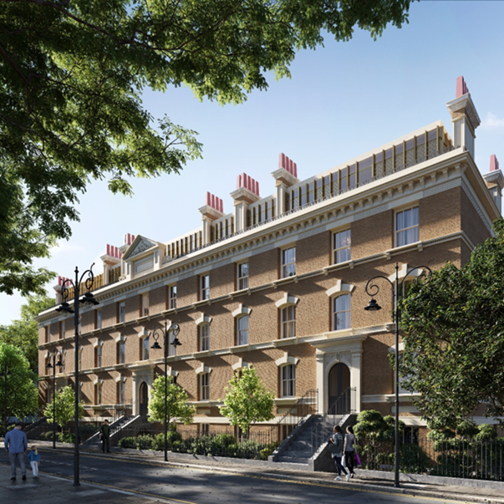

Notting Hill Genesis

Notting Hill Genesis was formed in April 2018 from Notting Hill housing and Genesis housing association, but our roots reach back to the 1960s when our legacy organisations were established by local people who shared a similar vision – to, provide the communities of West London with a home from which to build themselves and their families a secure future.

We have more than 2,000 colleagues, most of whom work at the heart of our communities, building relationships with residents that go beyond bricks and mortar. We strive to be the best we can and are committed to working with our residents to ensure that everyone has a safe, secure and good quality home, and access to high standard services delivered in the way that suits them best – whether that’s online or face-to-face.

Housing Officer details:
You will be provided your Housing Officer’s contact details prior to move in and via the NHG online portal.

Your first point of contact is your Housing Officer; however, if they are not able to answer the phone, you will be given an option to transfer the call to the customer call centre. You can also use NHG’s self-service portal to raise repairs or for a contact request.
NHG Call Centre: 020 3815 000

Emergency Line: For emergency defects that occur outside of normal office hours (evenings, weekends, and public holidays) please call 033 3000 3000.

Building Warranty
Your home benefits from coverage under the ICW warranty scheme. This includes a warranty from the developer during the first year and the ICW Warranty for up to 10 years following the property's practical completion. The developer is responsible for addressing defects in materials or workmanship in your new home.

Please note that the defect period begins from the date the development was practically completed and handed over to Notting Hill Genesis. Any defects occurring during the first year should be reported via My Account or to your Housing Officer, who will liaise with our in-house specialist defect management team. This team will pass the defect on to the developer, who is responsible for resolving any issues in line with the ICW Latent Defects policy. The defect team will monitor and follow up until the issue is resolved.

NHG online portal- My account
You will need to register your account with NHG, this is where you can get information on your account. You can also raise your own home repairs, pay your rent and seek any extra support that you may need to manage your tenancy.
Installing My account: https://www.nhhg.org.uk/residents/my-account/.
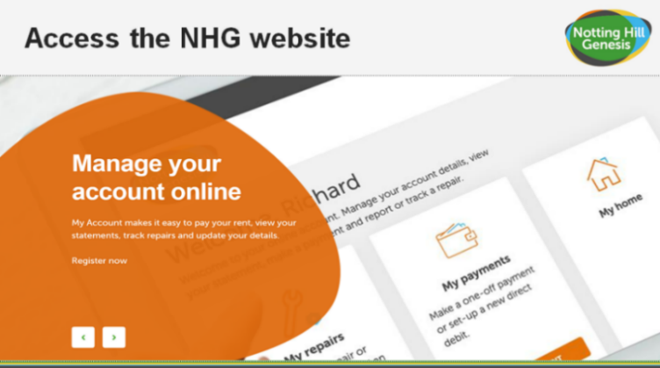
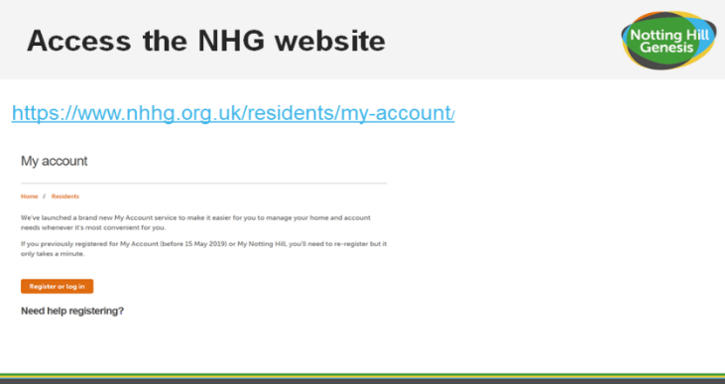
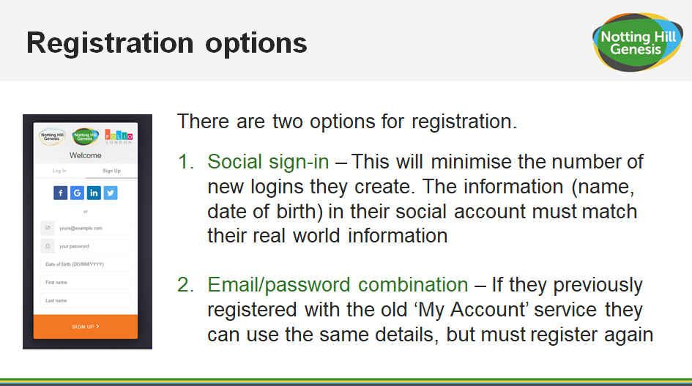
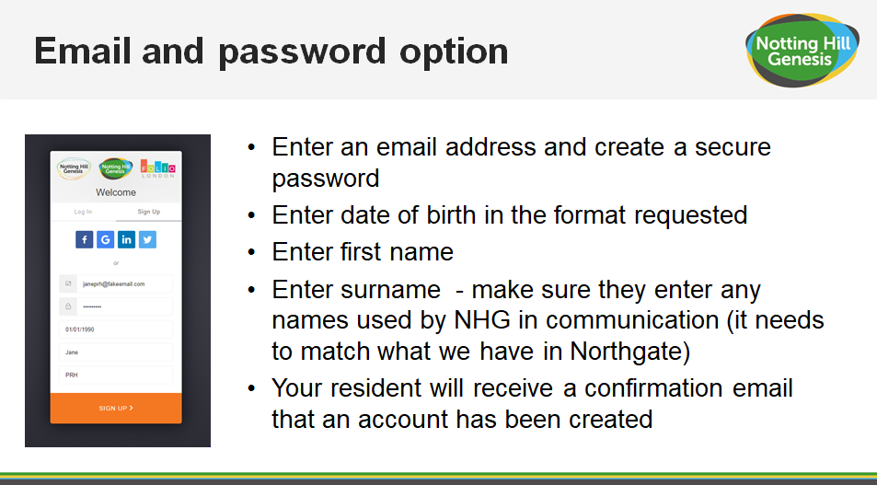
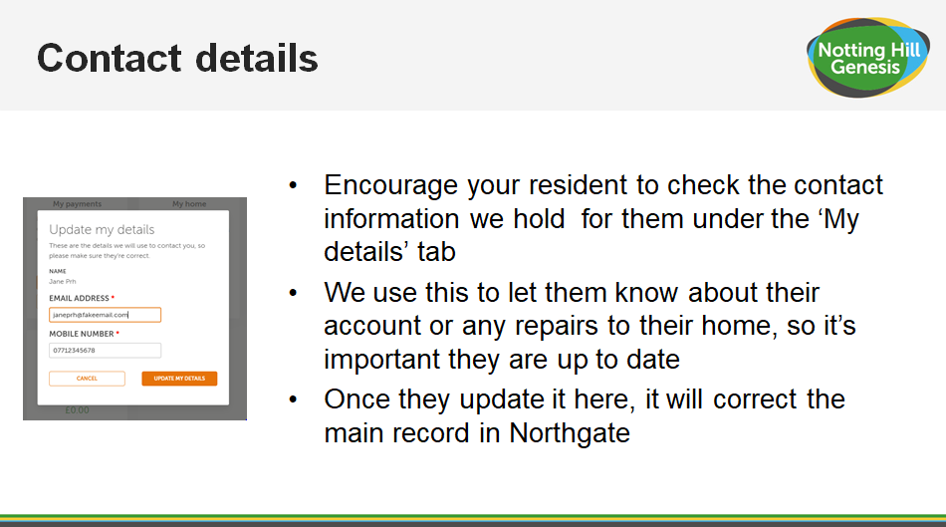
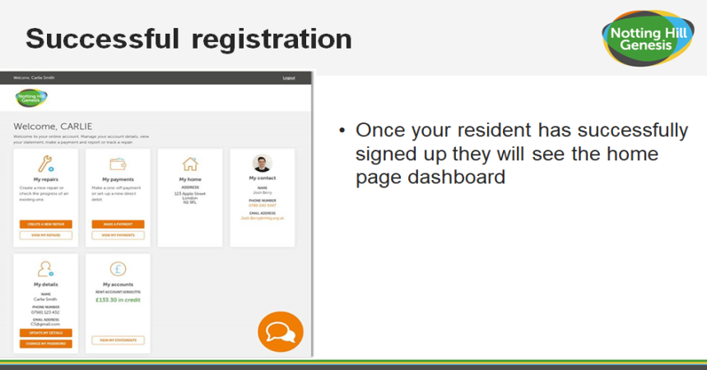
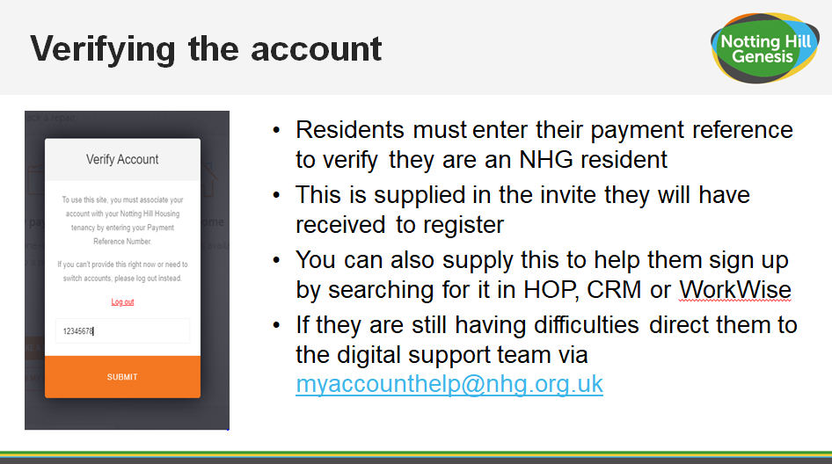
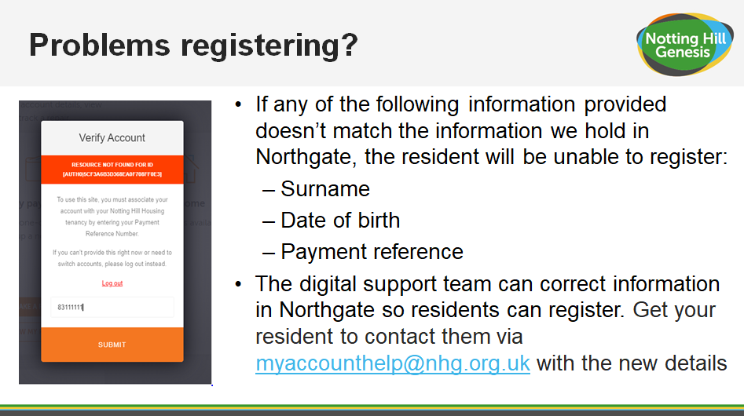
Estate management
Please contact the Housing Officer for any estate management queries.

Post and deliveries
Posts will mainly be delivered through the front door letter boxes, with the exception of a small number of properties where posts will be delivered to external post boxes.

Royal mail postal service delivers once a day, Monday to Saturday excluding bank holidays.
Delivery drivers will attempt to deliver the parcel to the property address by calling your door number.

Please note that you should always be home to receive, deliveries, groceries and take away deliveries. Large deliveries such as washing machines or sofa should be delivered at a time when you are home. For large deliveries you will need to arrange directly to meet them outside your block and provide escorted access to your property to complete the delivery.

Parking
There is no car parking on site at Castle Lane.

Cycle storage
Cycle racks are available across the development. The cycle store can be accessed using the same fob that allows access to the gate of your apartment block. 5no cycle stores are located within the central courtyard. Cycle Stores are numbered 001 – 005. The relevant key will be within the plot pack.

Please note that there is no cycle storage available in this area identified by the red boxes.

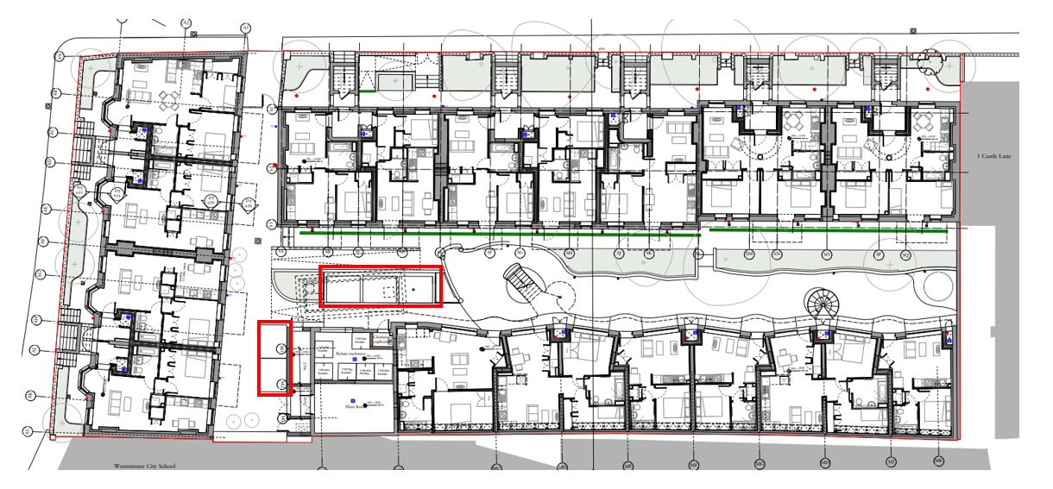
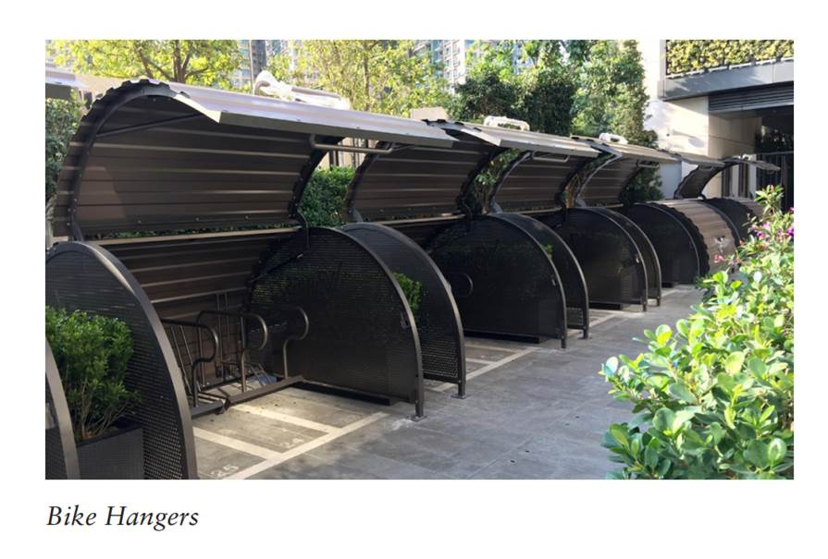
All cycles are stored at the owner’s risk.

Security/ Access/CCTV
The property is accessed with an access fob and a key that each resident is given. The access fob will permit you to enter the gate, bin store and cycle store.

Communal and Window cleaning
Cleaners managed by the NHG Estates Team will be responsible for the cleaning of the landscaped areas, shared surfaces and pedestrian routes as well as communal walkway, the lifts and all cores throughout normal working hours.

Residents are responsible for cleaning all accessible window (those on the walkway, terrace and balcony); street facing windows will be cleaned by the cleaners via an extended pole system. Communal windows will be cleaned once a year via an extended pole system.

- To clean the windows, use warm water and mild detergents, avoid harsh solvents as they may damage the finish.
- Avoid using glass cleaners that have an ammonia or alcohol base.
- No matter how stubborn certain stuck-on materials may be, never use a razor or any other kind of blade to scrape them off. This can cause permanent scratches and leave your windows more vulnerable to breaking in the future.
- Clean all the other parts of the window to maintain them.

If you have any queries regarding this, please contact the Housing Officer.

Refuse disposal
We ask that residents kindly remove any household waste and dispose of it in their designated bin store.
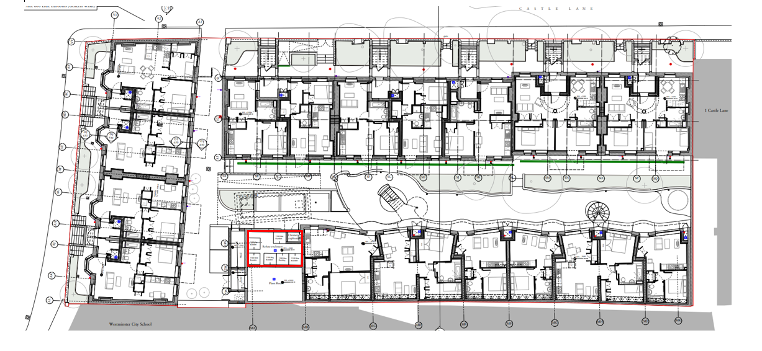

For residents living in 3 Castle Lane Core 1 and 2, your refuse store is located on Pine Apple Court, as per the below plan.

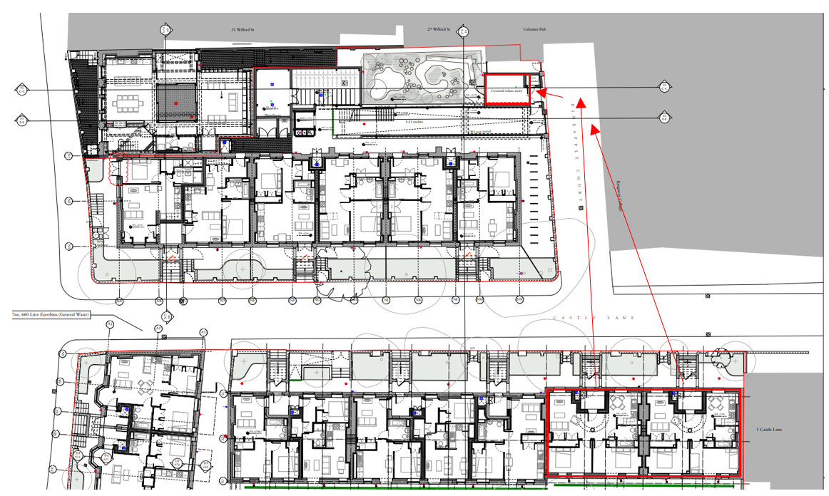

The refuse store is fitted with fob access controls.

Refuse is removed on a weekly basis from the communal bin stores, please contact your Housing Officer if the bin stores are overflowing.

When recycling, please ensure you follow the guidelines below:

- Cardboard - please flatten or tear into smaller pieces - card sleeves, cereal boxes, egg boxes, cards, etc.
- Mixed paper
- Plastic bottles - empty, rinsed and squashed
- Tins and cans - empty and rinsed

Do not put black sacks into the recycling bin as these cannot be recycled.

For further information please visit the Westminster Council website:

https://www.westminster.gov.uk/recycling-and-rubbish

Estate regulations
It is essential that estate regulations are set, implemented and appropriately managed in the event of non-compliance by any occupier. A full copy of the proposed estate regulations will be provided separately however below are general principles intended to enhance the quiet enjoyment of the Development for the benefit and convenience of all. The full estate regulations will form part of the leases and tenancy agreements.

CCTV
External and communal CCTV cameras are installed in a number of locations for your safety and security.

Noise - Noise levels are to be kept at a minimum as so not to disturb your neighbours. No loud noise is permitted between 11pm and 8am. Any noise allegations will be investigated by the management team.

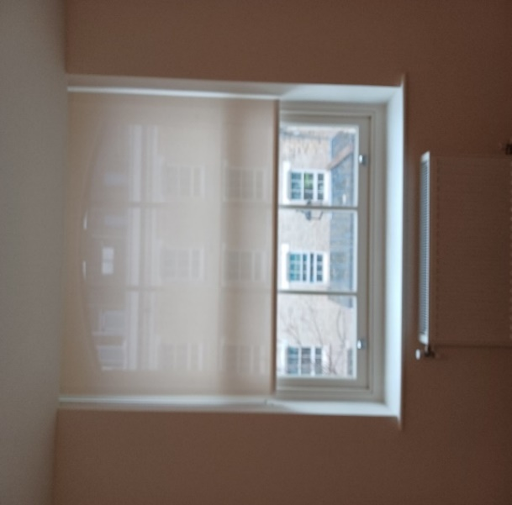
Balcony - No items should be stored on the balcony. This includes washing and bicycles.

Window Dressings - Windows should not be covered in any material other than the window dressings provided. Residents are not authorised to change the window dressings.

Black out Blinds have been installed on the bedroom windows and bedroom balcony doors.

Privacy Blinds have been installed on all other windows and balcony doors.
Barbecues/Fires - No barbecues or fires will be allowed at any time at, including on private or shared balconies, terraces, or podium gardens.

Courtyard and Roof Garden Space - Only the residents of 3 & 5 Castle Lane and 47, 49, 51, 53 Palace Street shall use the amenity space at the rear of the building and only between the hours of 9.00am and 20.00pm daily.

Satellite - Communal satellite dishes have been installed. No resident will be permitted to have a satellite on display at any time. Any satellite located will be removed immediately.

Podiums, gardens, shrubbery and Estate Areas - These areas are provided for the enjoyment of all residents at the Development. No ball games are permitted within these areas. The interfering or removal of any plants is not permitted.

Pets - All pets are to be registered and authorised by the landlord. Authorisation requests can be obtained from your Housing Officer.

Bicycles - All bicycles are parked at the owner’s risk.
Parking - There is no parking within the Development and street parking is restricted. For further information about parking please contact Westminster City Council. This Development is a car-free scheme. Notting Hill Genesis cannot not issue parking permits.

Common parts - Do not obstruct any of the access ways i.e. fire exits. Smoking is not permitted within any communal area or lifts.

Property - Any act that may interfere with the safety, comfort or convenience or cause nuisance or danger to any person or property is prohibited.

Disposal of waste - All waste is to be disposed of in the correct manner.

Advertising - No advertising by Estate agents will be allowed to be displayed within the Development. Window stickers, advertisements or notices will be removed immediately.

Immoral use - No apartment or area within the Development is to be used for any illegal, immoral, or improper activity.

Fire equipment - Residents are not to remove, dispose or interfere with any equipment or sign that is provided for their safety and the safety of others.

Road closures - The landlord with the approval Local Authority is permitted at any time to authorise the closure of any road so that building work may be carried out.

Service charge
Please see your tenancy agreement for list of payable service charge details.

Defects
Defect liability period
Your home is covered under a 12‐month defects warranty, known as the defect’s liability period. This period started when Notting Hill Genesis took possession of your home from the contractor. The contractor is responsible for the rectification of defects and faults that occur during this period. All you need to do is report any genuine defects you find via your online MyAccount.

A photo/video must be attached to the defect ticket (if possible) and a detailed description of the problem including the location within the property. Once completed you will receive a unique ID reference you can use to follow up with the defect team if required.

The Defect Team will review the information you have provided and will send it to the Developers aftercare team to arrange an appointment date and time to attend. The response time will vary depending on the urgency of the problem.

To report a defect please raise the repair though the customer portal or Housing Officer.
Defect response times
The repair line will take a decision as to whether the fault is a repair, a defect, or your responsibility. Please make sure that the information you provide to your Housing Officer is correct. Incorrect information which results in the contractor attending your home will be charged to you.
Defects categories
Emergency (Priority 1) – 24 hours:

- Gas leaks – to be telephoned immediately to the National Grid
- Dangerous electrical works
- Total failure of electrical lighting or power
- Failure of lighting to a communal staircase / corridor / lift to such degree as constitutes a health and safety risk.
- Burst water pipes or other ingress of water (including roof repairs) that are causing damage to property.
- No mains cold water supply to a property
- Complete Central heating failure only between October / March
- Complete Hot water failure
- Failure of front entrance doors to houses or flats
- Failure of lifts only if person is stuck inside
- Failure of communal gates or communal access doors
- Damaged flooring or stair tread in communal areas, where this presents a health and safety risk
- Temporary glazing repairs (permanent replacement classified as “Priority 3”)
- Defects that may render a dwelling unsecure – e.g. windows or doors not closing properly
- Defects that may cause injury or are a danger to any person
- Defects that may cause significant damage to property if left unresolved

7 days (Priority 2):

- Minor plumbing repairs – equipment failure
- General electrical repairs – defective items other than dangerous electrical works classified as “Priority 1”
- General repairs to heating and hot water systems
- Loose or detached banister or handrail
- Damaged flooring or stair tread in communal areas – other than a dangerous defect classified as “Priority 1”
- Individual door entry-phone not working
- Defective kitchen or bathroom fan
- Faults with television aerials and telephone connections
- Windows not closing property – other than where this is classified as “Priority 1”

4 Weeks (Priority 3):
- Minor roof repairs – unless there is ingress of water which will be classified as “Priority 1”
- Repairs to leaking gutters and rainwater pipes
- Re-glazing windows or doors – where there is no security issue
- Minor carpentry repairs to windows and doors
- Non-urgent plumbing repairs
- Repairs to wooden floors and floor coverings
- Repairs to external render and air vents
- Repairs to internal plaster
- Re-decoration after other repairs have been carried out
- Repairs to garden fencing

At the end of defects liability period a final joint inspection is carried out in each home and the communal areas. The inspection party consists of the building contractor, the development project manager, Notting Hill Genesis’ employer’s agent, site inspector, Housing Officer and Defect Officer. The purpose of the end of defects inspection is to check for any defects which need to be put right by the building contractor.

It is important that access is gained to all homes and the external and internal communal areas. This is the last opportunity to report defects for repair by the building contractor.

Following the inspection, the building contractor will arrange appointments directly with you to carry out final defect rectification works. You will be required to give access at this appointment time.

After the end of the defect’s liability period, general defects inside the home are the responsibility of the resident and/or NHG. Communal areas will be the responsibility of NHG. You should contact your Housing Officer for Communal issues.

If a repair arises out of misuse of or damage to the property, then the cost of the repair will be borne by the resident.

Don’t forget, the defects period starts from practical completion of the project, so will have already commenced at the date that you move in.

Repairs
Repairs are reported via MY ACCOUNT and or directly to your Housing Officer.
We are not responsible for repairs to:

- Repairs to gas installations such as cookers or gas fires (not installed by NHG) should be carried out by a certified Gas Safe engineer.
- Garden sheds
- Door handles
- Sink/toilet blockages in the first instance. The resident should attempt to unblock these with drain unblocker/plunger where appropriate.

We are responsible for emergency repairs to:

- A heavy leak in your property where it is not possible to contain the water, or it is leaking between floors or properties.
- An electrical fault in your property where it is not possible to contain the water, or it is leaking between floors or properties.
- An electrical fault in your property which endangers health or life.
- Complete electrical failure, or electrical failure in a kitchen/ bathroom
What is an Emergency repair?
- Any repair that will threaten the health or safety of our residents or the wider public if it is not carried out immediately is an emergency.
- Any repair that will seriously damage the property if it is not carried out immediately is an emergency.

We are responsible for repairs to:

- The structure of your home including the roof, outside walls, doors, windows and windowsills.
- Gutters, down pipes and drains.
- Garden walls, fences, and steps used to access and exit the property (except where they are the neighbouring property’s responsibility).
- Existing central heating, water heaters and fires (where provided by us).
- Electrical repairs (not including electrical appliances)
- Repairs to the gas installations such as boiler and pipework (not including appliances)
- Inside walls, floors and ceilings.
- Doors, door frames, door hinges, letter boxes and skirting boards, window catches, sash cords and window frames.
- Chimney stacks and flues.
- Banisters.
- Kitchen units, wall tiling, air vents and extractor fans.
- Showers (where provided by us), sinks, toilets and baths.
- Pest control in communal areas.
- Bathroom flooring and wall tiles.
- Persistent issues with drainage/removal of wastewater.

How long will I have to wait to have a repair carried out?
- We aim to have someone attend your property within 4 hours if you report an emergency repair.
- We aim to complete non-emergency repairs within 20 working days.

Please be aware that our contractors cannot always fix a problem on the first visit. If they cannot fix something, they will arrange a date and time to come back and finish the job.

Preparing for the repair
When waiting for a repair, it is important to clear space or move furniture so that the repair is accessible for the contractors. This will help them to carry out the works more quickly and minimise the risk of any accidental damage to possessions.

If you have any concerns or think you may have difficulty clearing space for the contractor, please let your housing officer know as soon as possible.

Household pests
You are responsible for dealing with household pests such as ants, bees, bedbugs, wasps, cockroaches, rats and mice within your property. Contact the environmental health department at your local council for advice. Go to www.gov.uk/report-pest-problem for more information.

If you cannot deal with the pest issue, or if you have a pest problem in a communal area then contact your Housing Officer.

Utilities

Mains water/ drainage
Thames Water supply the incoming mains water through an underground service pipe fitted with a stop valve at the boundary to the development for use by the water company in an emergency.

As water enters your home, its flow is controlled by the stopcock, which allows you to turn off the supply in an emergency or for maintenance.

Mains water and drainage supplier: Thames Water
Website: www.thameswater.co.uk
General Telephone: 0800 316 9800
Billing and account enquiries Telephone: 0800 980 8800

Water Meter
The water meters are located in the communal riser cupboards. Residents will be provided keys to the communal riser cupboard. For safety reasons and to ensure proper use of shared facilities, please do not store any items in the communal riser cupboard.

Stopcock:
Your water meter is located within the communal riser cupboards. The dwelling stopcock is located in the riser cupboard just above the water meter. The stop cock is a brass looking tap. Access to the communal riser cupboard is via your Housing Officer.

There is an isolation valve in the utility cupboard. The water supply for the whole apartment can be closed off from there. The isolation valve is a blue handle as shown in the image below.

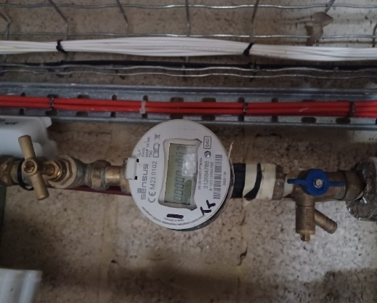
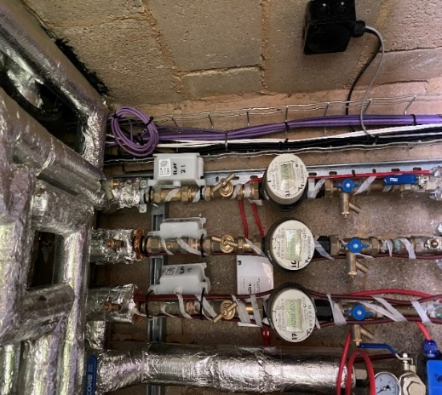
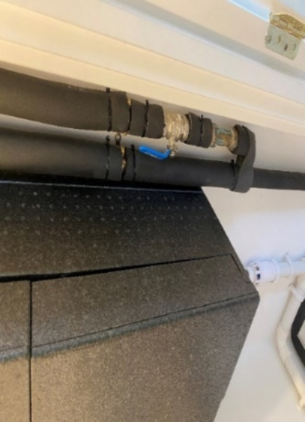

TROUBLE SHOOTING

Kitchen Wastepipes: If a blockage occurs and the sink is full of water try to remove the blockage by pushing a flexible drain rod down the plughole or by using a suction cup plunger to move water up and down the wastepipe. The risk of blockages can be reduced if you remember to put fat (which solidifies when cold) into an empty container rather than down the sink or drain.

Bath, Shower and Basins: Blockages here are normally caused by the build‐up of hair and soap in the plug hole and become noticeable when the bath or basin starts to drain away more slowly. Clear bath or basin wastes with a ‘Sani snake’ (available from hardware stores) or by using a proprietary chemical cleaner (please read instructions carefully). You can purchase a small filter to put over the bath/ water outlet to collect hair, etc. and prevent blockages.

Electricity
Electrical supplier details: British Gas
Website: www.britishgas.co.uk
Telephone: 0800 0728 625

Location of meter: Utility Cupboard

Location of Consumer unit: Utility Cupboard

Please note that you will be able to change to an electricity provider of your choice.

Energy Tips
Light  The light fittings in your property use energy efficient light bulbs. Although these lights may cost more, the cost saving in reduced energy bills will ensure money saving in the longer term.  See the Finishes section for electrical light fittings installed in your property.  For replacement bulbs contact your local electrical store.  Changing light bulbs  To change light bulbs, the light switch must be in the off position. It is advisable to replace the bulb with the same type of bulb that was removed.  For further information on energy saving lighting visit www.energysavingtrust.org.uk/electricity/lighting  Electrical alterations, including replacing light fixtures and fittings should only be carried out by a qualified electrician.  Cables may run in any position above a ceiling or under  A floor. Before fixing to walls, floors and ceilings always  Check for buried pipes and cables using a detector available  From diy stores.  Do not interfere with earth bonding cables connected to  Pipework and main earth connection. | Loss of power and troubleshooting  If your electricity goes off, start by checking to see if it is a power cut or a fault in your home. The easiest way to do this is to see if your neighbour’s have electricity. If they do not have power either then it is a power cut and you should contact 105.  It isn’t possible to predict a power cut however here are some precautions you can take in case a power cut occurs:  - Make sure you have multiple torches along with extra batteries  - Keep a plug‐in telephone that does not require electricity – remember that with cordless phones you may not be able to make phone calls once the batteries are dead  - Keep important documents safe and handy  - If your neighbours have power, then it could be a fault in your home.  Your trip switch may have turned itself off. If it has, try turning it back on. If it switches off again then one of your electrical appliances may be faulty. Your trip switch turns itself off to make sure you do not get injured by a faulty appliance. Once you have found the faulty appliance and turned it off, your power should stay on.  If you have only lost power in part of your home you may have a fault with your electrical wiring somewhere, in which case you should call a qualified electrician as soon as possible.  For further information on electric safety in the home visit the electrical safety council website www.esc.org.uk
Energy and water efficiency  Tips for saving energy and money around your home:  Washing machines  - Wash at the lowest temperature that will give efficient results.  - Wait until you have a full load or use the ‘half load’ setting to reduce water.  - Use short wash cycles for lightly soiled items.  - Consider buying a shower wash type of washing machine.  - If you are planning to use a tumble dryer, choose a washing machine with a high spin to save on drying time.  Dishwashers  - Always wait until the machine is full before running it.  For lightly soiled items some dishwashers have economy programmes that reduce the washing temperature and /or shorten the washing time.  Washer dryers  - Washer dryers save space and often cost less than two separate machines. They usually hold less than a dedicated built tumble dryer – you can’t wash a second load until the first load has finished drying, and they usually use an air/water heat exchanger, which means that heat extracted in the condenser is lost to the drain. Washer dryers can give a perfectly satisfactory service.  - Wait until you have a full load before using the washer and/or tumble dryer.  - If the machine has an energy saving load setting use it whenever possible.  Use low temperature settings for lightly soiled items  Fridges and freezers  - Try to keep your freezer at least three quarters full.  - Do not put warm food into the fridge.  - Defrost your fridge or freezer regularly and avoid leaving the door open longer than necessary.  - Check that the door seal on your fridge is working effectively by closing on a piece of paper to see if it is held tight. If your fridge builds up frost too quickly the door seal could be faulty.  Cooking  - Match pan sizes to ring and use pans that are appropriate for your type of hob.  - Where a long cooking time is needed use a conventional oven. However a microwave oven is more economical for short cooking times, particularly for smaller quantities of food.  - When cooking with a microwave always follow the manufacturer’s instructions and ensure that there are no “cool spots” left in the food. | Television sets  - When you choose your tv consider buying a model that uses less electricity.  - Do not leave the tv switched ‘on’ if nobody is watching it.  - Do not leave the tv in ‘stand‐by’ mode for long periods.  Irons  - Do not leave an iron switched ‘on’ if you are not going to use it within 5 minutes.  Kettles  - When you choose your kettle consider buying a jug‐style model or an energy efficient one.  - Remove lime scale from your kettle regularly.  - When boiling water use a kettle – not a pan.  - Only heat as much water as you need in the kettle but remember to always cover the element.  Computers  - Switch your computer off when it is not in use.  Mobile phones  - Unplug phone chargers when not in use.  In the bathroom  - When brushing your teeth using a tumbler, instead of running the tap water for rinsing, can save nine litres of water per minute.  - Taking a shower instead of a bath can save up to 40% of the water that you use.  - Reducing the time you spend in the shower will save water and energy.  - Put the plug in the basin when washing hands or shaving, rather than leaving the tap running.

Heating and hot water
Heating and hot water is distributed in your home via the heat interface unit (HIU), which is located in your Utility Cupboard. Image of the HIU below.

Hot water is produced by the HIU on demand.
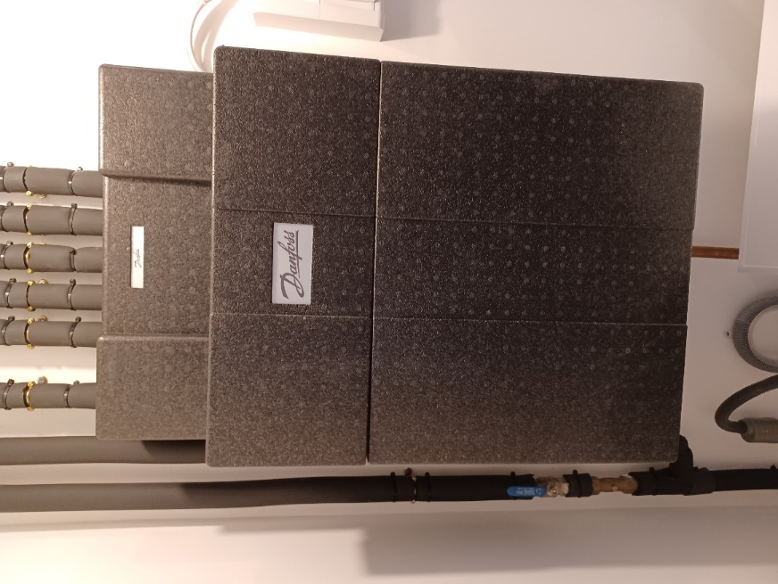
Heating and hot water consumption is measured by a heat meter and is read during your handover appointment. Please see image below.

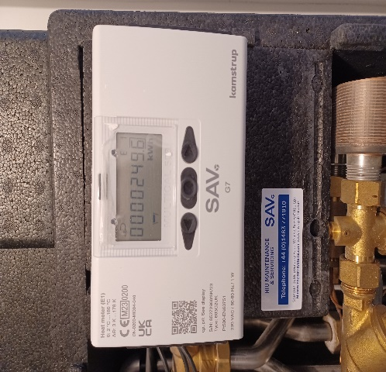
The Sycous has been chosen for your home. The Sycous Hub is a smart energy meter and heating and hot water controller, all in one. It is a popular metering solution which is linked to Insite’s "PayPoint" payment system. Your Sycous enables you to easily monitor your use
of heating and hot water and also the payments you make.

The Sycous Hub is connected to Insite's payment system via the internet, so it always knows how much credit you've purchased.

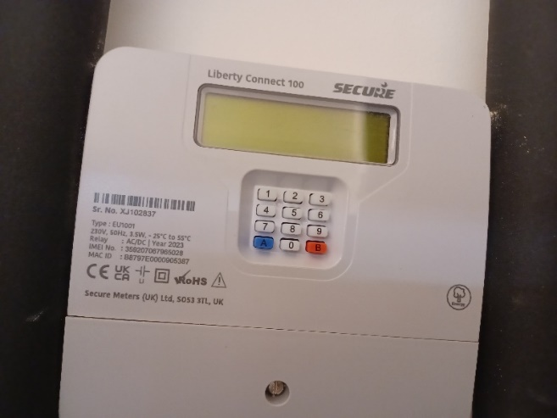
This is an image of the main screen display: This displays your balance, your emergency credit limit, your kWh (unit) charge, your daily standing charge, your kWh and Carbon Dioxide usage.

Any queries with regards to meters and billing for heating and hot water should be addressed to your metering and billing provider, please refer to the separate Insite Energy brochure for further details.

Heating Timer
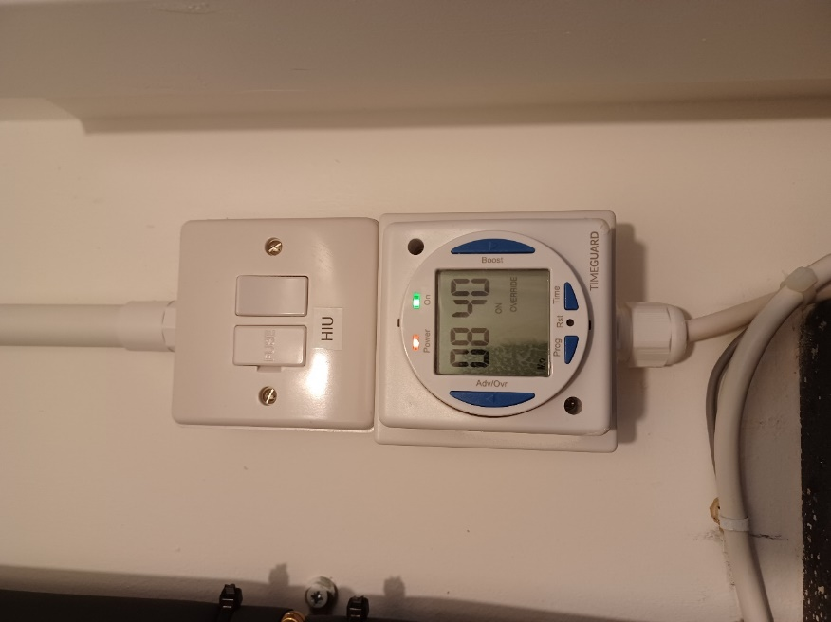
For instructions on programming the heating timer, please refer to the ‘Timeguard thermostat timer guide’ available on the ‘Welcome to Castle Lane’ home user guide page or www.nhg.org.uk/media/hc2nqkih/timeguard-thermostat-timer-guide.pdf

Television / Telephone / Internet
Your TV will have access to Sky (supporting Sky Q and also Sky Glass as long as there is internet), Virgin and Hyperopic.

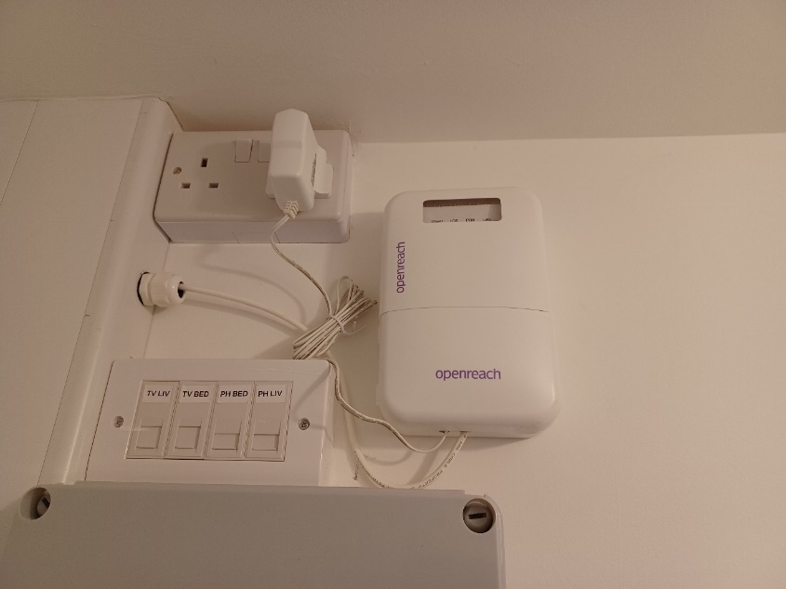
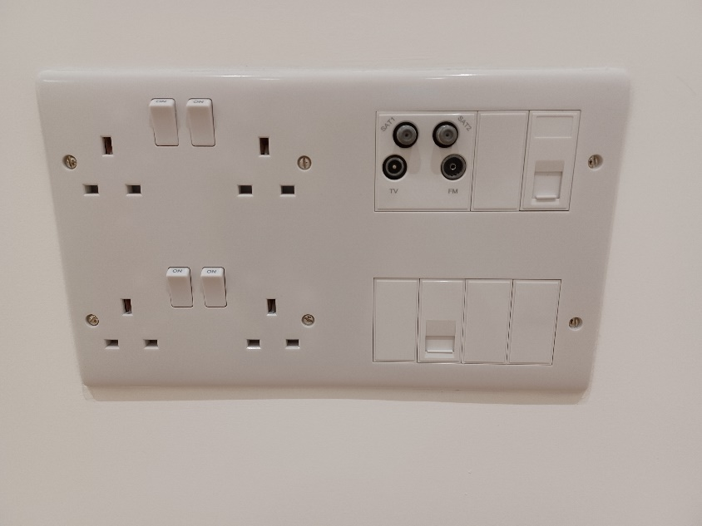

Radiators
Primary Heat is provided by communal boilers located in the plantroom; each apartment has a SAV HIU for transfer of this heat into Domestic Hot Water.

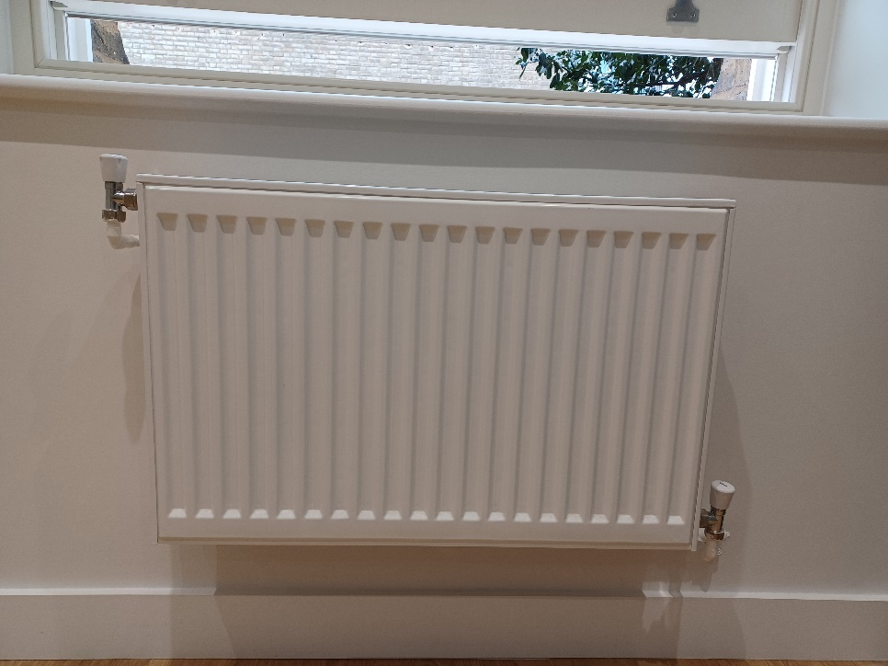
DO NOT attempt to bleed radiators or adjust the boiler filling loop. These are technical maintenance tasks that must only be carried out by qualified engineers.
An electric towel radiator has been installed in the bathroom.
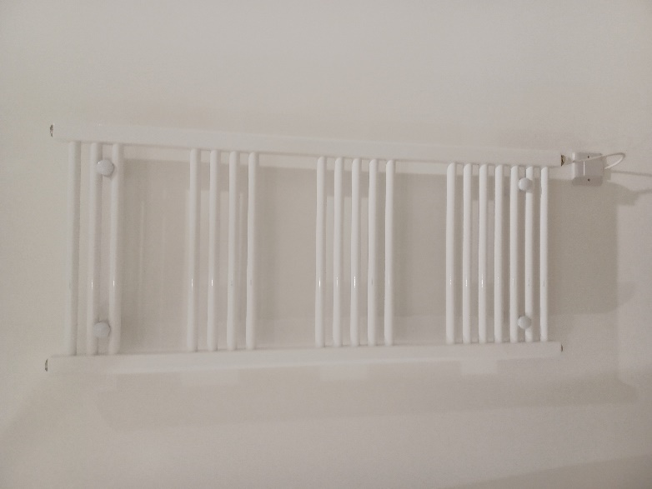

Mechanical ventilation
Each apartment has a Nuaire MVHR system installed providing both Ventilation and Heat Recovery within the apartment. The Heat Exchanger within the unit is protected by filters on the fresh air and exhaust side of the exchanger, these filters are accessible through the front of the unit for routine inspection and cleaning if required.
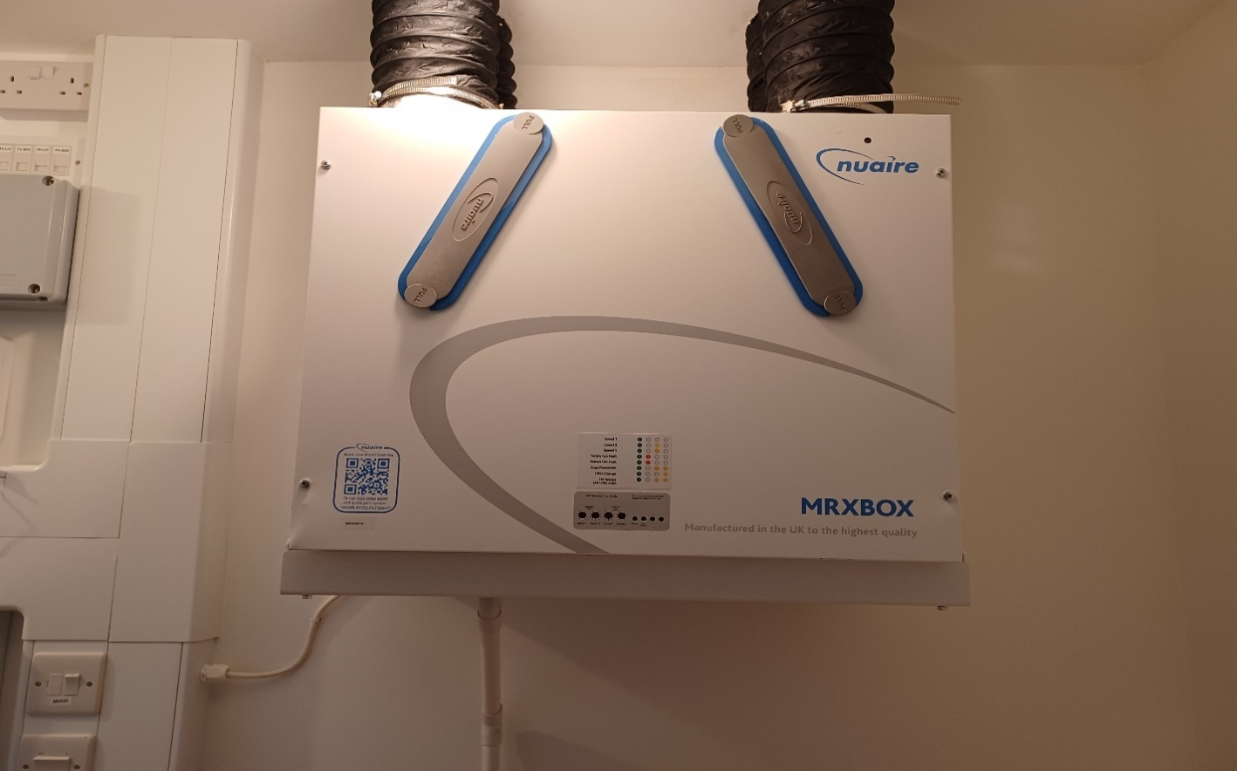

The ventilation system extracts warm, damp air from the home and draws in fresh air from the outside via ducted ceiling mounted terminals. The warm, extracted air is passed through a heat exchanger to recover the heat before being expelled outside. The cool, fresh air from outside is also passed through the heat exchanger, without coming into direct contact with the extracted air where it is pre‐warmed before being pumped into your home. The unit also has a summer bypass mode. This ensures that in the summer, fresh air is not passed over the heat exchanger and as such reduces the risk of overheating.

The ventilation system to your kitchen and bathroom where excessive moisture can be generated while cooking or using the bathroom is boosted. This is done automatically when the lights are turned on in the bathrooms, and there is an MVHR Boost Switch for the kitchen above the worktop.

Item | Maintenance Task | Task Frequency
Nuaire MVHR | Filter Clean - Remove filter and clean using a vacuum cleaner. | As required.
Nuaire Noxfilter | Remove filter and clean using a vacuum cleaner. | As required.
HRU | Remove filter and clean using a vacuum cleaner. | Monthly.

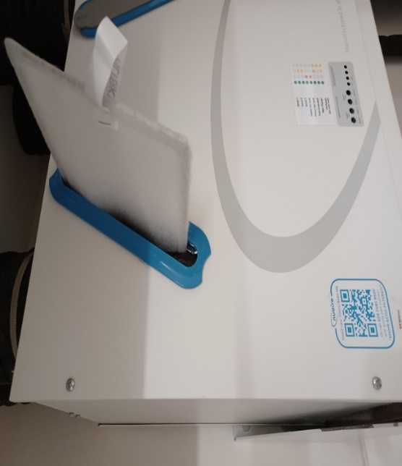
Filters are to be inspected every 6 months and replaced every 12 months (or sooner if
required). Failure to do so may impair the performance and energy efficiency of this unit. A
flashing LED (Section 6.2) will indicate that a filter change is required. This indication repeats every 12 months and will turn off automatically after 5 Days.

Remove the filter covers on the front panel of the unit by gripping the two circular tabs either end of the filter covers and pulling away from the unit. The filter can now be extracted by pulling the black removal loop on the front edge of the filter. Once the filters have been inspected return or replace them as necessary.

Thermostats
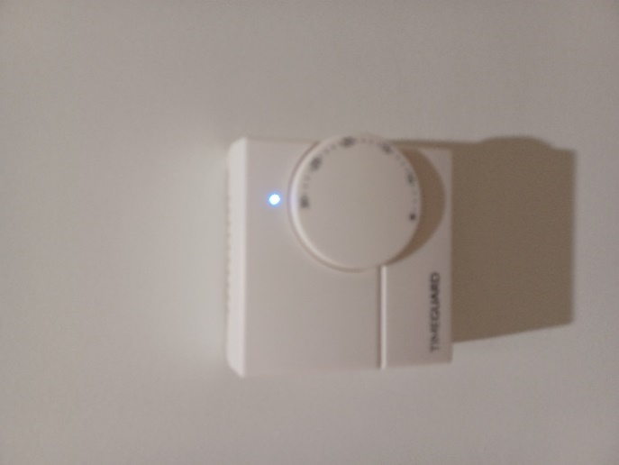
Your property is fitted with a thermostat to regulate the temperature.

There is a Timegaurd heating programmer in your utility cupboard, which provides timing control for your central heating system, letting you set ON and OFF periods to suit your own lifestyle.

For more information on this and how to set it up, please refer to the manufacturer’s literature section of this manual.

Looking after your new home

Lubrication
There are many areas within your new property that will benefit from regular lubrication. In particular, we recommend that window hinges and door mechanisms are regularly lubricated to keep them in good working order.

Door seals
The condition of all door seals should be examined at six-monthly intervals. If the seal is missing, in part or completely, it should be replaced immediately. It is necessary to replace like with like and the use of any seal, other than that originally installed, may jeopardise the performance of the door. Seals should be fitted in accordance with the manufacturer’s instructions.

Ironmongery
Stainless steel, brass effect and chrome finishes should be cleaned at least every six months with a dry cloth or duster and washed periodically with a soft cloth and soapy water and dried with a clean cloth. Do not use abrasive materials for regular cleaning. Acetones or solvents can be used to remove grease marks or paint from stainless steel finishes if needed. There are also special products available for removing scratches or rust from stainless steel. Always follow the manufacturer’s instructions when using cleaning products.

DIY

When hanging pictures care must be taken to not disturb or damage any pipes or electric cabling that may lie beneath the surface of the wall. It is strongly recommended that you use a cable/ pipe detector, which can be bought from most major DIY stores.

Plasterboard should be able to take a weight of approximately 10kg using appropriate plasterboard fixings.

Due to this weight limitation it is not advised that you fix heavy objects to plasterboard walls e.g. Flat screen tv unless the relevant provisions have been allowed for.

Redecorating
Please note that no DIY should be done within the defects period as it will mean that the defects period for that area is void. For example, if you change the sink tap and it breaks we will not fix it or put the old one back in place or if there were a leak from the new tap we would not fix it.

Alterations
Please note that structural or material alterations are not permitted. Please contact your Housing Officer for further guidance.

Reducing condensation
Condensation is caused by steam or water vapour when it comes into contact with cold surfaces (in the same way that steam in the bathroom condenses on the window).

Once materials have dried out, you should no longer experience significant condensation. However, normal daily activities produce a great deal of water vapour, which may cause condensation if allowed to spread around the home.

Measures you can take to control condensation:
  - Cover pans when cooking and do not leave kettles boiling
  - Put washing outdoors to dry if you can. If you use a tumble dryer, make sure that it is vented to the outside air (unless it is a self‐condensing type). DIY vent kits are available.
  - Use the cooker hood and/or extractor fans and keep the doors closed when cooking, washing and bathing.
  - Do not switch off the main isolator switch to the extractors in the bathroom or kitchen at any time, as they are needed to ventilate these rooms.
  - Regularly open windows to encourage air changes.

Ventilation is needed to get rid of the moisture that is naturally produced every day in your home. Your home will only maintain a healthy internal environment when ventilation systems are running. You risk damage to your health and home if you turn these off or block outlets.

Homes where the heating is off all day, because the occupants are out, are more likely to suffer condensation problems than those heated more continuously. This is because, when normal activities such as washing and cooking are carried out in the evening, the home has been unheated for long periods and the surfaces are cold.

Make sure the heating timer is set so that your home is warm by the time you return home. During very cold weather it is better to leave the heating on during the day to maintain an even temperature. The temperature can be set a few degrees lower and turned up when you return.

Most heating systems operate inefficiently if turned completely on and off. Use your thermostat to control heating operation. This will be more efficient and help to reduce fuel bills.

Remember that condensation is not normally a building fault. Learning to control moisture levels is a vital part of living in modern, well insulated, home.

Bathroom & kitchen care

Sanitaryware
To prevent a build-up of dirt and limescale, acrylic and ceramic sanitaryware should be wiped down immediately after use with a soft cloth and thoroughly cleaned with warm soapy water, a cream cleaner or multi-purpose surface cleaner on a weekly basis.

Many household chemicals such as paint stripper, nail varnish remover, household bleach, abrasive cleaning agents, perfume, aftershave or strong disinfectants can cause damage and should not be allowed to come into contact with your sanitaryware.

If such chemicals do accidentally come into contact with your sanitaryware then it is advised that you rinse the affected area with sufficient water to completely remove the chemical.

In hard water areas mild lime-scale remover may be used from time to time.

Never leave strong bleach or cleaners in the wc bowl for extended periods of time or overnight. Never mix different cleaners in the wc bowl as this may give off poisonous or volatile gases.

To avoid damaging internal fittings do not put bleach products in the cistern.

When cleaning your sanitaryware the manufacturer’s instructions take precedent over the above recommendations and should be followed at all times. The item should be rinsed and dried with a soft cloth after cleaning to provide the best finish.

Kitchen sink
Your stainless-steel kitchen sink is generally resistant to most household items and is very hard wearing, however the following substances should not be allowed to come into contact with the stainless-steel surface, mortar, cement, plaster, concrete, tile cement, grout, undiluted bleach, acids, silver dip.

Daily cleaning of your sink should be carried out using cream-based cleaners on a soft cloth. This should be adequate to remove such marks as tea stains and grease. More abrasive cleaners such as scouring powders, should not be used. The everyday film of limescale, which in hard-water areas, can be quickly removed using a standard cream cleaner but, should a thicker limescale layer form, then this will require treatment with a proprietary limescale remover and a soft brush.

It is likely that during its use the stainless-steel surface will scratch, you can reduce the appearance of scratches by using a stainless-steel cleaner.

Units & doors
It is important that you treat all cupboards with care in order maintain their appearance and functionality. Units and doors can be cleaned by using a soft damp cloth with warm water and a mild detergent, ensure to wipe excess water off immediately to ensure water is not left ‘standing’ on the surfaces.

Worktops
Your kitchen worktop has a laminated finish.

Due to their resistant and hygienic, dense surface, Wilsonart work surfaces do not require any special form of care.

Laminate worktops are easy to maintain with daily cleaning. For most day-to-day cleaning, all you have to do is wipe your counter down with a damp cloth. You can also use any pH balanced gentle household cleaner, such as dish soap or an all-purpose cleaner.

Please refer to the manufacturer’s recommendations for further information.

Finishes
Intermediate Rent
Location/room | Type/finish | Description
Bathrooms & Shower Rooms Walls | Wall Tiling | Johnson Tiles, Prismatic, PRG103, Glazed ceramic tile, Old lace (PRG103)
Bathrooms & Shower Rooms Walls | Wall Finish | Dulux Trade, Mouldshield Fungicidal Eggshell  Bleached Lichen No. 4
Bathrooms & Shower Rooms Flooring | Skirtings | Mosa, Global Collection 15030, Ceramic tile, Plain Grey Beige, Globalgrip
Bathrooms & Shower Rooms  Flooring | Floor Tiling | Mosa Global Collection 75030V, Ceramic tile, Plain Grey Beige, Globalgrip
Bathrooms & Shower Rooms | WC and Cistern | Ideal Standard, Sandringham 21 range, product nos. E822101 (toilet pan), E899901  (cistern), E907601 (seat and cover),  White (01)
Bathrooms & Shower Rooms | Washbasin and Pedestals | Ideal Standard Ltd, Sandringham 21 range, product nos. E896201 (basin) and E897601,  White (01)
Shower Rooms | Shower Tray & Enclosure | Ideal Standard Ltd, Simplicity Low profile rectangular flat top shower tray product no. L509201 1000mm(L) x 800mm(W) x 40mm(H). Shower enclosure: Kubo range slider door, product no. T7378 1000mm(W) x 1950mm(H) – EO-right Silver Finish.  &  Simplicity Low profile rectangular flat top shower tray product no. L509101 900mm(L) x 800mm (W) x 40mm (H). Shower enclosure: Kubo range slider door, product no. T7374 900mm(W) x 1950mm(H) – EO-right Silver Finish.
Bathrooms | Bath | Ideal Standard, Sandringham 21 range standard gauge bath, product no. S183901,  White (01)
Bathrooms | Bath Front Panel | Ideal Standard Ltd,  Nisa range, product no. S0915  Acrylic  White (01)
Bathrooms & Shower Rooms | Taps | Inta Interterm Modern Eco Copper Tails Thermostatic Bain Mixer Tap – Chrome – IT1008CP
Bathrooms & Shower Rooms | Basin Waste | Ideal Standard Ltd, Click basin waste, slotted, E1482AA, Chrome plated (AA)
Bathrooms | Bath Shower Mixer | Ideal Standard Ltd, Alto Ecotherm bath/shower mixer pack, product no. A5636AA, Chrome plated (AA)
Bathrooms | Bath Chain Waste & Overflow | Ideal Standard Ltd, 1 1/2 Bath chain waste and overflow (ABS plug), product no. S8830AA, Chrome plated (AA)
Shower Rooms | Bath Shower Mixer | Ideal Standard Ltd, Ceratherm 200 exposed thermostatic shower pack, product no. A5761, Chrome plated (AA)
Bathrooms & Shower Rooms | Heated Towel Rail | Stelrad Limited, Esprit range towel warmer, product no. 148050, White
Bathrooms & Shower Rooms | Toilet Roll Holder | Allgood plc, Washroom single toilet roll holder, product no. PC6680, PC - Polished chrome
Bathrooms & Shower Rooms | Mirror | Bevelled edge mirror  Quality: Free from tarnishing, discoloration, scratches and other defects  visible in the designed viewing conditions. Reflection undistorted.  Backing: Copper backed  Edges: Square and polished  Fixing: Dome headed screws  Installation: Accurately with sides vertical  Size: 450mm x 600mm
Bathrooms & Shower Rooms | Shelf | Clear toughened glass, square corners, 400(l) x 150(d) x 6-8 (thick) mm
Bathrooms | Shower Curtain | Shower rail and weighted shower curtain to bath
Bathrooms | Clothes Line | Brabantia (UK) Ltd, Pull-out clothes line, product no. 385728, White
Bathrooms | Clothes Hook | Allgood plc, Alite clothes hook, product no. 98230, SS - Satin stainless steel
Kitchen | Fitted Base Units, Wall Units, Worktop & Accessories | Symphony Kitchens Ltd.  Product reference: Plaza range in the Concept Group  Finish: Mussel
1 and 2 bed units only – Kitchens | Sink | Franke UK Ltd, Product reference: FRANKE Ascona inset sink, product no: ASX 611  Size: 860 x 510mm  Finish: Silk finish
3 bed units only –  Kitchen | Sink | Franke UK Ltd, FRANKE Ascona inset sink, product no: ASX 611  Size: 1000 x 510mm  Finish: Silk finish
Kitchen | Kitchen Tap | Hansgrohe, Logis M32 2-handle kitchen mixer 220 Eco Single Spray,  Product no. 71283000, Chrome
Kitchen Walls | Wall Tiling | Johnson Tiles, Prismatic, Glazed ceramic tile, White (PRS12), Gloss
Kitchen Walls | Paint | Dulux Trade, Mouldshield Fungicidal Eggshell RAL 9010
Kitchen Floor | Vinyl Flooring | Karndean Design Flooring, Van Gogh Rigid Core range timber effect vinyl plank flooring  Size: 1220mm x 180mm plank  Natural Prime Oak (VGW115T)
Kitchen | Light Fittings | Megaman, 5W TEGO Integrated Fire-Rated LED Downlight with tilt bezel. Product Number: (519030)
Kitchens; above  worktop | Sockets | ML Accessories Limited, Curved Edge range, White
Throughout units  except bedrooms,  bathrooms and  shower rooms | Vinyl Floor | Karndean Design Flooring, Van Gogh Rigid Core range timber effect vinyl plank flooring  Size: 1220mm x 180mm plank  Natural Prime Oak (VGW115T)
Bedrooms | Carpet | Joseph Hamilton & Seaton, New Elford Twist Standard Range, Sand
Wall (Throughout units except bathrooms and shower rooms) | Paint | Dulux Trade, Vinyl Matt RAL 9010
Throughout units | Sockets, Switches and Sundry Electrical | ML Accessories Limited, Curved Edge range, White
Throughout units | Media Plate | ML Accessories Limited, Curved Edge range, White
Throughout units except bathrooms and shower rooms | Blinds | Swanmac Ltd, SunBloc, Aluminium, PVC, Polyester, White
Intermediate  Rented Units | Pendant Set | Luceco plc, T2 Pendant Set  Lampholder Size: 38.5mm x 58.5mm
Intermediate  Rented Units | Clothes Dryer | Leifheit plc  Telegant Plus 100 White 83100
All internal unit doors except Bathroom and Shower Rooms doors | Interior Doors | JELD-WEN, MDF primed for painting in RAL 9010
Bathrooms and Shower Rooms | Bathroom Doorsets | JELD-WEN, MDF primed for painting in RAL 9010, WC locks to have emergency turn and release function
All internal unit doors | Ironmongery | SDS London Architectural Ironmongery, Spira lever on rose, product no. 95022
Throughout units except bathrooms and shower rooms | Skirting Boards | Contractors Choice, Square edge MDF, painted finish to match 4.1, Paint finish to match wall finish
Throughout units except bathrooms and shower rooms | Eggshell Paint to Skirtings, Linings and Joinery Generally | Dulux Trade, Eggshell RAL 9010

Appliances

Appliance instruction manuals & warranties
For further information on your appliance, please refer to your appliance manuals. Should you misplace any of your appliance instruction manuals over time, you can refer to the manufacturer website and download a pdf version of your appliance, by providing the model number.

You are responsible for registering your appliances in order for them to be covered under the manufacturer’s warranty. Should you experience a problem with any of the white goods installed in your property during the first two years following legal completion, you should contact the manufacturers directly.

Please refer to each manufacturer’s leaflet provided in the Welcome pack.

Intermediate Rent

Product description | Manufacturer | Model
Fridge Freezer | Electrolux  Zanussi  Zanussi | LNS5LE18S  ZNLK18ES3  ZEAN82FR
Oven | Electrolux  Zanussi | KOHLH00BX  ZOHHC0X2
Hob | Electrolux  Zanussi | LRR6436  ZHRN643K
Cooker Hood | Electrolux  Zanussi | EFU2165  ZHT 631 X
Washing Machine / Dryer | Electrolux  Zanussi | EWDK5846B  ZWD76NB4PW

Registering your appliance warranty
It is your responsibility to register your appliances with the correct manufacturer in order to validate your guarantee for each individual appliance within your home.

Please register your warranty by phone or you can register online.

Appliance cleaning & maintenance
To reduce the risk of damaging the finishes irreparably please follow these guidelines:

- Use a soft cloth, slightly dampened with water and a mild detergent solution
- Buff dry with either a soft lint free cloth or paper towel ensuring all excess moisture is removed

Do not use the following on kitchen appliances, cupboards and worktops:

- Scouring pads or similar products
- Abrasive or harsh cleaning agents
- High pressure cleaners.

Product description | Care & maintenance
Washer – dryer | The outer parts and rubber components of the appliance  can be cleaned using a soft cloth soaked in lukewarm  soapy water. Do not use solvents or abrasives.
Detergent dispenser drawer | Remove the dispenser by raising it and pulling it out. Wash under it under running water, this operation should be repeated frequently.
Hob | Clean the hob, when it is cool, after each use. This will prevent the build-up of dirt and make cleaning easier.  Use a clean cloth, absorbent kitchen wipes and washing up liquid or a specific glass ceramic cleaner.  Remove baked-on dirt with the special scraper tool (if provided) and specific cleaning products.  Any food spills should be cleaned off before they dry.  Do not use abrasive products, chlorine-based cleaners, oven-cleaner spray or pan scourers.
Fridge/ freezer | Open the freezer compartment door and remove the upper  drawer.  Unfasten the STOP FROST accessory and remove it, taking care not  to drop it on the glass shelf below.  Close the door of the freezer compartment. Remove the frost on the accessory by rinsing it under running (not hot) water  Let the accessory drip dry and dry the plastic parts with a soft  cloth.  Reinsert the accessory by placing the back part on the projections  shown in figure, then refasten the handle of the accessory to the  clasps above.  Reinsert the upper drawer and close the door of the freezer  compartment.
Extractor hood | Clean using only a cloth dampened with neutral liquid detergent. Do not clean with tools or instruments. Do not use abrasive products. Do not use alcohol
Dishwasher | The dishwasher must not be used without filters or if the filter is  loose. - Regularly clean the filter assembly so that the filters do not clog and that the wastewater flows away correctly.  Using dishwasher with clogged filters or foreign objects inside filtration system or spray arms may cause unit malfunction resulting in lose  of performance, noisy work or higher resources usage.  The filter assembly consists of three filters which remove food residues  from the washing water and then recirculate the water.

Windows, Door & Internal Security
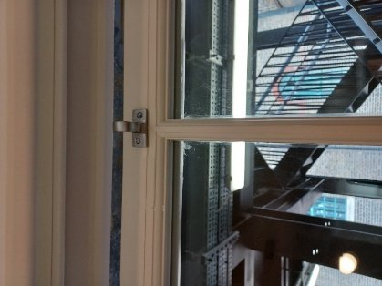
Your home has been fitted with double glazed sliding sash windows. The windows are fitted with window restrictors and are openable for ventilation purposes.
Generally, the sliding sash windows open from the bottom upwards and are fitted with restrictors. The windows on the open walkways are fitted with restrictors and open from the top and slide down for ventilation. A hook is provided to enable you to open the top window.

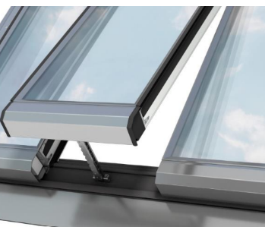
In 5 Castle Lane, the windows to the rear of the property are fitted with Velux windows. These windows are electric and are controlled via a local switch within the room the window is situated. A hook has also been provided to close/open the blinds for these windows.

Maintenance
Maintaining your windows couldn’t be simpler. All you have to do is check them carefully at least once a year for the following signs:

- Check that the handle moves freely and smoothly. If they are stiff, carefully use a recommended lubricant on the locking tongues/bolts while in their extended position.
- Check the glass does not have any water vapour inside the sealed unit or that the glass is damaged.
- Check all timber surfaces for damage and note if the finishing (paint etc.) needs refreshing.
- See additional information on how to use your windows in your handover pack and labels on windows.
- Look for (and remove) any airborne debris that might be trapped in between the frame and sash. To do this, open the window in the cleaning position.
- Routine cleaning should be carried using water with soap or domestic detergent to maintain the appearance of façade.
- If in any doubt or you need help with anything to do with maintenance refer to Operation Manual.

Doors Locks
Your doors are fitted with unique key locks. Entry into your home is gained by the use of this lock. The door and lock mechanism are constructed to resist unauthorised entry in line with Secured By Design guidelines and UK security regulations. When leaving your home, ensure that all windows and doors are locked.

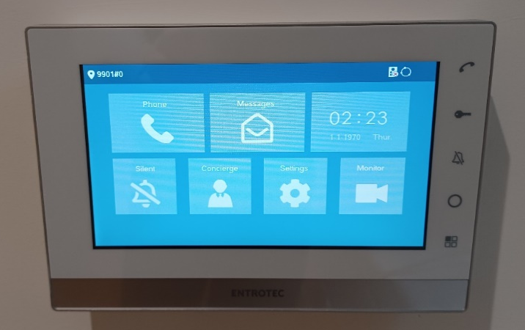
Access Control System
An Entrotec Audio / video Entry Systems has been installed in all buildings across the Development.

Fire Safety
If there is a fire in your flat, the smoke alarm will operate and where appropriate so will the sprinklers. You are to leave your flat without delay and ensure the front door to your flat is closed behind you.

Once in a safe location, preferably outside your building, call the fire Service on 999 giving your address.

The fire strategy for your building has adopted a stay-put policy in order to minimise any inconvenience from false alarms and to keep you free from harm during a fire in another part of your building. There are additional fire safety precautions within your home to help keep you safe and therefore it is normally safer for you to remain in your flat if there is a fire in another part of the building.

The London Fire Brigade have all the necessary information to undertake firefighting activities and respond swiftly and appropriately to ensure your safety. However, if you have any concerns, or you would like to contact your Housing Officer, please do so.

You are free to leave your flat should you wish, but direction from the fire service should be followed for your own safety.

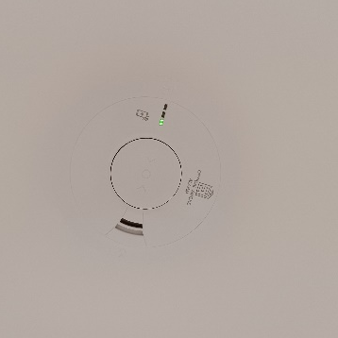
Your home has been provided with a fire alarm system, sprinklers, and fire-resistant walls, floors and fire doors and they are all very important components in keeping you safe if there is a fire in the building. Therefore, before any alterations or modifications are carried out to these parts of your home, we strongly advise that you seek professional advice and the permission of the landlord/ freeholder via your Housing Officer.

Smoke Alarm shown in the photo.

Fire alarm operation
Do not paint your alarm, or allow water or dust to contaminate your alarm:

- Regularly check that the green mains indicator light on the cover is on
- Test weekly – press and hold the Test/Hush button on the alarm for 10 seconds. The alarm will sound loudly and the red light on the cover should flash rapidly
- If the alarm beeps and the red-light flashes at the same time the battery is depleted – ensure green mains power light is on
- Check the red light on the cover flashes every 40 seconds, to ensure that the detector has performed an automatic self-test.
- The red indicator will flash rapidly to show an alarm condition for the smoke detector
- In ‘Test’ mode the alarm will perform a self-test and emit the alarm sound
- When in ‘hush’ mode the alarm enters a ten-minute period instead of the normal 40 seconds to indicate the sensitivity is reduced, and will then automatically reset itself
- When interconnected to other mains powered alarms, an alarm on one detector will trigger all other interconnected alarms within one second (only the triggered alarm will flash a red indicator)
- Aim to replace the batteries once a year to avoid them going flat.

Fire doors
The front doors throughout the development are fire rated. The stairs and external walkways are a protected area and internal doors onto the stairs are fire rated.

Sprinkler system
A sprinkler system has been installed within each dwelling. When a sprinkler head is activated (by a high temperature) the sprinkler will activate, and water will begin to flow.

The sprinkler system is maintained by NHHO/NHG management team. Any damage to the sprinkler head must be immediately reported to NHHO/NHG immediately. Do not decorate over the sprinkler head or position tall furniture, such as wardrobes near the sprinkler heads.

Fire Safety Guide
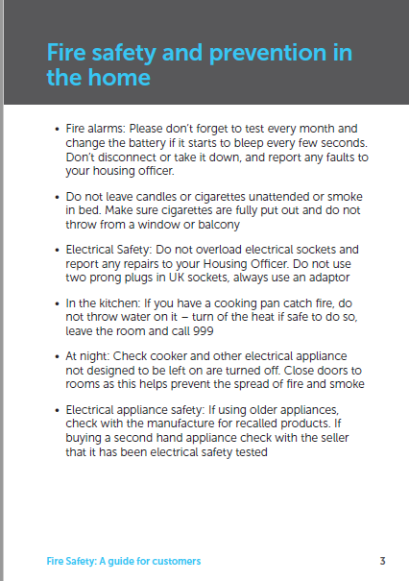
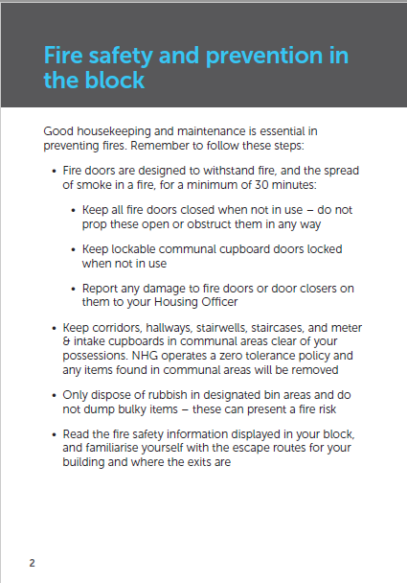
Fire safety & prevention
in the home
Fire safety & prevention
in the block
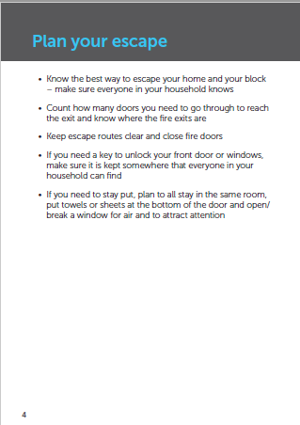
Plan your escape
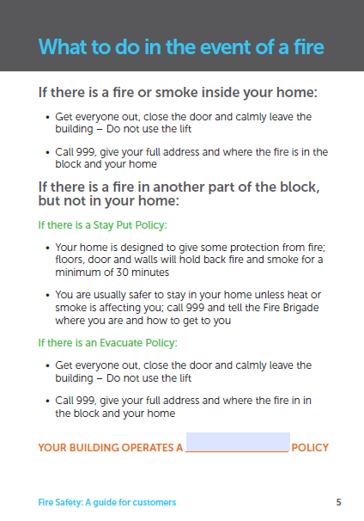
What to do in the event of a fire
If there is a Stay Put Policy
If there is an Evacuate Policy

Contents Insurance
We recommend everyone gets content insurance to protect their belongings from damage in the event of a leak or fire. We cannot recommend a provider for this service.

Local Information
Borough details
Westminster City Council
64 Victoria Street
London
SW1E 6QP

Tel: 020 7641 6000
Web: www.westminster.gov.uk

 | Location | Details of Service
Mainline Train Station | Victoria | Southern railway towards Bognor Regis, Portsmouth & Southsea, West Croydon, Reigate, Dorking, London Bridge, Southampton Central
Mainline Train Station | Victoria | Gatwick Express towards Brighton
Mainline Train Station | Victoria | Southeastern railway towards Dartford, Ramsgate, Gillingham
Underground Station | Victoria | Circle towards High St Kensington, Liverpool Street
Underground Station | Victoria | District Line towards Barking, Ealing Broadway, Richmond, Tower Hill, Upminster, Wimbledon
Underground Station | Victoria | Victoria towards Brixton, Walthamstow Central
Bus Stops | Bressenden Place (Stop CN) | 148 towards Camberwell
Bus Stops | Buckingham Palace Road Bressenden Place (Stop P) | 6, 13, 38, 52, 390 towards Victoria  Oxford tube towards Victoria
Bus Stops | Victoria Station (Stop G) | C10 towards Canada Water  44 towards Tooting  170 towards Roehampton
Bus Stops | Grosvenor Gardens (Stop Q) | 2 towards Marylebone  6 towards Willesden  13 towards North Finchley  36 towards Queens Park  52 towards Willesden  148 towards White City  390 towards Archway
Hospitals | St Thomas' Hospital | Westminster Bridge Road  London  SE1 7EH  Tel: 02071887188  Web: www.guysandstthomas.nhs.uk/
Hospitals | Chelsea and Westminster Hospital | 369 Fulham Road  London  SW10 9NH  Tel: 02033158000  Web: www.chelwest.nhs.uk/
Parks | St James's Park | London  SW1A 2BJ  Green space with a lake with daily pelican feeding, a grass-roofed cafe and ceremonial displays.
Parks | The Green Park | London  SW1A 1AA  Spacious park with deckchair-scattered lawns, mature trees and views of regal local neighbours.
GP | MyHealthcare Clinic | 27 Queen Anne's Gate  London  SW1H 9BU  Tel: 02070995555  Web: www.myhealthcareclinic.com/
GP | London Doctors Clinic Private GP | Spaces Building  London Doctors Clinic Suite 226 & 227, 25 Wilton Road  London  SW1V 1LW  Tel: 02087129378  Web: www.londondoctorsclinic.co.uk
Pharmacy | Star Pharmacy | 33 Strutton Ground  London  SW1P 2HY  Tel: 02072221589  Web: www.star-pharmacy.co.uk/
Pharmacy | Boots | Unit 42B Victoria Station  London SW1V 1JT  Tel: 02078340676  Web: https://www.boots.com/stores/1544-london-victoria-station-sw1v-1jt
Opticians | Specsavers | 1 Cathedral Walk  Cardinal Walk  London  SW1E 5JH  Tel: 02079764250  Web: www.specsavers.co.uk
Opticians | Unia Opticians | 9 Strutton Ground,  London  SW1P 2HY  Tel: 02072220066  Web: www.uniaopticians.co.uk
Dentist | UK Smile | 81 Buckingham Gate  London  SW1E 6PE  Tel: 02077888495  Web: www.uksmile.com
Dentist | EGO Dental Clinic | 13 Strutton Ground  London  SW1P 2HY  Tel: 02072225902  Web: www.egodentalclinic.co.uk/
Banks | Barclays Bank | 24 Palace Street  London  SW1E 5JD  Tel: 03457345345
Banks | Lloyds Bank | 98 Victoria Street  London  SW1E 5JL  Tel: 03456021997
Nursery | Busy Bees at Westminster | 84a Horseferry Road  London  SW1P 2AD  Tel: 02072224459  Web: www.busybeeschildcare.co.uk
Nursery | Miss Daisy's Nursery School, Belgravia | 28 Eccleston Street  London  SW1W 9PY  Tel: 02077305797  Web: www.missdaisysnursery.com/our-schools/belgravia/
Schools | St Vincent De Paul Primary School | St Vincent De Paul Primary School, Morpeth Terrace  London  SW1P 1EP  Tel: 02033515990  Web:
Schools | St Matthew's CE Primary School | 18 Old Pye Street  London  SW1P 2DG  Tel: 02075040500  Web: http://www.stmwschool.org.uk/
Schools | Westminster City School | 55 Palace Street  London  W1E 5HJ  Tel: 02079636300  Web: http://www.wcsch.com/
Schools | Harris Westminster Sixth Form | Steel House  11 Tothill Street  London  SW1H 9LH  Tel: 02037724555  Web: www.harriswestminstersixthform.org.uk
Place of Worship | Westminster Chapel | Buckingham Gate  London  SW1E 6BS  Tel: 02078341731  Web: wwwwestminsterchapel.org.uk/
Place of Worship | WBWT Community & Prayer Centre | Sherbourne House  Lower Ground  Abbots Manor  London SW1V 4LP  Tel: 07483172129  Web: www.wbwt.org.uk
Leisure Centre | Queen Mother Sports Centre | 223 Vauxhall Bridge Road  Pimlico  London  SW1V 1EL  Tel: 02077982040  Web: www.everyoneactive.com/centre/queen-mother-sports-centre/
Leisure Centre | Chaplin & Churchill's Ltd | Vincent Square  London  SW1P 4SA  Tel: 02080014991  Web: www.chaplinandchurchills.com
Restaurants | Quilon | 41 Buckingham Gate  London  SW1E 6AF  Tel: 02078211899  Web: www.quilon.co.uk
Restaurants | Bon Gusto | 75-77 Buckingham Gate  London  SW1E 6PD  Tel: 02072227185  Web: www.bongustorestaurant.com
Restaurants | Nando's Victoria - Cardinal Place | Cardinal Place  17 Cardinal Walk  London  SW1E 5JE  Tel: 02078280158  Web: www.nandos.co.uk/restaurants
Pubs & Bar | The Hamptons Bar | A Taj Hotel  St. James' Court  54 Buckingham Gate  London  SW1E 6AF  Tel: 02079638373  Web: www.stjamescourthotel.co.uk/dine/hamptons/
Pubs & Bar | Buckingham Arms | 62 Petty France  London  SW1H 9EU  Tel: 02072223386  Web: https://www.buckinghamarms.com/

Manufacturer’s Literature
- OFNL Welcome Letter
- MVHR Installation and Maintenance
- Intercom User Guide
- Heating Programmer
- Heating Interface Unit
- Consumer Unit
- Insite Energy
- Thermostat

