Apply to be on Notting Hill Genesis' Resident Forum Chair
In keeping with our resident involvement and engagement model, our Resident Forum exists to strengthen residents’ voices and communicate with senior staff, the Operations Committee, and the Group Board at Notting Hill Genesis. The Forum supports the NHG Better Together strategy, helping improve customer experience by focusing on stronger connections, better homes, and thriving communities.

There is now a unique opportunity to join the Forum, leading its work and engagement as Forum Chair.

The Chair is responsible for providing leadership and effective governance of the forum, chairing all meetings and working with the NHG Resident Involvement team to ensure effective meetings, engagement and involvement opportunities. The Chair is also responsible for ensuring the RF fulfils its purpose, strengthening the voice of NHG residents while ensuring NHG and the Forum operates with integrity, transparency and effectiveness in leadership, upholds regulatory expectations and building a positive and inclusive culture aligned with NHG’s values and Corporate Strategy.

More information on our Resident Forum is available here including the recently reviewed and updated Terms of Reference.

NHG’s resident involvement and engagement model is set out below. Led by residents and for residents, the Forum brings together people from across the resident involvement network, including those involved in governance. It aims to reflect the diversity of our communities and ensure residents have a meaningful role in shaping services.

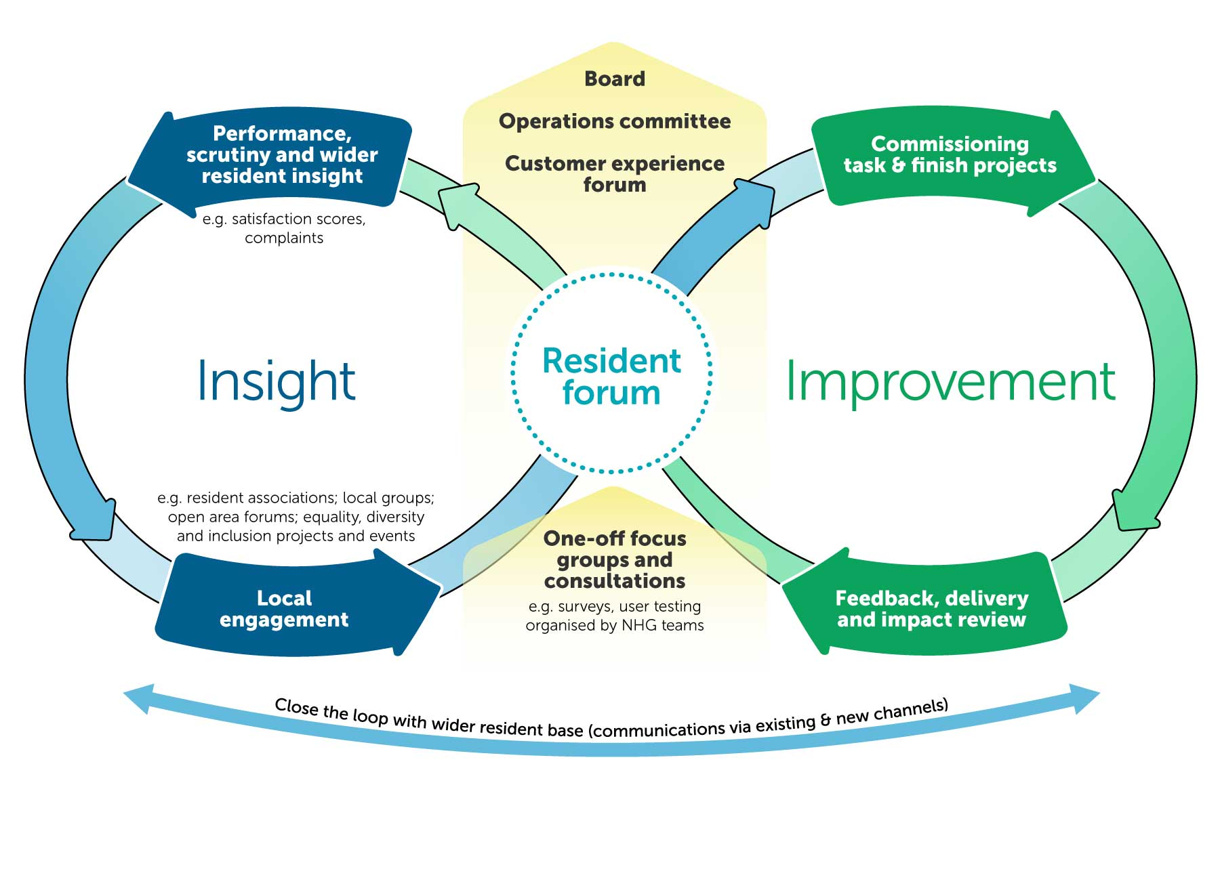

The Resident Forum plays a key role in representing residents’ views, recommending service improvements, and overseeing how residents are involved in shaping their homes and communities. It works independently to scrutinise NHG performance, share feedback and experience, and suggest improvements based on performance data. In addition, the Forum monitors the Resident Involvement and Engagement Programme to ensure it is delivering real impact and value for residents.

the position of Chair is critical to the success of the Forum. We are seeking residents who have demonstrable skills and experience as set out in the accompanying role profile.

If you meet the person specification, we encourage you to apply, whether you are involved with us already or not.

What we expect from members | What members can expect in return
To attend at least six meetings a year | Access to any free training, develop personal skills and receive other support required to fill out your role
To frequently communicate with members and staff outside of these meetings | The opportunity to participate in meetings in a way that suits you (i.e., in person or online)
To prepare for all meetings in advance by reading relevant paperwork | Recognition for your time in the form of shopping vouchers in line with our policy
To on occasion act as a ‘resident lead’ on a task and finish project | Expenses for travel and childcare/carer costs in line with our guidelines
To act as representatives of your communities and ensure that resident feedback is heard and acted on | The opportunity to engage and challenge Notting Hill Genesis staff on the most pressing issues for residents informed by the scrutiny of performance
To always adhere to the terms of reference of the group as well as the Resident Involvement Code of Conduct | The opportunity to shape service improvement project work and be kept informed of progress and impact

If you think you have relevant skills, passion, experience, and time to be part of this exciting group, please fill out this short application form.

Candidates will only progress through the application process if they are able to demonstrate they meet the person specification in the role profile. Candidates will be shortlisted for review by the Panel based on applicants’ response to Question 5 and 7. Any shortlisted residents will be invited to meet the Resident Forum members and to an interview before the recruitment panel.

Meetings and interviews are scheduled to take place on Wednesday 25 February 2026 at NHGs Bruce Kenrick House office, at 2 Killick St, London N1 9FL.

Please complete and return this application by 5pm on Friday 2 February 2026. If you cannot access this form online, please contact a member of the Resident involvement Team Involvement@nhg.org.uk

We would like to involve residents from a variety of backgrounds with different experiences to ensure we get a wide range of perspectives. By completing this form, you are giving consent for Notting Hill Genesis to hold on file the following personal data and use only for the purposes of resident involvement activities. Your personal data will not be shared with external agencies or third parties without your consent and all documents will be held in line with our retention schedule available on our website.

* These questions require an answer

1. Your full name*
_________________________________________________________________

2. Please enter your email address *
_________________________________________________________________
_________________________________________________________________
_________________________________________________________________

3. Please enter your preferred contact number *
_________________________________________________________________

4. Please enter your full home address and borough _________________________________________________________________
_________________________________________________________________
_________________________________________________________________
_________________________________________________________________

5. Writing up to 400 words, please explain why you would like to be a member of the Notting Hill Genesis' Residents’ Forum. Please refer to any skills, interests or experiences relevant which demonstrate you meet the person specification of the Forum Chair role profile. *

6. Additional Support - The group is likely to require commitments such as attending meetings in person and/or online throughout the year, reading materials in advance and scrutinising information. Please specify any additional barriers or support required to carry out these sorts of requirements (e.g., seen and unseen disabilities, digital support, caring responsibilities or other skill gaps). If none, please state. *

7. Do you have a conflict of interest which could affect your eligibility to be a Resident forum member or your position on the Residents forum (e.g., personal relationships, employment, involvement with other groups, business interest). This includes active being party to legal proceedings against Notting Hill Genesis or the subject of active investigations by Notting Hill Genesis (i.e. a breach of tenancy agreement).

 | Yes |  | No

If yes, please explain:

8. If you are unsuccessful in applying to be a member of this group, would you like to be contacted and kept informed about other involvement opportunities at Notting Hill Genesis? *

 | Yes |  | No

9. Tenure type *

 | General Needs |  | Temporary Housing
 | Shared Ownership/Leasehold |  | Supported Housing
 | Other

10. Please can you confirm which gender you identify as? *

 | Woman |  | Man
 | Non-binary |  | Prefer to self-describe
 | Prefer not to say

11. How would you describe your ethnicity? *

 | Arab |  | Asian/Asian British – Bangladesh
 | Asian/Asian British – Chinese |  | Asian/Asian British – Indian
 | Asian/Asian British – Pakistani |  | Asian/Asian British – Other
 | Black/Black British – African |  | Black/Black British – Caribbean
 | Black/Black British – Other |  | White – British
 | White – Gypsy or Irish Traveller |  | White – Irish
 | White – Roma |  | White – Other
 | Other
 | Mixed/Multiple Ethnic background (please specify below)

12. Please can you confirm us which age category you fall under? *

 | 16-25 |  | 26-35
 | 36-45 |  | 46-55
 | 56-65 |  | 66 +

