**HOME USER GUIDE**

Cambridge House

**Contents**

**Welcome to** **Aspect** 3

**Property Mangement Officer** 4

**ICW Building Warranty** 4

**NHG online portal- My account** 5

**Estate management** 6

**Post and deliveries** 6

**Parking** 6

**Cycle storage** 7

**Security/ Access** 7

**Communal and Window cleaning** 7

**Lifts** 8

**Refuse disposal** 8

**Estate regulations** 9

**Service charge** 10

**Defects** 10

**Repairs** 13

**How long will I have to wait to have a repair carried out?** 14

**Preparing for the repair** 14

**Household pests** 14

**Utilities** 15

**Mains water/ drainage** 15

**Stopcock:** 15

**Electricity** 16

**Heating and hot water** 19

**Television / Telephone / Internet** 20

**Underfloor Heating** 24

**Mechanical ventilation** 24

**Thermostats** 22

**Looking after your new home** 23

**Lubrication** 23

**Door seals** 23

**Ironmongery** 23

**DIY** 23

**Redecorating** 24

**Alterations** 24

**Reducing condensation** 24

**Bathroom & kitchen care** 26

**Sanitaryware** 26

**Kitchen sink** 26

**Units & doors** 27

**Worktops** 27

**Finishes** 28

**Appliances** 32

**Appliance instruction manuals & warranties** 32

**Registering your appliance warranty** 32

**Appliance cleaning & maintenance** 33

**Windows, Door & Internal Security** 35

**Maintenance** 36

**Doors Locks** 36

**Access Control System** 36

**Burglar Alarm Wiring** 36

**Fire Safety** 37

**Fire alarm operation** 38

**Fire doors** 38

**Sprinkler system** 38

**Fire Safety Guide** 39

**Contents Insurance** 40

**Local Information** 41

**Manufacturer’s Literature** 43

**Welcome to** **Aspect**

In this Home user guide, you will find useful information to help you get settled in. The purpose of this guide is to help you to familiarize yourself with your home and Aspect. It is important that you review the contents of this manual to ensure that the features installed within your home are utilised fully.

Aspect is a 26-storey residential building, with 92 new homes in a variety of one, two and three – bedroom flats, with 10% of these capable of adaption for wheelchair users. All have a winter garden and basement cycle storage.

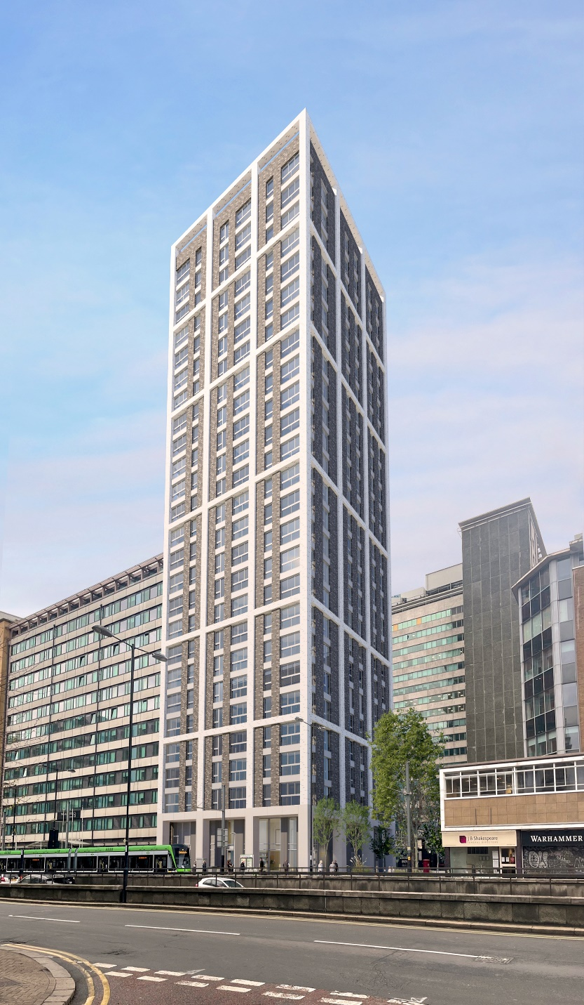

**Property Management Officer details:**

Your property manager’s details will be provided as part of the welcome pack.

NHG Call Centre : **020 3815 0000**

## **ICW Building Warranty**

## Your home benefits from coverage under the ICW warranty scheme. This includes a warranty from the developer during the first year and the ICW Warranty for up to 10 years following the property's practical completion. The developer is responsible for addressing defects in materials or workmanship in your new home.

Please note that the defect period begins from the date the development was practically completed and handed over to Notting Hill Genesis. Any defects occurring during the first year should be reported via My Account or to your Property Management Officer, who will liaise with our in-house specialist defect management team. This team will pass the defect on to the developer, who is responsible for resolving any issues in line with the ICW Latent Defects policy. The defect team will monitor and follow up until the issue is resolved

**ICW Customer Service Centre:**

**Tel:** [**+44 (0) 208 0991 393**](tel:+44%20(0)%20208%200991%20393)

**Email: https://i-c-w.co.uk**

## **NHG online portal- My account**

## We strongly recommend registering your account with NHG, this is where you can get information on your account. You can also raise your own home repairs, pay your rent and seek any extra support that you may need to manage your tenancy.

**Installing My account:** <https://www.nhhg.org.uk/residents/my-account/>.

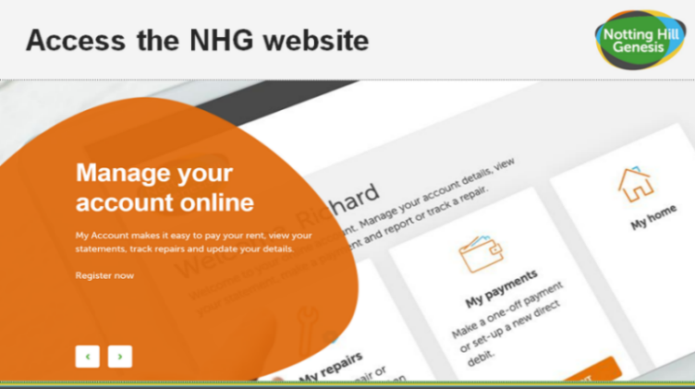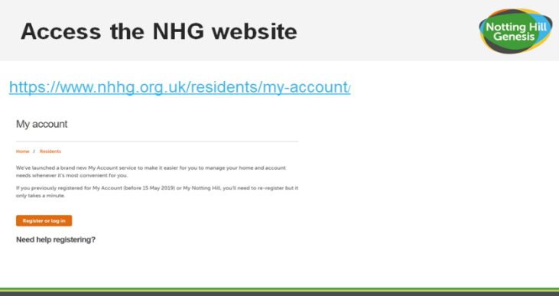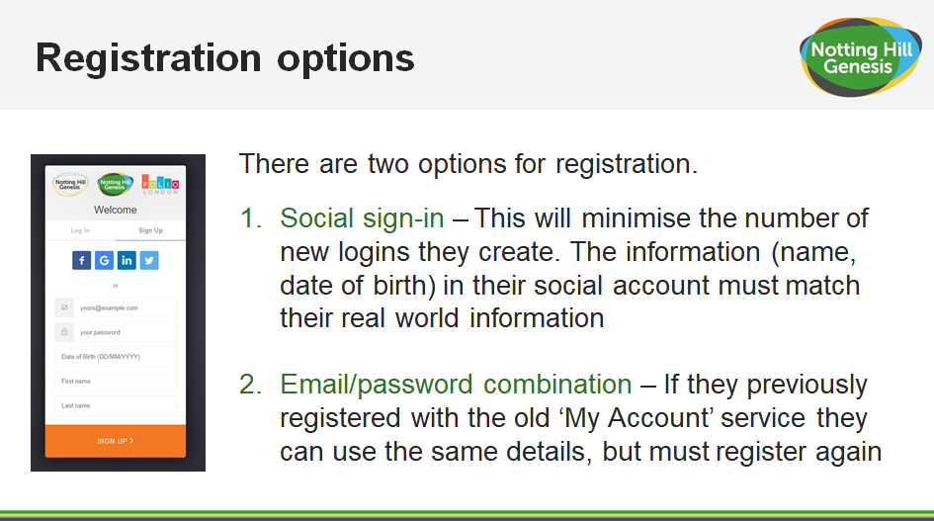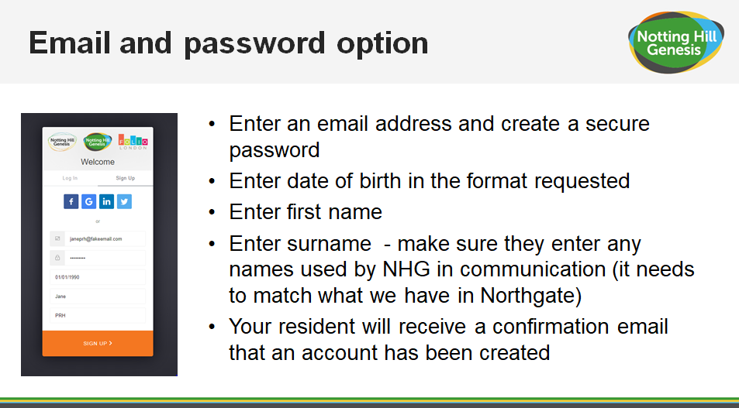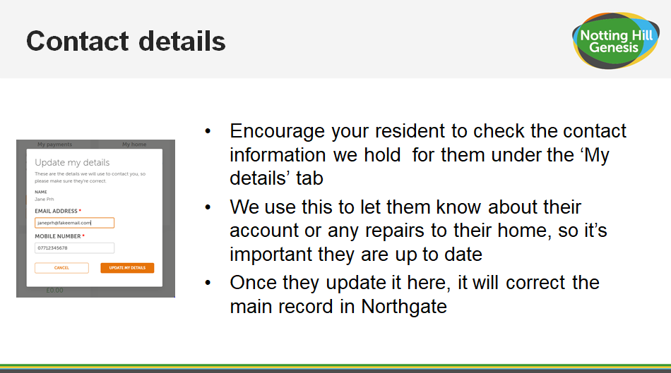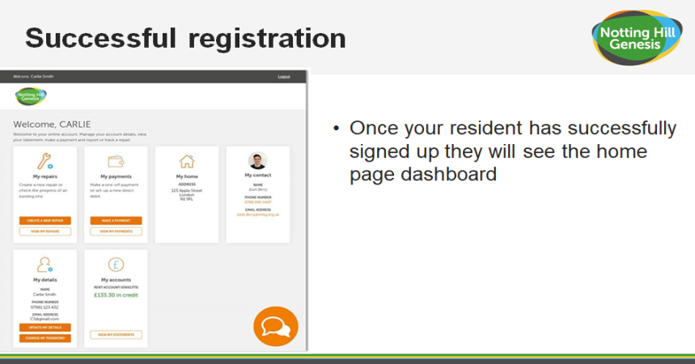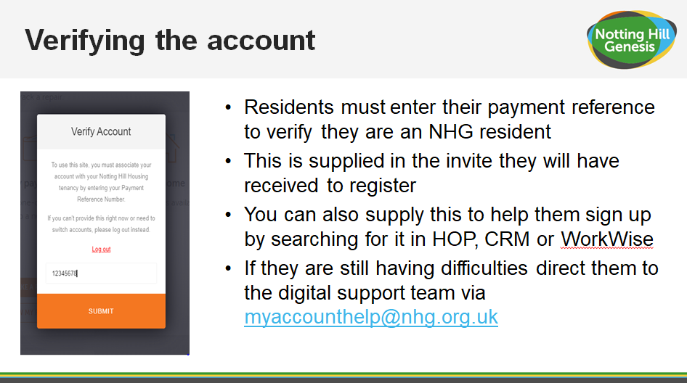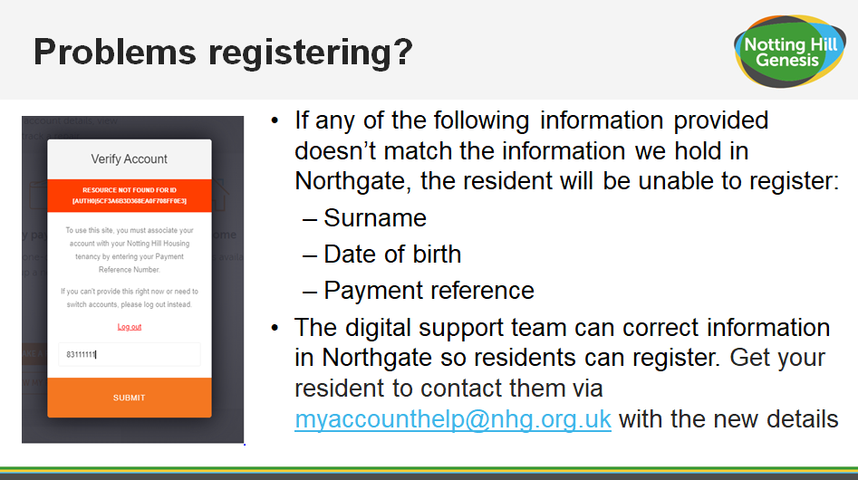

# **Estate management**

## **Post and deliveries**

## The post boxes for standard posts for apartments are located in the Main Lobby.

## Royal mail postal service delivers once a day, Monday to Saturday excluding bank holidays.

## Delivery drivers should make an attempt to deliver the parcel to the property address by calling your door number. If your parcel is delivered within the hours that the facilities manager is at the desk they will let the delivery drive in to the lobby where the parcel can be delivered to the parcel storage lockers provided. When the parcel has been stored in the parcel locker you will receive notification via text or email that your parcel is ready for collection. We will not be able to physically hold parcels so your delivery will need to be within the size that is able to be stored in the parcel lockers for collection. All parcels are stored securely inside the lockers and the locker can only be opened by you upon collection. We do not take any responsibility for any items delivered or the stored inside the parcel lockers.

## Parcels can be collected from 24 hours a day 7 days a week from the parcel lockers. Please note that you should always be home to receive grocery and take away deliveries as we cannot store them and they should not be left in the parcel lockers. For grocery and take away deliveries you will need to arrange to meet them outside your block.

## Large deliveries such as washing machines or sofas should be delivered at a time when you are home as these cannot be stored in the parcel lockers or on site. For large deliveries you will need to arrange directly to meet them outside your block and provide escorted access to your property to complete the delivery.

## **Parking**

## There is no carparking available on site at Aspect.

**Car Club**

Notting Hill Genesis will be offering residents a 2-year free membership plus £60 driving credit, more information on how to claim this will be included in your welcome pack.

## **Cycle storage**

## Cycle racks will be provided in the cycle store at basement level as shown in the diagram below. Please use the cycle lift provided to transport bikes to and from the lobby area to minimise damage caused to communal areas.

**Please note that all cycles are stored at the owner’s risk**

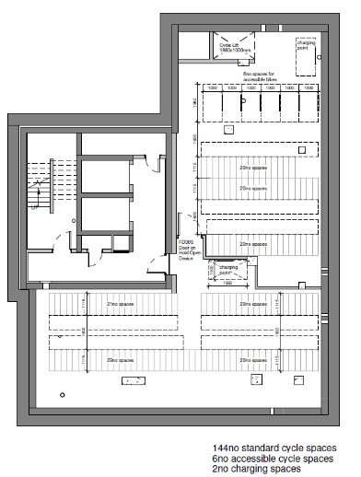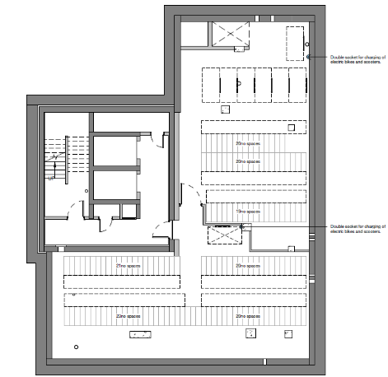

## 

## **Security/ Access**

## The blocks are accessed with an access fob that each resident is given. The access fob will permit you to enter the block. You will not be permitted to access other areas of the block for security reasons.

## **Communal and Window cleaning**

## Cleaners managed by the Aspect estates team will be responsible for the cleaning of the landscaped areas, shared surfaces and pedestrian routes as well as communal corridors/entrance lobbies and lifts all cores throughout normal working hours. Please contact your property manager for further details.

## As part of the estate management your external windows will be professionally cleaned at least once a year by abseil. You will be notified in advance of when these works will take place. If you have any queries regarding this, please contact your property manager.

## **Lifts**

## There are2 lifts in the lobby on the ground floor. If a lift goes out of service, please report to the Aspect management team. An emergency is only considered when someone is trapped inside the lift, please note a lift being out of service is not considered as an emergency.

## In the event of a fire, do not use the lifts. When the fire alarm is activated, the lifts will automatically return to the ground floor and anyone in the lifts can evacuate. Once the fire service arrives and get access to the firefighting lift, this lift will go up the floors for evacuation.

## 

## **Refuse disposal**

## We ask that residents kindly remove any household waste and dispose of it in their designated bin store which is located on the ground floor as pictured below.

Residents have direct access to the refuse store from the lift lobby via a controlled separating lobby.

Refuse is removed on a weekly basis from the communal bin stores, please contact your property management officer or the Aspect management if the bin stores are overflowing.

When recycling, please ensure you follow the guidelines below:

* Cardboard - please flatten or tear into smaller pieces - card sleeves, cereal boxes, egg boxes, cards, etc.
* Mixed paper
* Plastic bottles - empty, rinsed and squashed
* Tins and cans - empty and rinsed

Do not put black sacks into the recycling bin as these cannot be recycled.

For further information please visit the Croydon Council website:

[**https://www.croydon.gov.uk/rubbish-and-recycling**](https://www.croydon.gov.uk/rubbish-and-recycling)

## **Estate regulations**

## It is essential that estate regulations are set, implemented and appropriately managed in the event of non-compliance by any occupier. A full copy of the proposed estate regulations will be provided separately, however below are general principles intended to enhance the quiet enjoyment of Aspect for the benefit and convenience of all. The full estate regulations will form part of the leases and tenancy agreements.

**Noise** - Noise levels are to be kept at a minimum as so not to disturb your neighbours. No loud noise is permitted between 11pm and 8am. Any noise allegations will be investigated by the management team.

**Balcony** - No items should be stored on the balcony. This includes washing and bicycles.

**Window Dressings -** Windows should not be covered in any material other than the window dressings provided. Residents are not authorised to change the window dressings.

**Barbecues/Fires -** No barbecues or fires will be allowed at any time at Aspect, including on private or shared balconies, terraces or podium gardens.

**Satellite** - Aspect has a communal television system with a single roof array comprising Sky Q + Hotbird + Turksat, Digital Freeview SD & HD, FM & DAB dish and antennas. Residents will need to pay for any subscription service they wish to receive. No resident will be permitted to have a satellite on display at any time. Any satellite located will be removed immediately

**Podiums, gardens, shrubbery and Estate Areas -** These areas are provided for the enjoyment of all residents at Aspect. No ball games are permitted within these areas, except within designated facilities. The interfering or removal of any plants is not permitted, and the interfering of any water features is not permitted.

**Pets** - All pets are to be registered and authorised by the landlord. Authorisation requests can be obtained from your property management officer.

**Bicycles** - All bicycles are parked at the owner’s risk.

**Parking** – This is a car free development.

**Common parts** - Do not obstruct any of the access ways i.e. fire exits. Smoking is not permitted within any communal area or lifts.

**Property** - Any act that may interfere with the safety, comfort or convenience or cause nuisance or danger to any person or property is prohibited.

**Disposal of waste** - All waste is to be disposed of in the correct manner.

**Advertising** - No advertising by Estate agents will be allowed to be displayed within Aspect. Window stickers, advertisements or notices will be removed immediately.

**Immoral use** - No apartment or area within Aspect is to be used for any illegal, immoral or improper activity.

**Fire equipment** - Residents are not to remove, dispose or interfere with any equipment or sign that is provided for their safety and the safety of others.

**Road closures** - The landlord is permitted at any time to authorise the closure of any road so that building work may be carried out.

## **Service charge**

## Please see your tenancy agreement or contact your property management officer for list of payable service charge details.

## **Defects**

## **Defect liability period**

Your home is covered under a 12‐month defects warranty, known as the defect’s liability period. This period started when Notting Hill Genesis took possession of your home from the contractor. Notting Hill Home Ownership will co-ordinate the rectification of defects and faults that occur during this period.All you need to do is report any genuine defects you find via your online MyAccount. A photo/video must be attached to the defect ticket (if at all possible) and a detailed description of the problem including the location within the property.

The team will then log the information we need to know, give your case a unique ID and arrange an appointment with the aftercare manager. The response time will vary depending on the urgency of the problem

To report a defect please raise the repair though the customer portal or PMO. Communal defects should be reported via the facilities manager.

**Defect response times**

The repair line will take a decision as to whether the fault is a repair, a defect, or your responsibility. Please make sure that the information you provide to the property management office is correct. **Incorrect information which results in the contractor attending your home will be charged to you**.

**Defects categories**

Emergency (Priority 1) – 24 hours:

* Gas leaks – to be telephoned immediately to the National Grid
* Dangerous electrical works
* Total failure of electrical lighting or power
* Failure of lighting to a communal staircase / corridor / lift to such degree as constitutes a health and safety risk
* Burst water pipes or other ingress of water (including roof repairs) that are causing

damage to property and are not containable.

* No mains cold water supply to a property
* Central heating or hot water failure
* Failure of front entrance doors to houses or flats (where property is left unsecure).
* Failure of lifts
* Failure of communal gates or communal access doors
* Defective flooring or stair tread in communal areas, where this presents a health and

safety risk.

* Temporary glazing repairs (permanent replacement classified as “Priority 3”)
* Defects that may render a dwelling unsecure – e.g. windows or doors not closing properly
* Defects that may cause injury or are a danger to any person
* Defects that may cause significant damage to property if left unresolved

7 days (Priority 2):

* Minor plumbing repairs – equipment failure
* Defective front door lock
* Ease and adjust external door
* General electrical repairs – defective items other than dangerous electrical works classified as “Priority 1”
* General repairs to heating and hot water systems
* Loose or detached banister or handrail
* Defective flooring or stair tread in communal areas – other than a dangerous defect
* classified as “Priority 1”
* Individual door entry-phone not working
* Faults with television aerials and telephone connections
* Windows not closing property – other than where this is classified as “Priority 1”

28 days (Priority 3):

* Minor roof repairs – unless there is ingress of water which will be classified as “Priority 1”
* Defective kitchen or bathroom fan
* Repairs to leaking gutters and rainwater pipes
* Re-glazing windows or doors – where there is no security issue
* Minor carpentry repairs to windows and doors
* Non-urgent plumbing repairs
* Repairs to wooden floors and floor coverings
* Repairs to external render and air vents
* Repairs to internal plaster
* Re-decoration after other repairs have been carried out
* Repairs to garden fencing

Please note, if residents raise an emergency repair and on receipt it is reviewed by the Defect Officer and is not an emergency it will be cancelled and re-raised to the relevant priority.

At the end of defects liability period a final joint inspection is carried out in each home and the communal areas. The inspection party consists of the building contractor, the development project manager, Notting hill Genesis’ employer’s agent, defects officer and property management officer. The purpose of the end of defects inspection is to check for any defects which need to be put right by the building contractor.

It is important that access is gained to all homes and the external and internal communal areas. This is the last opportunity to report defects for repair by the building contractor.

Following the inspection, the building contractor will arrange appointments directly with you to carry out final defect rectification works. You will be required to give access at this appointment time.

After the end of the defect’s liability period, general defects inside the home are the responsibility of the homeowner or NHG. Communal areas will be the responsibility of NHG/managing agents.

If a repair arises out of misuse of or damage to the property, then the cost of the repair will be borne by the resident.

**Don’t forget, the defects period starts from practical completion of the project, so will have already commenced at the date that you move in.**

# **Repairs**

Repairs are reported via MY ACCOUNT and or directly to your PMO.

* A heavy leak in your property where it is not possible to contain the water, or it is leaking between floors or properties.
* An electrical fault in your property where it is not possible to contain the water, or it is leaking between floors or properties.
* An electrical fault in your property which endangers health or life.
* Complete electrical failure, or electrical failure in a kitchen/ bathroom

**We are responsible for emergency repairs to:**

* Any repair that will threaten the health or safety of our residents or the wider public if it is not carried out immediately is an emergency.
* Any repair that will seriously damage the property if it is not carried out immediately is an emergency.

**What is an Emergency repair?**

**We are not responsible for repairs to:**

* Repairs to gas installations such as cookers or gas fires should be carried out by a certified Gas Safe engineer.
* Garden sheds
* Door handles
* Sink/toilet blockages in the first instance. The resident should attempt to unblock these with drain unblocker/plunger where appropriate.
* The structure of your home including the roof, outside walls, doors, windows and windowsills.
* Gutters, down pipes and drains.
* Garden walls, fences, and steps used to access and exit the property (except where they are the neighbouring property’s responsibility).
* Existing central heating, water heaters and fires (where provided by us).
* Electrical repairs (not including electrical appliances)
* Repairs to the gas installations such as boiler and pipework (not including appliances)
* Inside walls, floors and ceilings.
* Doors, door frames, door hinges, letter boxes and skirting boards, window catches, sash cords and window frames.
* Chimney stacks and flues.
* Banisters.
* Kitchen units, wall tiling, air vents and extractor fans.
* Showers (where provided by us), sinks, toilets and baths.
* Pest control in communal areas.
* Bathroom flooring and wall tiles.
* Persistent issues with drainage/removal of wastewater.

**We are responsible for repairs to:**

## **How long will I have to wait to have a repair carried out?**

* We aim to have someone attend your property within 4 hours if you report an emergency repair.
* We aim to complete non-emergency repairs within 28 working days.

Please be aware that our contractors cannot always fix a problem on the first visit. If they cannot fix something, they will arrange a date and time to come back and finish the job.

## **Preparing for the repair**

## When waiting for a repair, it is important to clear space or move furniture so that the repair is accessible for the contractors. This will help them to carry out the works more quickly and minimise the risk of any accidental damage to possessions.

## If you have any concerns or think you may have difficulty clearing space for the contractor, please let your housing officer know as soon as possible.

## **Household pests**

## You are responsible for dealing with household pests such as ants, bees, bedbugs, wasps, cockroaches, rats and mice within your property. Contact the environmental health department at your local council for advice. Go to [www.gov.uk/report-pest-problem](http://www.gov.uk/report-pest-problem) for more information.

## If you cannot deal with the pest issue, or if you have a pest problem in a communal area then contact your property management officer.

# **Utilities**

## **Mains water/ drainage**

## Thames Water supply the incoming mains water through an underground service pipe fitted with a stop valve at the boundary to the development for use by the water company in an emergency.

## As water enters your home, its flow is controlled by the stopcock, which allows you to turn off the supply in an emergency or for maintenance.

**Mains water and drainage supplier: Thames water**

**Website: www.thameswater.co.uk**

**General Telephone: 0800 316 9800**

**Billing and account enquiries Telephone: 0800 980 880**

**Stopcock:**

* Your water meter is located within the communal riser cupboards.
* The dwelling stopcock is located in the Utility Cupboard of your property adjacent to the HIU.
* There is an isolation valve outside the front entrance door. The water supply for the whole apartment can be closed off from there. The stop cock within the Utility Cupboard will also perform the same function.
* Isolation valves within the Utility Cupboards above the access hatch can shut off water supply for these rooms.

**TROUBL SHOOTING**

Kitchen Wastepipes: If a blockage occurs and the sink is full of water try to remove the blockage by pushing a flexible drain rod down the plughole or by using a suction cup plunger to move water up and down the wastepipe. The risk of blockages can be reduced if you remember to put fat (which solidifies when cold) into an empty container rather than down the sink or drain.

Bath, Shower and Basins: Blockages here are normally caused by the build‐up of hair and soap in the plug hole and become noticeable when the bath or basin starts to drain away more slowly. Clear bath or basin wastes with a ‘Sani snake’ (available from hardware stores) or by using a proprietary chemical cleaner (please read instructions carefully). You can purchase a small filter to put over the bath/ water outlet to collect hair, etc. and prevent blockages.

## **Electricity**

## **Electrical supplier details: Ecotricity**

**Telephone:** [**0345 555 710**](tel:+443455557100)

**Location of meter: Utility Cupboard**

**Location of Consumer unit: Utility Cupboard**

Please note that you will be able to change to an Electricity provider of your choice.

|  |  |
| --- | --- |
| **Energy Tips** | |
| **Lights**  The light fittings in your property use energy efficient light bulbs. Although these lights may cost more, the cost saving in reduced energy bills will ensure money saving in the longer term.  See the Finishes section for electrical light fittings installed in your property.  For replacement bulbs contact your local electrical store.  **Changing light bulbs**  To change light bulbs, the light switch must be in the off position. It is advisable to replace the bulb with the same type of bulb that was removed.  For further information on energy saving lighting visit:  [www.energysavingtrust.org.uk/electricity/lighting](http://www.energysavingtrust.org.uk/electricity/lighting)  Electrical alterations, including replacing light fixtures and fittings should only be carried out by a qualified electrician.  Cables may run in any position above a ceiling or under  A floor. Before fixing to walls, floors and ceilings always  Check for buried pipes and cables using a detector available from diy stores.  Do not interfere with earth bonding cables connected to Pipework and main earth connection.  For further information on electric safety in the home visit the electrical safety council website: [www.esc.org.uk](http://www.esc.org.uk/) | **Loss of power and troubleshooting**  If your electricity goes off, start by checking to see if it is a power cut or a fault in your home. The easiest way to do this is to see if your neighbour’s have electricity. If they do not have power either, then it is a power cut and you should contact 105.  It isn’t possible to predict a power cut however here are some precautions you can take in case a power cut occurs:   * + Make sure you have multiple torches along with extra batteries   + Keep a plug‐in telephone that does not require electricity – remember that with cordless phones you may not be able to make phone calls once the batteries are dead   + Keep important documents safe and handy   + If your neighbours have power, then it could be a fault in your home.   Your trip switch may have turned itself off. If it has, try turning it back on. If it switches off again then one of your electrical appliances may be faulty. Your trip switch turns itself off to make sure you do not get injured by a faulty appliance. Once you have found the faulty appliance and turned it off, your power should stay on.  If you have only lost power in part of your home you may have a fault with your electrical wiring somewhere, in which case you should call a qualified electrician as soon as possible. |
| **Energy and water efficiency**  Tips for saving energy and money around your home:  **Washing machines**   * + Wash at the lowest temperature that will give efficient results.   + Wait until you have a full load or use the ‘half load’ setting to reduce water.   + Use short wash cycles for lightly soiled items.   **Dishwashers**   * + Always wait until the machine is full before running it.   For lightly soiled items some dishwashers have economy programmes that reduce the washing temperature and /or shorten the washing time.  **Washer dryers**   * + Washer dryers save space and often cost less than two separate machines. They usually hold less than a dedicated built tumble dryer – you can’t wash a second load until the first load has finished drying, and they usually use an air/water heat exchanger, which means that heat extracted in the condenser is lost to the drain. Washer dryers can give a perfectly satisfactory service.   + Wait until you have a full load before using the washer and/or tumble dryer.   + If the machine has an energy saving load setting use it whenever possible.   Use low temperature settings for lightly soiled items  **Fridges and freezers**   * + Try to keep your freezer at least three quarters full.   + Do not put warm food into the fridge.   + Defrost your fridge or freezer regularly and avoid leaving the door open longer than necessary.   + Check that the door seal on your fridge is working effectively by closing on a piece of paper to see if it is held tight. If your fridge builds up frost too quickly the door seal could be faulty.   **Cooking**   * + Match pan sizes to ring and use pans that are appropriate for your type of hob.   + Where a long cooking time is needed use a conventional oven. However, a microwave oven is more economical for short cooking times, particularly for smaller quantities of food.   + When cooking with a microwave always follow the manufacturer’s instructions and ensure that there are no “cool spots” left in the food. | * + Consider buying a shower wash type of washing machine.   + If you are planning to use a tumble dryer, choose a washing machine with a high spin to save on drying time.   **Television sets**   * + When you choose your tv consider buying a model that uses less electricity.   + Do not leave the tv switched ‘on’ if nobody is watching it.   + Do not leave the tv in ‘stand‐by’ mode for long periods.   **Irons**   * + Do not leave an iron switched ‘on’ if you are not going to use it within 5 minutes.   **Kettles**   * + When you choose your kettle consider buying a jug‐style model or an energy efficient one.   + Remove lime scale from your kettle regularly.   + When boiling water use a kettle – not a pan.   + Only heat as much water as you need in the kettle but remember to always cover the element.   **Computers**   * + Switch your computer off when it is not in use.   **Mobile phones**   * + Unplug phone chargers when not in use.   **In the bathroom**   * + When brushing your teeth using a tumbler, instead of running the tap water for rinsing, can save nine litres of water per minute.   + Taking a shower instead of a bath can save up to 40% of the water that you use.   + Reducing the time you spend in the shower will save water and energy.   + Put the plug in the basin when washing hands or shaving, rather than leaving the tap running. |

## 

## **Heating and hot water**

## Heating and hot water is distributed in your home via the heat interface unit (HIU), which is located in your Utility Cupboard.

Hot water is produced by the HIU on demand.

Heating and hot water consumption is measured by a heat meter, which is visible on your HIU and is read during your handover appointment with your customer liaison.

The Guru Hub has been chosen for your home. The Guru Hub is a smart energy meter and heating and hot water controller, all in one. It is a popular metering solution which is linked to Insite’s "PayPoint" payment system. Your Guru Hub enables you to easily monitor your use

of heating and hot water and also the payments you make.

The Guru Hub is connected to Insite's payment system via the internet, so it always knows how much credit you've purchased.

Below is an image of the main screen display: This displays your balance, your emergency credit limit, your kWh (unit) charge, your daily standing charge, your kWh and Carbon Dioxide usage.



Any queries with regards to meters and billing for heating and hot water should be addressed to your metering and billing provider, please refer to the separate Insite Energy brochure for further details.

## **Television / Telephone / Internet**

## Your TV will have access to Sky (supporting Sky Q and also Sky Glass as long as there is internet), Virgin and Hyperoptic

**Underfloor Heating**

Primary Heat is provided by the ground floor energy centre with another plant room on the 6th floor, each apartment has a SAV HIU for transfer of this heat into Domestic Hot Water.

Room thermostats sense the temperature in each room and open or close valves on the manifold to allow the hot water to run through the pipes until the room is warm enough. When the stat senses the room is warm enough it closes the valve to stop the flow of water.

## **Mechanical ventilation**

## Each apartment has a NuAir MVHR system installed providing both Ventilation and Heat Recovery within the apartment. The Heat Exchanger within the unit is protected by filters on the fresh air and exhaust side of the exchanger, these filters are accessible through the front of the unit for routine inspection and cleaning if required.

## The ventilation system extracts warm, damp air from the home and draws in fresh air from the outside via ducted ceiling mounted terminals. The warm, extracted air is passed through a heat exchanger to recover the heat before being expelled outside. The cool, fresh air from outside is also passed through the heat exchanger, without coming into direct contact with the extracted air where it is pre‐warmed before being pumped into your home. The unit also has a summer bypass mode. This ensures that in the summer, fresh air is not passed over the heat exchanger and as such reduces the risk of overheating.

## The ventilation system to your kitchen and bathroom where excessive moisture can be generated while cooking or using the bathroom is boosted. This is done automatically when the lights are turned on in the bathrooms, and there is an MVHR Boost Switch for the kitchen above the worktop.

|  |  |  |
| --- | --- | --- |
| **Item** | **Maintenance Task** | **Task Frequency** |
| NuAir MVHR | Filter Clean - Remove filter and clean using a vacuum cleaner. | As required. |
| NuAir Noxfilter | Remove filter and clean using a vacuum cleaner. | As required. |
| HRU | Remove filter and clean using a vacuum cleaner. | Monthly. |

Filters are to be inspected every 6 months and replaced every 12 months (or sooner if required). Failure to do so may impair the performance and energy efficiency of this unit. A flashing LED (Section 6.2) will indicate that a filter change is required. This indication repeats every 12 months and will turn off automatically after 5 Days. Remove the filter covers on the front panel of the unit by gripping the two circular tabs either end of the filter covers and pulling away from the unit. The filter can now be extracted by pulling the black removal loop on the front edge of the filter. Once the filters have been inspected return or replace them as necessary.

**Thermostats**

Each room has its own Heatmiser thermostat.

There is a heating programmer in your utility cupboard, which provides timing control for your central heating system, letting you set ON and OFF periods to suit your own lifestyle.

For more information on this and how to set it up, please refer to the manufacturer’s literature section of this manual.

# **Looking after your new home**

## **Lubrication**

There are many areas within your new property that will benefit from regular lubrication. In particular, we recommend that window hinges and door mechanisms are regularly lubricated to keep them in good working order.

## **Door seals**

The condition of all door seals should be examined at six-monthly intervals. If the seal is missing, in part or completely, it should be replaced immediately. It is necessary to replace like with like and the use of any seal, other than that originally installed, may jeopardise the performance of the door. Seals should be fitted in accordance with the manufacturer’s instructions.

## **Ironmongery**

Stainless steel and chrome finishes should be cleaned at least every six months with a dry cloth or duster and washed periodically with a soft cloth and soapy water and dried with a clean cloth. Do not use abrasive materials for regular cleaning. Acetones or solvents can be used to remove grease marks or paint from stainless steel finishes if needed. There are also special products available for removing scratches or rust from stainless steel. Always follow the manufacturer’s instructions when using cleaning products.

## **DIY**

When hanging pictures care must be taken to not disturb or damage any pipes or electric cabling that may lie beneath the surface of the wall. It is strongly recommended that you use a cable/ pipe detector, which can be bought from most major DIY stores.

Plasterboard should be able to take a weight of approximately 10kg using appropriate plasterboard fixings.

Due to this weight limitation it is not advised that you fix heavy objects to plasterboard walls e.g. Flat screen tv unless the relevant provisions have been allowed for.

## **Redecorating**

Please note that no DIY should be done within the defects period as it will mean that the defects period for that area is void. For example, if you change the sink tap and it breaks we will not fix it or put the old one back in place or if there were a leak from the new tap we would not fix it.

## **Alterations**

Please note that structural or material alterations are not permitted. Please contact your PMO for further guidance.

## **Reducing condensation**

Condensation is caused by steam or water vapour when it comes into contact with cold surfaces (in the same way that steam in the bathroom condenses on the window).

Once materials have dried out, you should no longer experience significant condensation. However, normal daily activities produce a great deal of water vapour, which may cause condensation if allowed to spread around the home.

Measures you can take to control condensation:

* + Cover pans when cooking and do not leave kettles boiling
  + Put washing outdoors to dry if you can. If you use a tumble dryer, make sure that it is vented to the outside air (unless it is a self‐condensing type). DIY vent kits are available.
  + Use the cooker hood and/or extractor fans and keep the doors closed when cooking, washing and bathing.
  + Do not switch off the main isolator switch to the extractors in the bathroom or kitchen at any time, as they are needed to ventilate these rooms.
  + Regularly open windows to encourage air changes.

Ventilation is needed to get rid of the moisture that is naturally produced every day in your home. Your home will only maintain a healthy internal environment when ventilation systems are running. You risk damage to your health and home if you turn these off or block outlets.

Homes where the heating is off all day, because the occupants are out, are more likely to suffer condensation problems than those heated more continuously. This is because, when normal activities such as washing and cooking are carried out in the evening, the home has been unheated for long periods and the surfaces are cold.

Make sure the heating timer is set so that your home is warm by the time you return home. During very cold weather it is better to leave the heating on during the day to maintain an

even temperature. The temperature can be set a few degrees lower and turned up when you return.

Most heating systems operate inefficiently if turned completely on and off. Use your thermostat to control heating operation. This will be more efficient and help to reduce fuel bills.

Remember that condensation is not normally a building fault. Learning to control moisture levels is a vital part of living in modern, well insulated, home.

# 

# **Bathroom & kitchen care**

## **Sanitaryware**

## To prevent a build-up of dirt and limescale, acrylic and ceramic sanitaryware should be wiped down immediately after use with a soft cloth and thoroughly cleaned with warm soapy water, a cream cleaner or multi-purpose surface cleaner on a weekly basis.

Many household chemicals such as paint stripper, nail varnish remover, household bleach, abrasive cleaning agents, perfume, aftershave or strong disinfectants can cause damage and should not be allowed to come into contact with your sanitaryware.

If such chemicals do accidentally come into contact with your sanitaryware then it is advised that you rinse the affected area with sufficient water to completely remove the chemical.

In hard water areas mild lime-scale remover may be used from time to time.

Never leave strong bleach or cleaners in the WC bowl for extended periods of time or overnight.

Never mix different cleaners in the WC bowl as this may give off poisonous or volatile gases.

To avoid damaging internal fittings do not put bleach products in the cistern.

When cleaning your sanitaryware the manufacturer’s instructions take precedent over the above recommendations and should be followed at all times. The item should be rinsed and dried with a soft cloth after cleaning to provide the best finish.

## **Kitchen sink**

## Your stainless-steel kitchen sink is generally resistant to most household items and is very hard wearing, however the following substances should not be allowed to come into contact with the stainless-steel surface; mortar, cement, plaster, concrete, tile cement, grout, undiluted bleach, acids, silver dip.

Daily cleaning of your sink should be carried out using cream-based cleaners on a soft cloth. This should be adequate to remove such marks as tea stains and grease. More abrasive cleaners such as scouring powders, should not be used. The everyday film of limescale, which in hard-water areas, can be quickly removed using a standard cream cleaner but, should a thicker limescale layer form, then this will require treatment with a proprietary limescale remover and a soft brush.

It is likely that during its use the stainless-steel surface will scratch, you can reduce the appearance of scratches by using a stainless-steel cleaner.

## **Units & doors**

## It is important that you treat all cupboards with care in order maintain their appearance and functionality. Units and doors can be cleaned by using a soft damp cloth with warm water and a mild detergent, ensure to wipe excess water off immediately to ensure water is not left ‘standing’ on the surfaces.

## **Worktops**

## Your kitchen worktop has a laminated finish.

Due to their resistant and hygienic, dense surface, Wilsonart work surfaces do not require any special form of care.

The surfaces are generally easy to clean. As a general rule, dirt and spilled substances such as tea, coffee, wine etc. should be cleaned immediately as the cleaning effort increases if they are left to dry. When necessary, cleaning should be done with non-aggressive agents.

Please refer to the manufacturer’s recommendations for further information.

# **Finishes**

# **Living/Kitchen/Dining**

|  |  |
| --- | --- |
| **Element** | **Finish** |
| Walls | Plasterboard with taped and joint finish (NBS Section K10), coated with vinyl matt emulsion paint (NBS Clause M60/110A), Colour: White |
| Floors | Floor laminate (NBS Clause K21/115A), Finish: Natural Prime Oak, Ref: VGW115T |
| Ceilings | Plasterboard with taped and joint finish (NBS Section K10), coated with vinyl matt emulsion paint (NBS Clause M60/110A), Colour: White |
| Skirtings | MDF (NBS Clause P20/200A), coated with full Satinwood paint (NBS Clause M60/130A), Colour: White |
| Door | Ply faced veneer, coated with full Satinwood paint (NBS Clause M60/130A), Colour: White |
| Frame and Architrave | MDF (NBS Clause P20/200A), coated with full Satinwood paint (NBS Clause M60/130A), Colour: White |
| Window Boards | MDF (NBS Clause P20/200C), coated with Satinwood paint (NBS Clause M60/130A), Colour: White |
| Furnishing and Accessories | Kitchen Unit and Drawer Fronts – Refer to WCA A-70 Series Drawings Kitchen Worktops – Refer to WCA A-70 Series Drawings Kitchen Splashback – Refer to WCA A-70 Series Drawings |

**Bedroom**

|  |  |
| --- | --- |
| **Element** | **Finish** |
| Walls | Plasterboard with taped and joint finish (NBS Section K10), coated with vinyl matt emulsion paint (NBS Clause M60/110A), Colour: White |
| Floors | Carpet to be 80/20 wool mix twist carpet 32oz tenth gauge quality (NBS Clause M52/110A), Colour: Stone |
| Ceilings | Plasterboard with taped and joint finish (NBS Section K10), coated with vinyl matt emulsion paint (NBS Clause M60/110A), Colour: White |
| Skirtings | MDF (NBS Clause P20/200A), coated with full Satinwood paint (NBS Clause M60/130A), Colour: White |
| Door | Solid Core flush doors with plywood facings for painting and hardwood lippings to all edges, Colour: White |
| Frame and Architrave | MDF (NBS Clause P20/200A), coated with full Satinwood paint (NBS Clause M60/130A), Colour: White |
| Window Boards | MDF (NBS Clause P20/200C), coated with Satinwood paint (NBS Clause M60/130A), Colour: White |
| Furnishing and Accessories | Built in wardrobes to have sliding mirror doors top hung on sturdy 25mm backing material and painted colour: TBC. Provide hanging rail, hat shelf, sliding head track and stops to the bottom track. |

**En-suite**

|  |  |
| --- | --- |
| **Element** | **Finish** |
| Walls | Plasterboard (NBS Section K10), Tiling – Refer to WCA A-74 Series Drawings, Remaining walls matt emulsion (NBS Clause M60/110A), Colour: White |
| Floors | Tiling – Refer to WCA A-74 Series Drawings |
| Ceilings | Plasterboard with taped and filled joints painted with matt emulsion (NBS M60/110A), Colour: White. Ceiling designed to be capable of support the future installation of a hoist and hoist rails. |
| Skirtings | MDF (NBS Clause P20/200A), coated with full Satinwood paint (NBS Clause M60/130A), Colour: White |
| Door | Solid Core flush doors with plywood facings for painting and hardwood lippings to all edges, Colour: White |
| Frame and Architrave | MDF (NBS Clause P20/200A), coated with full Satinwood paint (NBS Clause M60/130A), Colour: White |

**Winter Garden**

|  |  |
| --- | --- |
| **Element** | **Finish** |
| Walls | Plasterboard with taped and joint (NBS Section K10), coated with vinyl matt emulsion paint (NBS Clause M60/110A), Colour: White |
| Floors | Ceramic tiles on pedestals (NBS Section P20), Colour: Castlerock with Natural finish |
| Ceilings / Soffits | Suspended MF ceiling system. Lining to be plasterboard with taped and joint (NBS Section K10), coated with vinyl matt emulsion paint (NBS Clause M60/110A), Colour: White |
| Skirtings | MDF (NBS Clause P20/200A), coated with full Satinwood paint (NBS Clause M60/130A), Colour: White |
| Door | Full height Insulated aluminium framed glazed doors with polyester powdercoat finish. Refer to A(31) series for details. Frame colour: Grey RAL 7040 |

# **Appliances**

## 

## **Appliance instruction manuals**

For further information on your appliance, please refer to your appliance manuals. Should you misplace any of your appliance instruction manuals over time, you can refer to the manufacturer website and download a pdf version of your appliance, by providing the model number.

Should you experience a problem with any of the white goods installed in your property during the first year following legal completion, you should report this via the defect’s procedure.

Please refer to each manufacturer’s leaflet provided in the Welcome pack.

|  |  |  |
| --- | --- | --- |
| **Product description** | **Manufacturer** | **Model** |
| Oven | Indesit | IFW63401X |
| Hob | Indesit | RI860C |
| Cooker hood | Beko | HNU51310SC |
| Fridge/freezer | Indesit | IBC185050F1 |
| Dishwasher | Indesit | DSIE2810UK |
| Washer dryer | Indesit | IWDC65125UKN |

**Appliance cleaning & maintenance**

To reduce the risk of damaging the finishes irreparably please follow these guidelines:

* Use a soft cloth, slightly dampened with water and a mild detergent solution
* Buff dry with either a soft lint free cloth or paper towel ensuring all excess moisture is removed

Do not use the following on kitchen appliances, cupboards and worktops:

* Scouring pads or similar products
* Abrasive or harsh cleaning agents
* High pressure cleaners.

|  |  |
| --- | --- |
| **Product description** | **Care & maintenance** |
| Washer – dryer | The outer parts and rubber components of the appliance  can be cleaned using a soft cloth soaked in lukewarm  soapy water. Do not use solvents or abrasives. |
| Detergent dispenser drawer | Remove the dispenser by raising it and pulling it out. Wash under it under running water, this operation should be repeated frequently. |
| Hob | Clean the hob, when it is cool, after each use. This will prevent the build-up of dirt and make cleaning easier.  Use a clean cloth, absorbent kitchen wipes and washing up liquid or a specific glass ceramic cleaner.  Remove baked-on dirt with the special scraper tool (if provided) and specific cleaning products.  Any food spills should be cleaned off before they dry.  Do not use abrasive products, chlorine-based cleaners, oven-cleaner spray or pan scourers. |
| Fridge/ freezer | Open the freezer compartment door and remove the upper  drawer.  Unfasten the STOP FROST accessory and remove it, taking care not  to drop it on the glass shelf below.  Close the door of the freezer compartment. Remove the frost on the accessory by rinsing it under running (not hot) water  Let the accessory drip dry and dry the plastic parts with a soft  cloth.  Reinsert the accessory by placing the back part on the projections  shown in figure, then refasten the handle of the accessory to the  clasps above.  Reinsert the upper drawer and close the door of the freezer  compartment. |
| Extractor hood | Clean using only a cloth dampened with neutral liquid detergent. Do not clean with tools or instruments. Do not use abrasive products. Do not use alcohol |
| Dishwasher | The dishwasher must not be used without filters or if the filter is  loose. - Regularly clean the filter assembly so that the filters do not clog and that the wastewater flows away correctly.  Using dishwasher with clogged filters or foreign objects inside filtration system or spray arms may cause unit malfunction resulting in lose  of performance, noisy work or higher resources usage.  The filter assembly consists of three filters which remove food residues  from the washing water and then recirculate the water. |

# **Windows, Door & Internal Security**

# Your home has been fitted with Alukoenigstahl windows. Operating and maintenance instructions are included separately.

## **Maintenance**

## Maintaining your windows couldn’t be simpler. All you have to do is check them carefully at least once a year for the following signs:

## See additional information on how to use your windows in your handover pack and labels on windows.

## Look for (and remove) any airborne debris that might be trapped in between the frame and sash. To do this, open the window in the cleaning position.

## Routine cleaning should be carried using water with soap or domestic detergent to maintain the appearance of façade.

## Check that the handle moves freely and smoothly. If they are stiff, carefully use a recommended lubricant on the locking tongues/bolts while in their extended position

## Check the glass does not have any water vapour inside the sealed unit or that the glass is damaged.

## Check all timber surfaces for damage and note if the finishing (paint etc.) needs refreshing.

## Check all handle and ventilator controls are not loose. If they are then tighten them with an appropriate screwdriver. Tighten enough so the handles and controls work freely without being too loose. Do not overtighten.

## If in any doubt or you need help with anything to do with maintenance refer to Operation Manual

## **Doors Locks**

## Your doors are fitted with unique key locks. Entry into your home is gained by the use of this lock. The door and lock mechanism are constructed to resist unauthorised entry in line with Secured By Design guidelines and UK security regulations. When leaving your home, ensure that all windows and doors are locked.

## **Access Control System**

Access control has been installed throughout the block for the safety of all residents. Fob readers have been installed at the front entrance door to the building, the bin store and the bike store to ensure only residents can access these areas.

The panel installed is Entrotech and the fobs and reader are supplied by KMS.

## **Burglar Alarm Wiring**

There is a power supply for a future alarm within the Utility Cupboard if required, however installation of a wireless intruder alarm is recommended.

# **Fire Safety**

If there is a fire in your flat, the smoke alarm will operate and where appropriate so will the sprinklers. You are to leave your flat without delay and ensure the front door to your flat is closed behind you. The onsite staff have spare keys and they will assist the Fire service to gain entry.

Once in a safe location, preferably outside your building, call the fire Service on 999 giving your address.

Do not be concerned if there are new noises in the corridors outside your flat. The corridors are equipped with smoke vents, which will remove any smoke and keep it clear.

The fire strategy for your building has adopted a stay-put policy in order to minimise any inconvenience from false alarms and to keep you free from harm during a fire in another part of your building. There are additional fire safety precautions within your home to help keep you safe and therefore it is normally safer for you to remain in your flat if there is a fire in another part of the building.

The fire service have all the necessary information to undertake firefighting activities and respond swiftly and appropriately to ensure your safety. However, if you have any concerns, or you would like to contact your property management officer please do so.

You are free to leave your flat should you wish, but direction from the fire service should be followed for your own safety.

Your home has been provided with a fire alarm system, sprinklers, and fire-resistant walls, floors and fire doors and they are all very important components in keeping you safe if there is a fire in the building. Therefore, before any alterations or modifications are carried out to these parts of your home, we strongly advise that you seek professional advice and the permission of the landlord/ freeholder via your Property Management Officer.

Evacuation alarms have been added to all apartments, these are located above the front entrance door and will allow the fire brigade to evacuate individual units / floors in case of an emergency.

## **Fire alarm operation**

Do not paint your alarm, or allow water or dust to contaminate your alarm:

* + Regularly check that the green mains indicator light on the cover is on
  + Test weekly – press and hold the Test/Hush button on the alarm for 10 seconds. The alarm will sound loudly and the red light on the cover should flash rapidly
  + If the alarm beeps and the red-light flashes at the same time the battery is depleted – ensure green mains power light is on
  + Check the red light on the cover flashes every 40 seconds, to ensure that the detector has performed an automatic self-test.
  + The red indicator will flash rapidly to show an alarm condition for the smoke detector
  + In ‘Test’ mode the alarm will perform a self-test and emit the alarm sound
  + When in ‘hush’ mode the alarm enters a ten-minute period instead of the normal 40 seconds to indicate the sensitivity is reduced, and will then automatically reset itself
  + When interconnected to other mains powered alarms, an alarm on one detector will trigger all other interconnected alarms within one second (only the triggered alarm will flash a red indicator)
  + Aim to replace the batteries once a year to avoid them going flat.

## **Fire doors**

The front doors throughout the development are fire rated. The stairs are a protected area and internal doors onto the stairs are fire rated.

## **Sprinkler system**

A sprinkler system has been installed within each dwelling. When a sprinkler head is activated (by a high temperature) the sprinkler will activate, and water will begin to flow.

The sprinkler system is maintained by the Aspect management team. Any damage to the sprinkler head must be immediately reported to property management officer immediately. Do not decorate over the sprinkler head.

# **Fire Safety Guide**

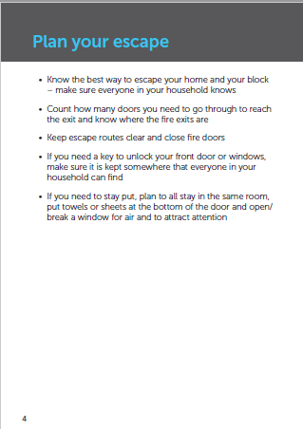

* Know the best way to escape your home and your block – make sure everyone in your household know
* Count how many doors you need to go through to reach the exit and know where the fire exits are
* Keep escape routes clear and close fire doors
* If you need to stay put, plan to all stay in the same room, put towels or sheets at the bottom of the door and open/break a window for air and o attract attention

**If there is a fire or smoke inside your home:**

* Get everyone out, close the door and calmly leave the building – Do not us ethe lift
* Call 999, give your full address and where the fire is in the block and your home

**If there is a fire in another part of the block, but not in your home:**

* Your home is designed to give some protection from fire; floors, door and walls will hold back fire and smoke for minimum of 30 minutes
* You are usually safer to stay in your home unless heat or smoke is affecting you; call 999 and tell the fire brigade where you are and how to get to you
* Get everyone out, close the door and calmly leave the building – Do not use the lift
* Call 999, give your full address and where the fire is in the block and your name

**If there is an Evacuation policy**

**If there is a Stay Put Policy**

Good housekeeping and maintenance is essential in preventing fires. Remember to follow these steps:

* Fire doors are designed to withstand fire, and the spread of smoke in a fire, for a minimum of 30minutes:
* Keep all fire doors closed when not in use – do not prop these open or obstruct them in any way.
* Keep lockable communal cupboard doors locked when not in use
* Report any damage to fire doors or door closers on them to your Housing Officer
* Keep corridors, hallways, stairwells, staircases, and meter & intake cupboards in communal areas clear of your possessions. NHG operates a zero-tolerance policy and any items found in communal areas will be removed
* Only dispose of rubbish in designated bin areas and do not dump bulky items - these can present a fire risk
* Read the fire safety information displayed in your block, and familiarise yourself with the escape routes for your building and where the exits are
* Fire alarms: Please don’t forget to test every month and change the battery if it starts to bleep every few seconds. Don’t disconnect or take it down and report any faults to your housing officer
* Do not leave candles or cigarettes unattended or smoke in bed. Make sure cigarettes are fully put out and do not throw from a window or balcony.
* Electrical safety: Do not overload electrical sockets and report any repairs to your Housing Officer. Do not use two prong plugs in UK sockets, always use an adaptor
* In the kitchen: If you have a cooking pan catch fire, do not throw water on it - turn off the heat if safe to do so, leave the room and call 999
* At night: Check cooker and other electrical appliances not designated to be left on are turned off. Close doors to rooms as this helps prevent the spread of fire and smoke
* Electrical appliance safety: If using older appliances, check with the manufacturer for recalled products. If buying a second-hand appliance check with the seller that it has been electrical safety tested

**What to do in the event of a fire**

**Plan your escape**

**Home safety and prevention in the home**

**Home safety and prevention in the block**

# **Contents Insurance**

We recommend everyone gets content insurance to protect their belongings from damage in the event of a leak or fire. We cannot recommend a provider for this service.

**Local Information**

**Borough details**

Croydon Council

Bernard Weatherill House

8 Mint Walk

Croydon, CR0 1EA

Web: https://www.croydon.gov.uk//

**Environmental Health and Bulk Refuse**

Croydon Council

Bernard Weatherill House

8 Mint Walk

Croydon, CR0 1EA

Web: https://www.croydon.gov.uk/environment

Tel: 020 8726 6000

Email: contact@croydon.gov.uk

|  |  |  |
| --- | --- | --- |
|  | **Location** | **Details of Service** |
| **Mainline Train Station** | East Croydon | • Thameslink towards Gatwick Airport  • Southern Railway towards East Grinstead, London Victoria, London Bridge, Eastbourne, Southampton Central, Bognor Regis, Caterham, Tattenham Corner,  • Thameslink towards Peterborough, Horsham, Bedford, Brighton |
| West Croydon | • Southern Railway towards Epsom, Epsom Downs, London Bridge, London Victoria, Sutton. |
| South Croydon | • Southern Railway towards London Bridge, London Victoria, Caterham, Tattenham Corner, East Grinstead |
| **Bus Stops** | Fairfield Halls | 50, 197, N250 towards Croydon Town Centre |
| West Croydon Bus Station | 157, 410 towards Crystal Palace  367 towards Bromley  450 towards Lower Sydenham  194 towards Bell Green  75 towards Lewisham |
| **Hospitals** | Croydon University Hospital | 530 London Road, Thornton Heath, CR7 7YE |
| Shirley Oaks Hospital | Poppy Ln Shirley Oaks Village, Croydon, CR9 8AB |
| West Valley Hospital | 81-85 Wellesley Rd, Croydon, CR0 2AJ |
| Woodleigh Community Independent Hospital | 28 Elmwood Rd, Croydon, CR0 2SG |
| **Parks** | Park Hill Park | Arthur Court, 2 Fairfield Path, Croydon CR0 5PB |
| Queens Gardens | Park Ln, Croydon CR0 1YJ |
| Fairfield Gardens | Fairfield Gardens, Croydon CR0 1JN |
| Wandle Park | Cornwall Rd, Croydon CR0 3RD |

# 

# **Manufacturer’s Literature**

* OFNL Welcome Letter
* MVHR Installation and Maintenance
* Intercom User Guide
* Heating Programmer
* Heating Interface Unit
* Consumer Unit
* Insite Energy