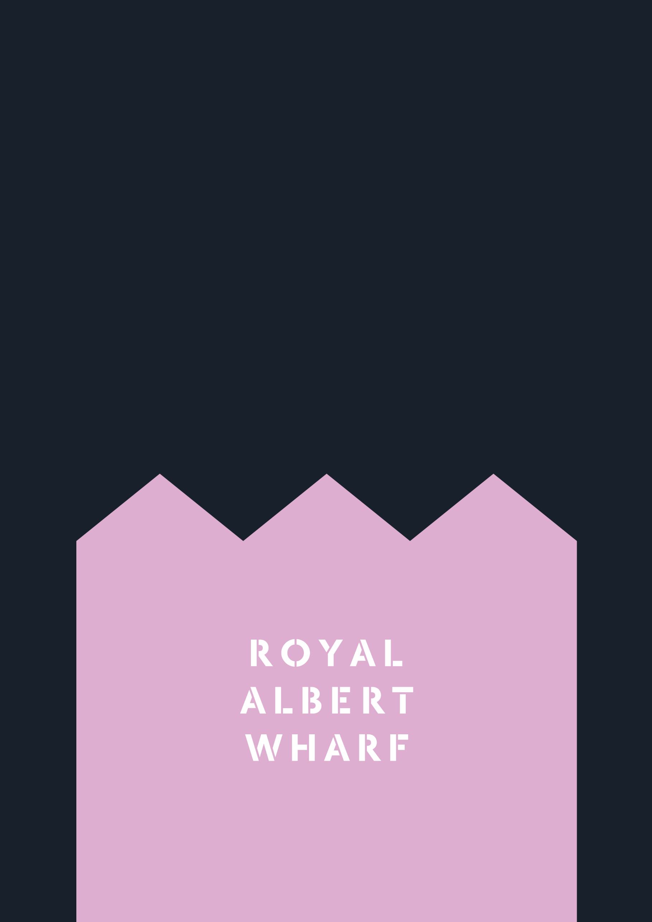

Home User Guide
Gallions View

The Carmen Building, 2 Magellan Boulevard

Contents
`

Welcome to Gallions View 3
NHG online portal- My account 4
Estate management 5
Post and deliveries 6
Parking 7
Cycle storage 8
Security/ Access 9
Communal and Window cleaning 9
Lifts 9
Refuse disposal 10
Estate Regulations 11
Service charge 12
Council Tax 12
TV Licensing 13
Communal and Landscaped areas 13
Defects 16
NHBC 18
Repairs 18
How long will I have to wait to have a repair carried out? 18
Preparing for the repair 19
Utilities 20
Mains water/ drainage 20
Stopcock: 20
Electricity 22
Heating and hot water 25
Television / Telephone / Internet 27
Radiators 28
Mechanical Ventilation 29
Thermostats 30
Looking after your new home 31
Lubrication 31
Door seals 31
Ironmongery 31
DIY 32
Redecorating 33
Alterations 33
Reducing condensation 34
Bathroom & kitchen care 35
Sanitaryware 35
Kitchen sink 35
Units & doors 36
Worktops 36
Finishes 37
Appliances Error! Bookmark not defined.
Appliance instruction manuals & warranties Error! Bookmark not defined.
Appliance cleaning & maintenance Error! Bookmark not defined.
Windows, Doors & Internal Security 41
Maintenance 42
Doors Locks 43
Access Control System 43
Fire Safety 44
Fire alarm operation 45
Fire Alarm Maintenance and testing 48
Fire doors 50
Sprinkler system 50
Fire Safety Guide 51
Contents Insurance 52
Local Information 53
Manufacturer’s Literature 56

Welcome to Gallions View
In this Home user guide, you will find useful information to help you get settled in. The purpose of this guide is to help you to familiarise yourself with your home and Gallions View. It is important that you review the contents of this manual to ensure that the features installed within your home are fully utilised.

Gallions View includes 238 Residential apartments across six residential blocks. The proposal comprises of a perimeter block with heights ranging from Three - Eleven Storeys as well as 3, 6, 7 and 8 storey separate building which are jointed together by a central garden podium. The provision includes vehicular access onto Magellan Boulevard, under-croft vehicle & cycle parking, hard and soft landscaping (including the provision of temporary landscape open space).


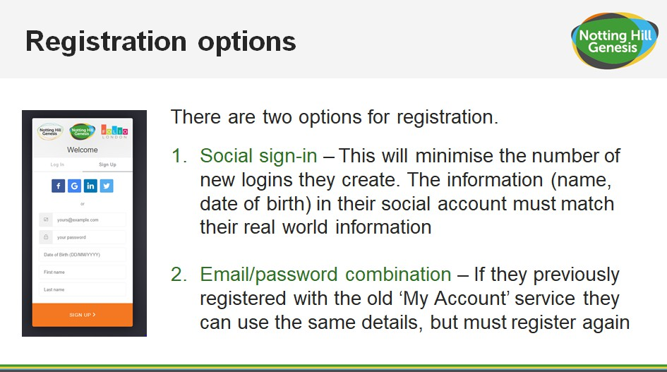
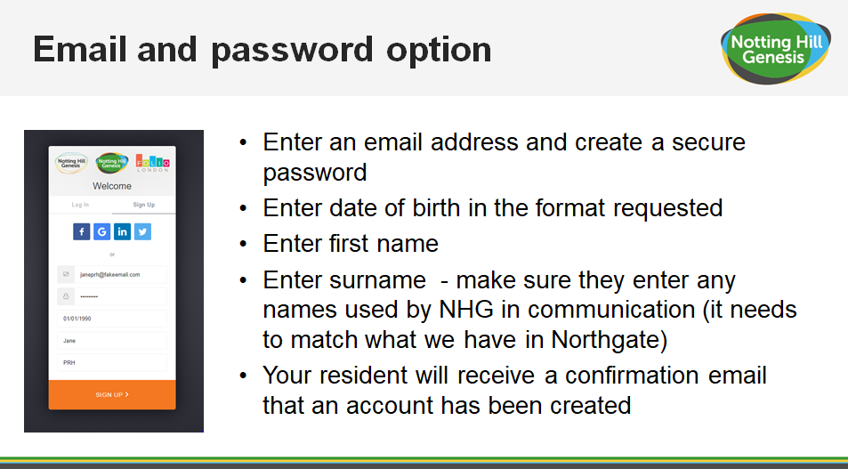
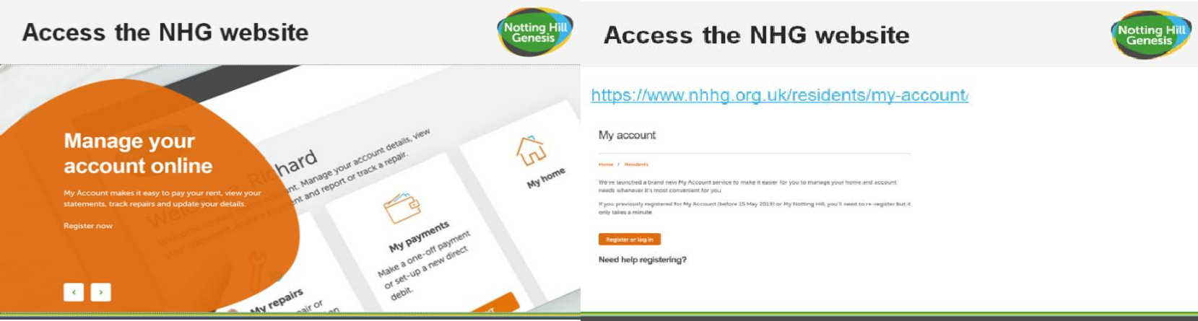
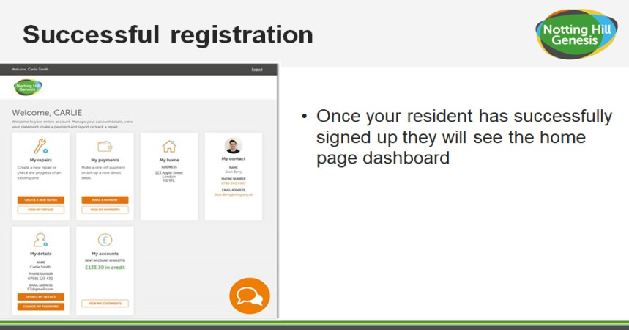
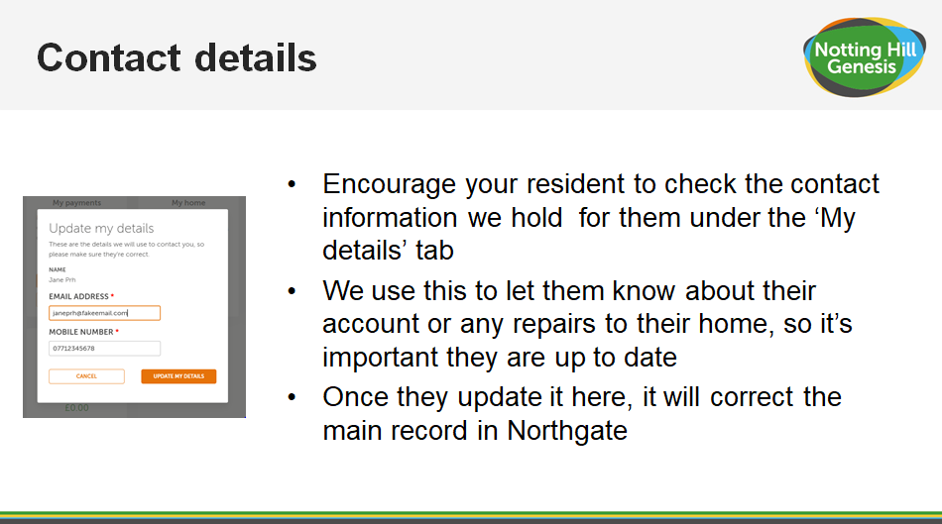
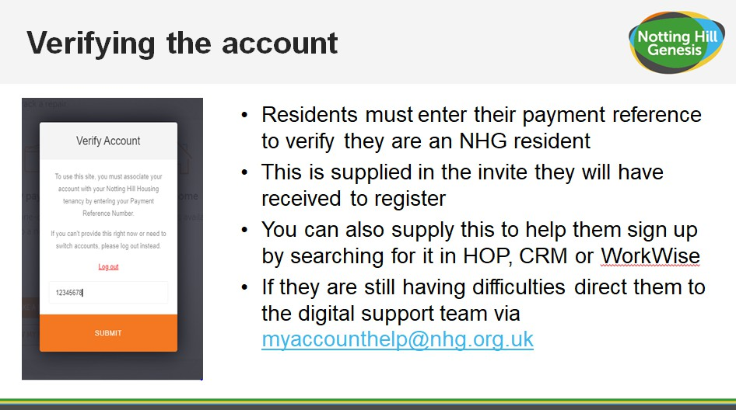
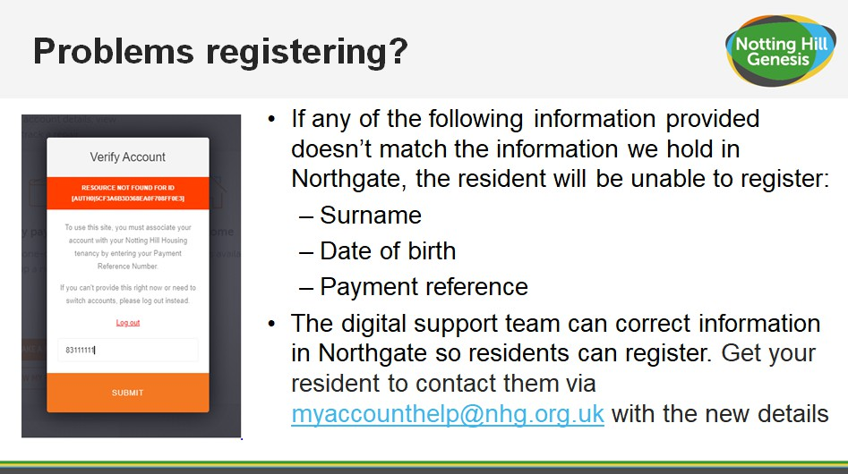
NHG online portal- My account
We strongly recommend registering your account with NHG, this is where you can get information to your tenancy and rent details. You can also raise your own home repairs, pay your rent and seek any extra support that you may need to manage your tenancy.
Installing My account: Access the NHG website https://www.nhhg.org.uk/residents/my-account/

Estate management

Concierge
The concierge office is the point of contact for residents if you have any questions or queries regarding any other aspects of the estate. The concierge service is based on the ground floor level of The Lockmen Building From 7am- 7pm.

From here you will be able to speak with our concierge member of staff with any questions regarding the estate and they will be able to point you in the right direction.
The concierge member of staff will also be carrying out inspections of the communal areas from time to time to ensure the estates are clean and tidy, while also checking for any issues relating to health & safety. When on patrol a notice will be left at the entrance lobby providing contact details for the security officer.
Outside of the concierge hours there will be a security officer on site who will also patrol the estate. Please note that security staff will not have the same knowledge and expertise as the concierge so they may ask you to return the following day or to e-mail us.
These members of staff will be managed by the Estate Operations Manager who has overall responsibility for the operation and upkeep of the estate.
If you need to contact a member of the Estate Operations Team please e-mail: concierge@gallionsview.uk

Community Space
Your new home includes a dedicated community space designed for all residents to enjoy. You’re welcome to use the space informally at any time for relaxing, socialising, or meeting neighbours. If you would like to book the private room located at the rear of the space—for gatherings, small events, or other activities—please contact the concierge, who will be happy to assist. Over time, we’d love to work with residents to shape how this space evolves. We will be inviting your ideas on the types of activities, events, and uses you’d like to see here, as well as how the space should be managed to best support the community.

Post and deliveries
The post boxes for apartments are located on the ground floor of your building, within the main lobby.

Royal mail postal service delivers once a day, Monday to Saturday excluding bank holidays.

Any parcels for residents will be taken at the concierge desk and kept for your collection unless you have requested for the courier to contact you directly so you can take personal collection. We advise you to do this if a parcel is particularly important or valuable. We take all parcels on your behalf and in good faith. We do not take any responsibility for any items in our storage.
We use a digital collection service. When a package is delivered it is scanned by our concierge staff and given a specific bar code and kept in our store room. You will then be sent a message by e-mail and text with a bar code in which you can scan at the screen in the concierge office and we will then give you your parcel.
Parcels can be collected from 8.00am-10.00pm on a daily basis.

Please note we do not hold grocery or take-away deliveries.

For grocery deliveries you will need to arrange directly to meet them outside your block.
For take-aways you will need to meet them outside the entrance to site as they will not be permitted past the entrance until the site is fully open.

Parking
Gallions View has restricted allocated undercroft parking including 12 Blue Badge and 11 EV Parking spaces. If you have been allocated a parking space, you will be made aware.
You can enter the car park, accessed via Magellan Boulevard using your fob on the pedestrian gate if you are on foot. Similarly, you can exit the car park by using the Push to Exit button on the pedestrian gate, or by simply approaching the gate, and it will automatically open upon detecting your car when it comes into range.

The car park will be patrolled regularly, and parking enforcement will be in operation for any unauthorised vehicles.

Please note that all vehicles must be registered with Gallions View management before a parking permit can be issued. All parking permits are required to be placed in the front windscreen of the vehicle and visible. There are several blue badge parking spaces allocated in the car park, these can be used by any resident who hold a blue badge, providing the badge is up to date and clearly displayed.
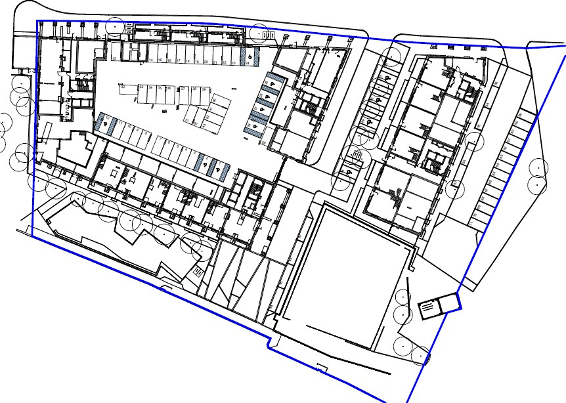

Cycle storage
Cycle racks will be provided across the development, within cycle stores dedicated to each block. Your own cycle store is on the ground floor of your residential block, with secure Fob Access via Car Park.
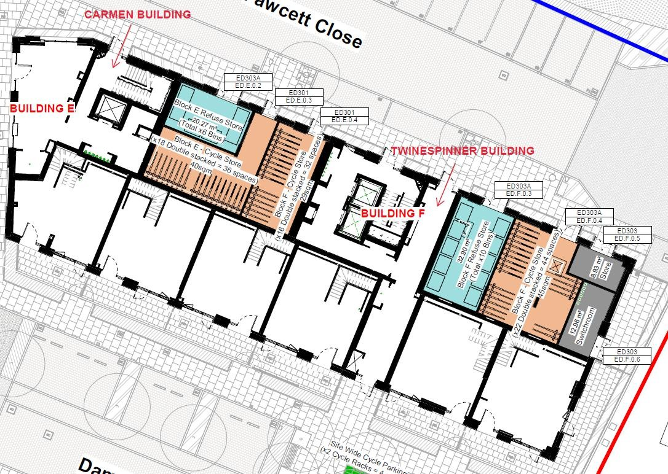

All cycles are stored at the owner’s risk.

Security/ Access
Gallions View has onsite security 24/7 7 days a week and there is extensive CCTV coverage around the estate. For any security matters please contact the concierge office at the following email: concierge@gallionsview.uk

The blocks are accessed with an access fob that each resident is given. The access fob will permit you to enter the block.

If your fob stops working, please see the Concierge and they will reprogram it, you must show I.D.

Communal and Window cleaning

Cleaners managed by the Gallions View estates team will be responsible for the cleaning of landscaped areas, shared surfaces and pedestrian routes as well as communal corridors/entrance lobbies and lifts cores throughout normal working hours. Please contact the concierge for further details.
All windows are to be self-cleaned by resident. Communal windows will be cleaned by management company on a regular basis.

Lifts
There is 1no. lift in Carmen Building (Block E). If a lift goes out of service, please report to the Gallions View management team. An emergency is only considered when someone is trapped inside the lift, please note a lift being out of service is not considered as an emergency.

In the event of a fire, do not use the lifts. When the fire alarm is activated, the lift will automatically return to the ground floor.

Refuse disposal
We ask that residents kindly remove any household waste and dispose of it in their designated bin store.

The refuse store for each apartment is located on the ground floor level in your building. These stores will require fob access.

Refuse is removed on a weekly basis from the communal bin stores, please contact Gallions View management if the bin stores are overflowing -

Residents should ensure that all items are broken down and boxes flattened before placing them in the relevant bins. Do not leave rubbish/recycling on the floor of the bin store as this is likely to prevent LB Newham collection and result in the management team having to pay for collections, which will be reflected in future service charges.

When recycling, please ensure you follow the guidelines below:

Types of cardboard - please flatten or tear into smaller pieces
- Card sleeves
- Cardboard boxes (polystyrene removed)
- Cereal boxes
- Egg boxes
- Greetings cards (without glitter)
Mixed paper - no shredded paper
- Brochures and leaflets
- Junk mail and envelopes
- Newspapers and magazines
- Telephone directories
- Other white household paper
Plastic packaging - empty, rinsed and squashed
- Fizzy drink and water bottles
- Plastic detergent and shampoo bottles
- Cleaning bottles
- Plastic milk bottles
- Yoghurt pots
- Plastic punnets and trays
Tins and cans - empty and rinsed
- Aluminium and steel cans
- Drink cans and tins
- Food tins and cans
- Metal lids
- Empty aerosol cans (i.e. deodorant sprays)
Glass – clean and dry (no broken glass)
- Milk bottles

- Wine and beer bottles
- Perfume bottles
- Glass jars i.e. sauces
Aluminium foil – rinsed, clean and dry
- Scrunched up tin foil
- Tin foil food trays

Do not put black sacks into the recycling bin as these cannot be recycled.

For further information please visit the Newham London Borough Council website:

https://www.newham.gov.uk/rubbish-recycling-waste/

Estate Regulations
If the street lighting is out or for any pavement issues, please contact concierge at concierge@gallionsview.uk

It is essential that estate regulations are set, implemented and appropriately managed in the event of non-compliance by any occupier. A copy of the proposed estate regulations is below and is intended to enhance the quiet enjoyment of Gallions View for the benefit and convenience of all. The estate regulations will form part of the leases and tenancy agreements.
Noise - Noise levels are to be kept at a minimum as so not to disturb your neighbours. No loud noise is permitted between 11pm and 8am. Any noise allegations will be investigated by the management team.

Balcony - No items should be stored on the balcony. This includes washing and bicycles.

Window Dressings - Windows should not be covered in any material other than the window dressings provided. Residents are not authorised to change the window dressings.
Barbecues/Fires - No barbecues or fires will be allowed at any time at Gallions View, including on private or shared balconies, terraces or podium gardens.
Satellite - All blocks have a communal satellite. No resident will be permitted to have a satellite on display at any time. Any satellite located will be removed immediately.

Podiums, gardens, shrubbery and Estate Areas - These areas are provided for the enjoyment of all residents at Gallions View. No ball games are permitted within these areas, except within designated facilities. The interfering or removal of any plants is not permitted.

Pets - All pets are to be registered and authorised by the landlord.

Bicycles - All bicycles are parked at the owner’s risk.
Parking - There is limited provision for residents or visitors parking on the estate. Cars may be parked in designated bays as long as they are displaying valid permits. Any abandoned vehicle will be removed.

Common parts - Do not obstruct any of the access ways i.e. fire exits. Smoking is not permitted within any communal area or lifts.

Property - Any act that may interfere with the safety, comfort or convenience or cause nuisance or danger to any person or property is prohibited.
Disposal of waste - All waste is to be disposed of in the correct manner.

Advertising - No advertising by Estate agents will be allowed to be displayed within Gallions View. Window stickers, advertisements or notices will be removed immediately.

Immoral use - No apartment or area within Gallions View is to be used for any illegal, immoral or improper activity.

Fire equipment - Residents are not to remove, dispose or interfere with any equipment or sign that is provided for their safety and the safety of others.

Road closures - The landlord is permitted at any time to authorise the closure of any road so that building work may be carried out.

Service charge

Please see your tenancy agreement for list of payable service charge details.

Council Tax

Please see the following link for updating and paying your Council Tax www.gov.uk/pay-council-tax

TV Licensing
You need a TV Licence if you:
- watch or record live TV on any channel or service
- use BBC iPlayer
You may be able to get a free or discounted TV Licence if you’re 75 or over and get Pension Credit, or if you’re blind or in residential care.
You do not need a TV Licence to watch:
- streaming services like Netflix and Disney Plus
- on-demand TV through services like All 4 and Amazon Prime Video
- videos on websites like YouTube
- videos or DVDs

Please see the following link for updating and paying your Tv License www.gov.uk/find-licences/tv-licence

Communal and Landscaped areas

There are external communal and landscaped areas at Gallions View for resident’s enjoyment. You have access to the first-floor podium garden.

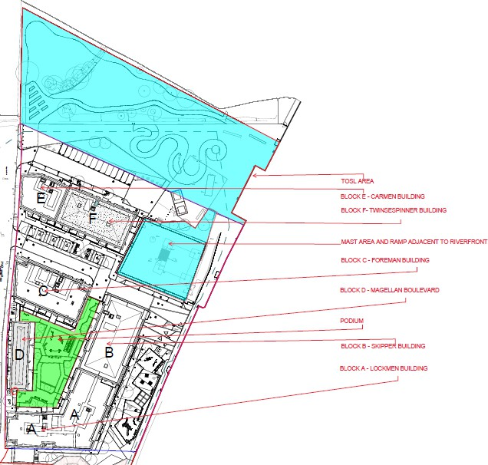

Please note these areas are for all residents to share and therefore the following rules must be adhered to:

Please report any damage on this First Floor podium garden to the Concierge immediately
First floor podium garden landscaped areas
Whilst enjoying these spaces please use in a considerate manner and in respect of your neighbours and keep noise to a minimum
- CCTV in operation
- No Loitering or Noise after 10pm
- Use of Play Area prohibited past 8pm
- No Barbeques or Fires
- No Smoking
- No Ball Games
- No Littering

- No Dog Fouling
- Children must be supervised at all times

Please report any damage in this Area to the Concierge immediately concierge@gallionsview.uk,

Riverside
This area is open to public access, but we will try and ensure many of the same restrictions apply:
- CCTV in operation
- No Loitering or Noise after 10pm
- No Barbeques or Fires
- No Ball Games
- No Littering
- No Dog Fouling
- Children must be supervised at all times.
- No access over the river wall or into the river
- No interfering with river wall escape area’s or life safety equipment

Temporary Open Space Land
Situated to the north of the development, this area contains a number of infrastructure facilities managed by others,
- Port of London Authority radar mast and compound. Vehicles will access across the concrete hard standing area and down the ramp into the compound and we would ask that no obstructions are created to this access. Do not attempt to enter this compound.
- Electrical Sub Stations. Please do not interfere with these facilities and take the usual precautions.
- Thames Water Drainage – A drainage outfall runs under the concrete hard standing, with associated inspection facilities.
Please report any damage in this area to the Concierge immediately

Defects

Defect liability period
Your home is covered under a 24‐month defects warranty, known as the defect’s liability period. This period started when Notting Hill Genesis took possession of your home from the contractor. The contractor is responsible for the rectification of defects and faults that occur during this period. You need to report all repair issues on MY ACCOUNT or to your Housing Officer / Property Management Officer, once this is reported it will be forwarded to the contractor who will contact you to arrange a time to visit your property and rectify the problem. The response time will vary depending on the urgency of the problem.

Defect response times
The Defects Team will take a decision as to whether the fault is a repair, a defect, or your responsibility. Please make sure that the information you provide to the Housing Officer/ property management officer is correct. Incorrect information which results in the contractor attending your home will be charged to you.

Defects categories

- “Priority 1” - Emergency repairs that must be responded to and made safe immediately and fully rectified within 24 hours:
  - Gas leaks – to be telephoned immediately to the National Grid
  - Dangerous electrical works
  - Total failure of electrical lighting or power
  - Failure of lighting to a communal staircase / corridor / lift to such degree as constitutes a health and safety risk
  - Burst water pipes or other ingress of water (including roof repairs) that are causing damage to property
  - Blocked drains
  - Blocked toilets or other sanitary fittings
  - No mains cold water supply to a property
  - Central heating or hot water failure
  - Failure of front entrance doors to houses or flats
  - Failure of lifts
  - Failure of communal gates or communal access doors
  - Damaged flooring or stair tread in communal areas, where this presents a health and safety risk
  - Temporary glazing repairs (permanent replacement classified as “Priority 3”)
  - Defects that may render a dwelling unsecure – e.g. windows or doors not closing properly
  - Defects that may cause injury or are a danger to any person
  - Defects that may cause significant damage to property if left unresolved

- “Priority 2” - Urgent repairs to be rectified within 7 days:
  - Minor plumbing repairs – equipment failure
  - General electrical repairs – defective items other than dangerous electrical
works classified as “Priority 1”
  - General repairs to heating and hot water systems
  - Loose or detached banister or handrail
  - Damaged flooring or stair tread in communal areas – other than a dangerous
defect classified as “Priority 1”
  - Individual door entry-phone not working
  - Defective kitchen or bathroom fan
  - Faults with television aerials and telephone connections
  - Windows not closing property – other than where this is classified as “Priority 1”

- “Priority 3” – Routine repairs to be rectified within 4 weeks:
  - Minor roof repairs – unless there is ingress of water which will be classified as
“Priority 1”
  - Repairs to leaking gutters and rainwater pipes
  - Re-glazing windows or doors – where there is no security issue
  - Minor carpentry repairs to windows and doors
  - Non-urgent plumbing repairs
  - Repairs to wooden floors and floor coverings
  - Repairs to external render and air vents
  - Repairs to internal plaster
  - Re-decoration after other repairs have been carried out
  - Repairs to garden fencing

At the end of defects liability period a final joint inspection is carried out in each home and the communal areas. The inspection party consists of the building contractor, the development project manager, Notting Hill Genesis’ employer’s agent and site inspector. The purpose of the end of defects inspection is to check for any defects which need to be put right by the building contractor.
It is important that access is gained to all homes and the external and internal communal areas. This is the last opportunity to report defects for repair by the building contractor.
Following the inspection, the building contractor will arrange appointments directly with you to carry out final defect rectification works within your home. You will be required to give access at this appointment time.
If a repair arises out of misuse of or damage to the property, then the cost of the repair will be borne by the resident.

NHBC
Your home has the benefit of cover under the NHBC Buildmark warranty scheme. This is a warranty under which the developer, during the first 24 Months, and the NHBC during years 2-12 following legal completion, has defined responsibilities with regards to defects in materials or workmanship in your new home.

Please note the defect period begins from the date the development was completed and handed over to Notting Hill Genesis. Any defects occurring during the first 24 Months should be reported via My Account or to your Housing officer/Property Management Officer who will pass them on to the developer who is responsible for resolving any issues in line with Buildmark policy. Following this period, NHBC will provide cover for latent defects for the lifetime of the warranty policy, in accordance with the policy terms.

NHBC advice centre Tel: 0844 633 1000 / www.nhbc.co.uk

Repairs
Repairs are reported via MY ACCOUNT
- A heavy leak in your property where it is not possible to contain the water, or it is leaking
between floors or properties.
- An electrical fault in your property where it is not possible to contain the water, or it is leaking between floors or properties.
- An electrical fault in your property which endangers health or life.
- Complete electrical failure, or electrical failure in a kitchen/ bathroom
We are responsible for emergency repairs to:
- Any repair that will threaten the health or safety of our residents or the wider public if it is not carried out immediately is an emergency.
- Any repair that will seriously damage the property if it is not carried out immediately is an emergency.
What is an Emergency repair?

How long will I have to wait to have a repair carried out?

- We aim to have someone attend your property within 24 hours if you report an emergency repair.
- We aim to complete non-emergency repairs within 20 working days.
Please be aware that our contractors cannot always fix a problem on the first visit. If they cannot fix something, they will arrange a date and time to come back and finish the job.

Preparing for the repair

When waiting for a repair, it is important to clear space or move furniture so that the repair is accessible for the contractors. This will help them to carry out the works more quickly and minimise the risk of any accidental damage to possessions.
If you have any concerns or think you may have difficulty clearing space for the contractor, please let your housing officer know as soon as possible.

Utilities

Mains water/ drainage

Thames Water supply the incoming mains water through an underground service pipe fitted with a stop valve at the boundary to the development for use by the water company in an emergency.

As water enters your home, it’s flow is controlled by the stopcock located in your home, which allows you to turn off the supply in an emergency or for maintenance.
Mains water and drainage supplier: Thames Water
www.thameswater.co.uk
Telephone 0800 316 9800/ Billing and account enquiries/ Telephone 0800 980 8800

Stopcock:

Your water meter is located within your Utility cupboard.
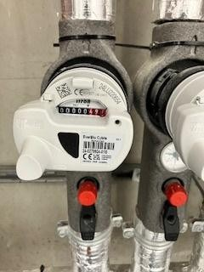

The dwelling stopcock is located in the Utility Cupboard of your property.

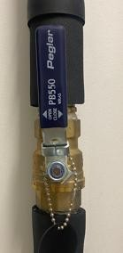

There is an isolation valve within the ceiling void above the apartment front entrance door.


Kitchen Wastepipes: If a blockage occurs and the sink is full of water try to remove the blockage by pushing a flexible drain rod down the plughole or by using a suction cup plunger to move water up and down the wastepipe. The risk of blockages can be reduced if you remember to put fat (which solidifies when cold) into an empty container rather than down the sink or drain.

Bath, Shower and Basins: Blockages here are normally caused by the build‐up of hair and soap in the plug hole and become noticeable when the bath or basin starts to drain away more slowly. Clear bath or basin wastes with a ‘Sani snake’ (available from hardware stores) or by using a proprietary chemical cleaner (please read instructions carefully). You can purchase a small filter to put over the bath/ water outlet to collect hair, etc. and prevent blockages.
The water supply for the whole apartment can be closed off from there. However, the ceiling void should only be accessed by a trade professional. The stop cock within the Utility Cupboard will also perform the same function.

Electricity

Electrical supplier details: EON Telephone: 0345 302 4312 Location of meter: Utility Cupboard
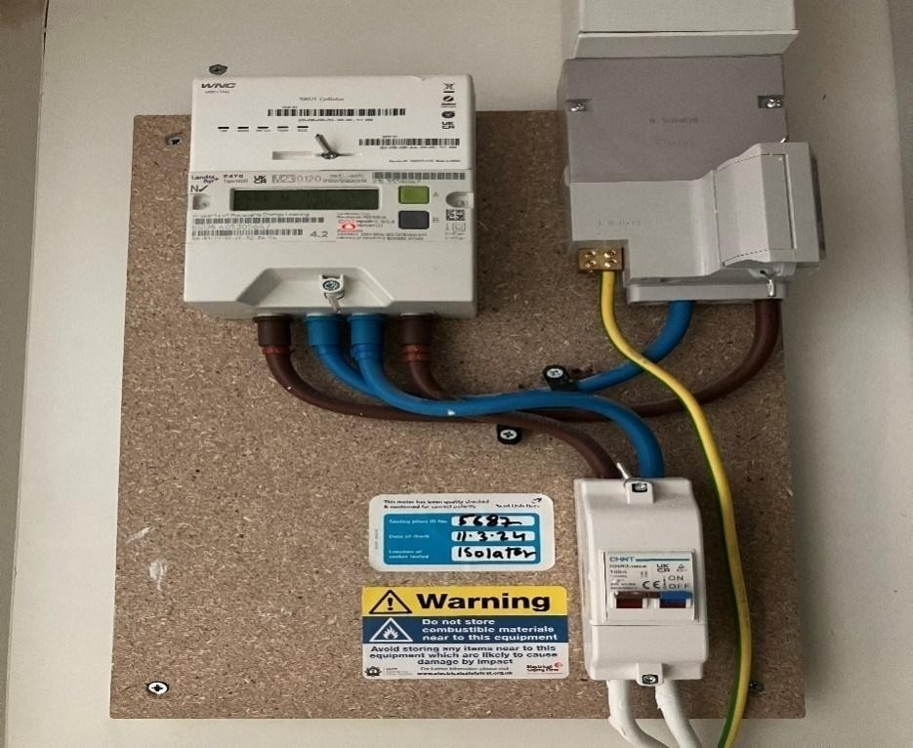

Location of Consumer unit: Utility Cupboard
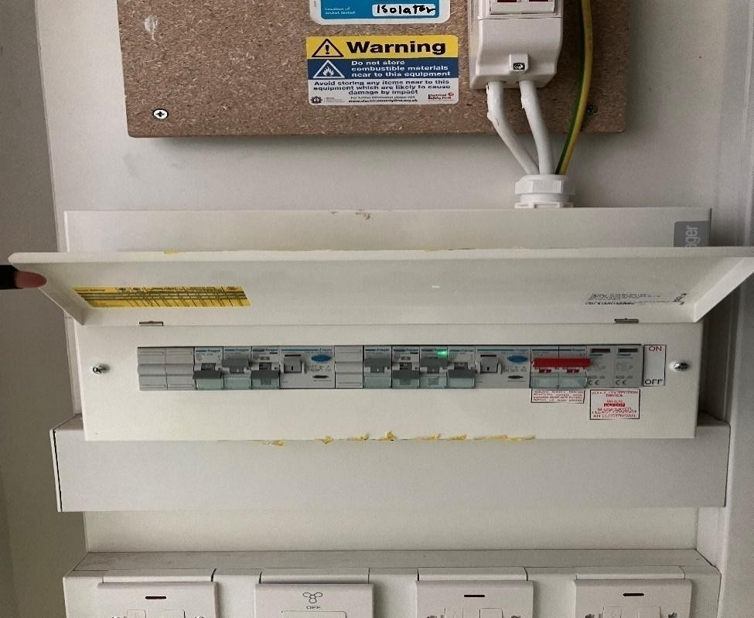

Energy Tips
Light  The light fittings in your property use energy efficient light bulbs. Although these lights may cost more, the cost saving in reduced energy bills will ensure money saving in the longer term. See the Finishes section for electrical light fittings installed in your property.  For replacement bulbs contact your local electrical store.  Changing light bulbs  To change light bulbs, the light switch must be in the off position. It is advisable to replace the bulb with the same type of bulb that was removed.  For further information on energy saving lighting visit www.energysavingtrust.org.uk/electricity/lighting  Electrical alterations, including replacing light fixtures and fittings should only be carried out by a qualified electrician.  Cables may run in any position above a ceiling or under  A floor. Before fixing to walls, floors and ceilings always  Check for buried pipes and cables using a detector available  From diy stores.  Do not interfere with earth bonding cables connected to  Pipework and main earth connection.  For further information on electric safety in the home visit the electrical safety council website  www.esc.org.uk | Loss of power and troubleshooting  If your electricity goes off, start by checking to see if it is a power cut or a fault in your home. The easiest way to do this is to see if your neighbour’s have electricity. If they do not have power either then it is a power cut and you should contact 105.  It isn’t possible to predict a power cut however here are some precautions you can take in case a power cut occurs:  - Make sure you have multiple torches along with extra batteries  - Keep a plug‐in telephone that does not require electricity – remember that with cordless phones you may not be able to make phone calls once the batteries are dead  - Keep important documents safe and handy  - If your neighbours have power, then it could be a fault in your home.  Your trip switch may have turned itself off. If it has, try turning it back on. If it switches off again then one of your electrical appliances may be faulty. Your trip switch turns itself off to make sure you do not get injured by a faulty appliance. Once you have found the faulty appliance and turned it off, your power should stay on.  If you have only lost power in part of your home you may have a fault with your electrical wiring somewhere, in which case you should call a qualified electrician as soon as possible.
Energy and water efficiency  Tips for saving energy and money around your home:  Washing machines  - Wash at the lowest temperature that will give efficient results.  - Wait until you have a full load or use the ‘half load’ setting to reduce water.  - Use short wash cycles for lightly soiled items. | Dishwashers  - Always wait until the machine is full before running it.  - For lightly soiled items some dishwashers have economy programmes that reduce the washing temperature and /or shorten the washing time.  - Please there is no dishwasher in the property however provision of a spur is

- Consider buying a shower wash type of washing machine.  - If you are planning to use a tumble dryer, choose a washing machine with a high spin to save on drying time.  Washer dryers  - Washer dryers save space and often cost less than two separate machines. They usually hold less than a dedicated built tumble dryer – you can’t wash a second load until the first load has finished drying, and they usually use an air/water heat exchanger, which means that heat extracted in the condenser is lost to the drain. Washer dryers can give a perfectly satisfactory service.  - Wait until you have a full load before using the washer and/or tumble dryer.  - If the machine has an energy saving load setting use it whenever possible.  Use low temperature settings for lightly soiled items  Fridges and freezers  - Try to keep your freezer at least three quarters full.  - Do not put warm food into the fridge.  - Defrost your fridge or freezer regularly and avoid leaving the door open longer than necessary.  - Check that the door seal on your fridge is working effectively by closing on a piece of paper to see if it is held tight. If your fridge builds up frost too quickly the door seal could be faulty.  Cooking  - Match pan sizes to ring and use pans that are appropriate for your type of hob.  - Where a long cooking time is needed use a conventional oven. However a microwave oven is more economical for short cooking times, particularly for smaller quantities of food.  - When cooking with a microwave always follow the manufacturer’s instructions and ensure that there are no “cool spots” left in the food.  - For toasting use a toaster rather than the grill. | provided within a removable panel in your kitchen.  Television sets  - When you choose your tv consider buying a model that uses less electricity.  - Do not leave the tv switched ‘on’ if nobody is watching it.  - Do not leave the tv in ‘stand‐by’ mode for long periods.  Irons  - Do not leave an iron switched ‘on’ if you are not going to use it within 5 minutes.  Kettles  - When you choose your kettle consider buying a jug‐style model or an energy efficient one.  - Remove lime scale from your kettle regularly.  - When boiling water use a kettle – not a pan.  - Only heat as much water as you need in the kettle but remember to always cover the element.  Computers  - Switch your computer off when it is not in use.  Mobile phones  - Unplug phone chargers when not in use.  In the bathroom  - When brushing your teeth using a tumbler, instead of running the tap water for rinsing, can save nine litres of water per minute.  - Taking a shower instead of a bath can save up to 40% of the water that you use.  - Reducing the time you spend in the shower will save water and energy.  - Put the plug in the basin when washing hands or shaving, rather than leaving the tap running.

Heating and hot water

Heating and hot water is distributed in your home via the heat interface unit (HIU), which is located in your Utility Cupboard.
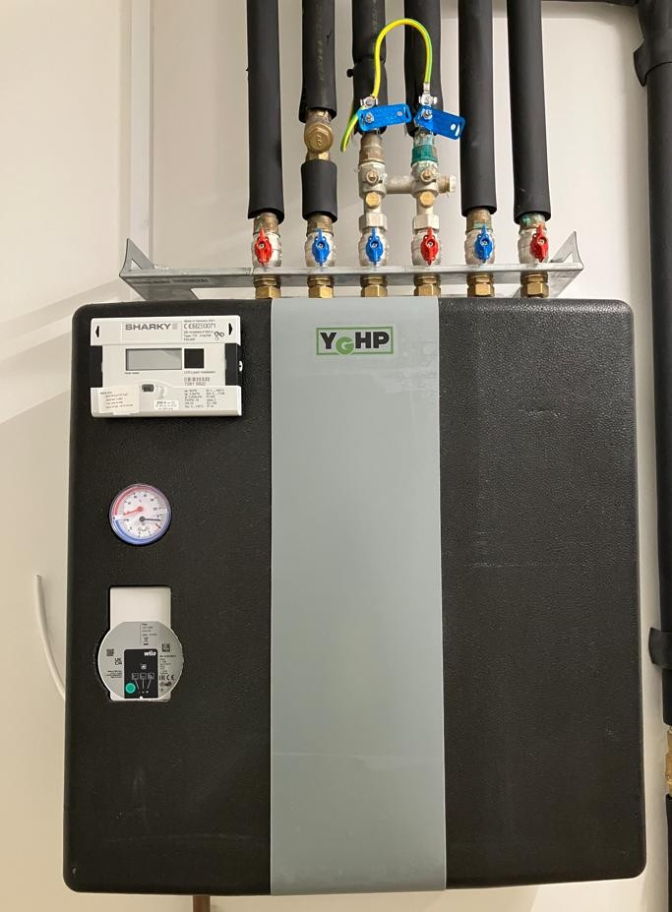

Hot water is produced by the HIU on demand.

Heating and hot water consumption is measured by a heat meter, which is visible on your HIU and is read during your handover appointment with your Housing Officer / Property Management Officer.

The Sharky Meter has been chosen for your home. The Sharky Meter is a smart energy meter and heating and hot water controller, all in one. Your Sharky Meter enables you to easily monitor your use of heating and hot water and also the payments you make.

The Sharky Meter is connected to EON’s payment system via the internet, so it always knows how much credit you've purchased.

Below is an image of the main screen display: This displays your balance, your emergency credit limit, your kWh (unit) charge, your daily standing charge, your kWh and Carbon Dioxide usage.

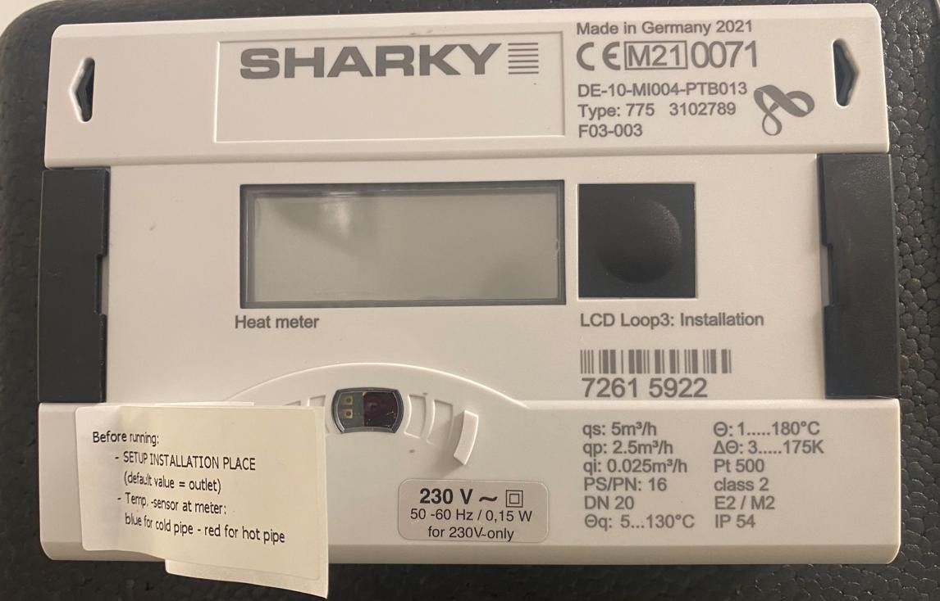
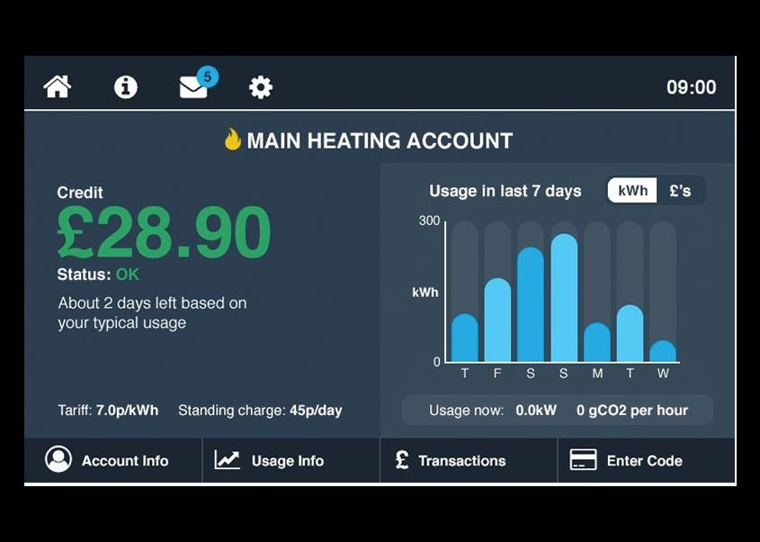

Any queries with regards to meters and billing for heating and hot water should be addressed to your supplier, please refer to the separate EON Energy brochure for further details.

Television / Telephone / Internet
The TV signal in your apartment is supplied via a communal satellite dish and aerial; also known as Fibre Integrated Reception System (FIRS), You do not need a dish or aerial installed to receive TV.

FIRS delivers entertainment services, including satellite and terrestrial TV to your apartment. There is a media plate installed within your property which is connected via the installed aerial sockets to enable you to connect satellite (Sky or Freesat) or terrestrial (Freeview) set top boxes, TVs or DAB radios.

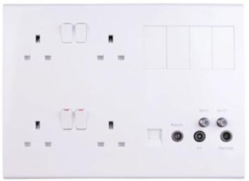
Socket Plate

For any questions or issues with your TV system, please contact BT on the contact details below.

When calling, please advise of the status of the lights on the GTU, an understanding of these lights can be found on the following BT website:
www.bt.com/help/landline/lights-on-the-openreach-modem

Contact Information
Call: 020 7356 5000
Contact form: www.bt.com/help/contact-bt
BT’s Contact information is made through your account on their website, please log in or create an account to communicate with BT.

You will find an Optical Network Terminal (ONT) pre-installed within your home. This is the main fibre box where the fibre connects into your home.

To set up BT broadband
To setup BT Broadband please see the following link to view the different packages and find out what is appropriate for your needs:
www.bt.com/broadband

Radiators

The pipework runs back to a manifold in your services cupboard which is connected to the heat interface unit (HIU).
Room thermostats sense the temperature in each room and open or close valves on the manifold to allow the hot water to run through the pipes until the room is warm enough. When the stat senses the room is warm enough it closes the valve to stop the flow of water.
Heated towel rails are fitted in your bathroom.

Mechanical Ventilation

Ventilation in your home is supplied by mechanical ventilation with heat recovery unit (MVHR).
The ventilation unit installed in your home will not only ensure that your property has a good level of indoor air quality, it will protect the fabric of your home from condensation and remove odours and indoor pollutants, resulting in a healthier living environment for you.

The ventilation system extracts warm, damp air from the home and draws in fresh air from the outside via ducted ceiling mounted terminals. The warm, extracted air is passed through a heat exchanger to recover the heat before being expelled outside. The cool, fresh air from outside is also passed through the heat exchanger, without coming into direct contact with the extracted air where it is pre‐warmed before being pumped into your home. The unit also has a summer bypass mode. This ensures that in the summer, fresh air is not passed over the heat exchanger and as such reduces the risk of overheating.

The ventilation system to your kitchen and bathroom where excessive moisture can be generated while cooking or using the bathroom is boosted. The kitchen boost is controlled via a switch on the kitchen grid plate and the bathroom boost is interlocked with the bathroom light switch.

Cooling unit
Where cooling units have been installed an additional cooling module has been installed above the MVHR unit located within the utility cupboard. The cooling module works by further tempering the supply air when the system is in summer by-pass mode. The user can set a target temperature on the controller (factory preset to 23°C) and the cooling module will modulate the level of ventilation and cooling achieve this temperature.

In order to maintain the proper function of your cooling unit, it is important to check and service your filters regularly. It is recommended to check filters 3-6 months and replacing filters once a year.
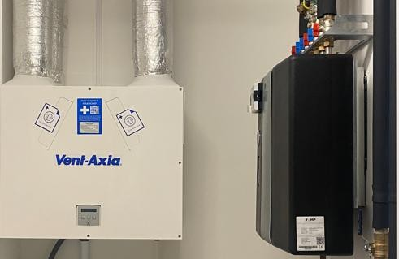
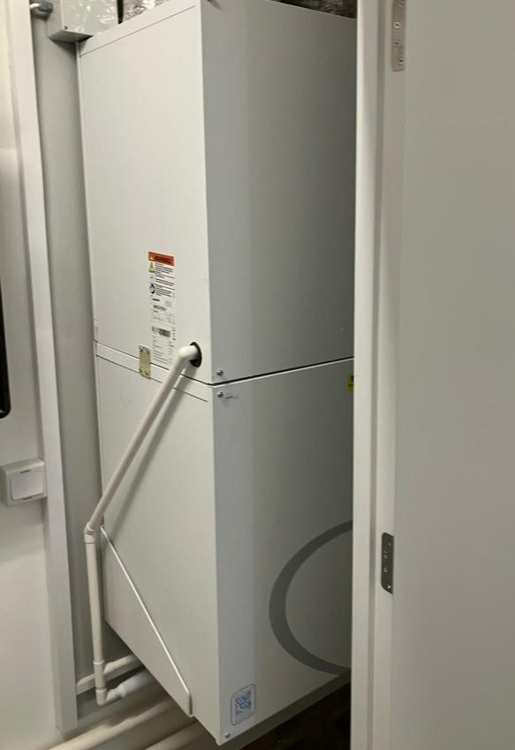

Thermostats

Thermostats are located within your apartment hallway.
There is an ESI heating programmer in your hallway, which provides timing control for your central heating system, letting you set ON and OFF periods to suit your own lifestyle.

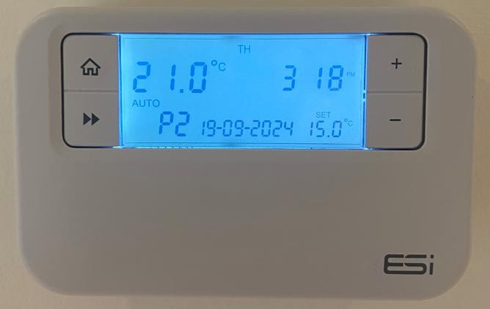

There is also an Electric Towel Radiator Thermostat located in your bathroom/WC.

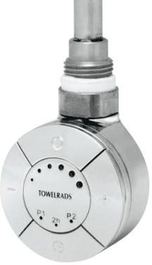

For more information on this and how to set it up, please refer to the manufacturer’s literature section of this manual.

Looking after your new home

Lubrication

There are many areas within your new property that will benefit from regular lubrication. We recommend that window hinges and door mechanisms are regularly lubricated to keep them in good working order.

Door seals

The condition of all door seals should be examined at six-monthly intervals. If the seal is missing, in part or completely, it should be replaced immediately. It is necessary to replace like with like and the use of any seal, other than that originally installed, may jeopardise the performance of the door. Seals should be fitted in accordance with the manufacturer’s instructions.

Ironmongery

Stainless steel and chrome finishes should be cleaned at least every six months with a dry cloth or duster and washed periodically with a soft cloth and soapy water and dried with a clean cloth. Do not use abrasive materials for regular cleaning. Acetones or solvents can be used to remove grease marks or paint from stainless steel finishes if needed. There are also special products available for removing scratches or rust from stainless steel. Always follow the manufacturer’s instructions when using cleaning products.

DIY

When hanging pictures or attaching anything to the wall, we recommend waiting 6 months before doing so. Care must be taken to not disturb or damage any pipes or electric cabling that may lie beneath the surface of the wall. It is strongly recommended that you use a cable/ pipe detector, which can be bought from most major DIY stores.
Plasterboard should be able to take a weight of approximately 10kg using appropriate plasterboard fixings.
Due to this weight limitation, it is not advised that you fix heavy objects to plasterboard walls
e.g. Flat screen tv unless the relevant provisions have been allowed for.
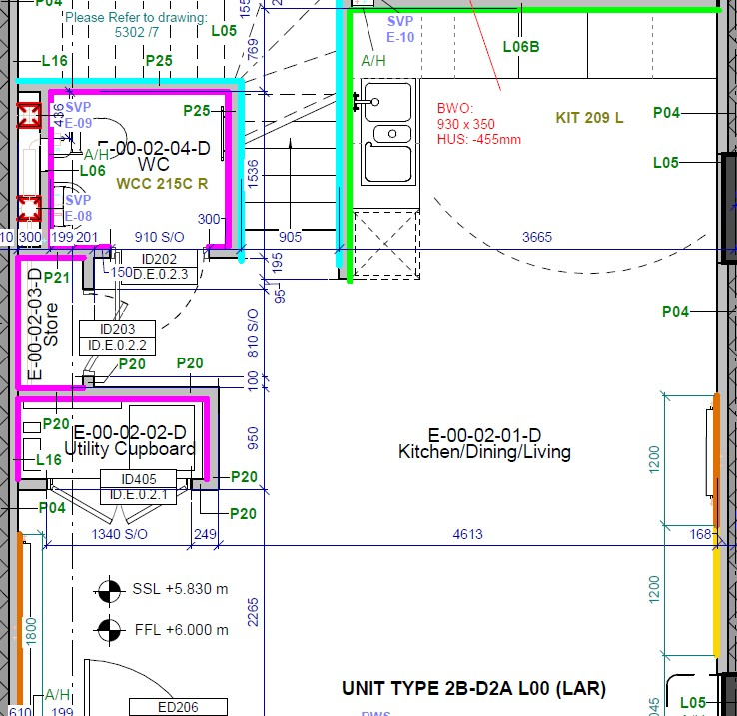

Here is an example of the TV Patressing in the apartments with the area marked yellow as the TV Patressing.

Redecorating

If you plan to redecorate your home, we recommend that you wait for the drying out process is complete, which usually takes between 6 and 18 months. Paint that is applied too soon may crack as the moisture in the construction evaporates. Unfortunately, NHG cannot be held responsible for damage to decorations that have been applied too soon. We recommend using emulsion paint to assist in drying out process.

Alterations

Please note that structural or material alterations are not permitted. Please contact your Housing Officer for further guidance.

Reducing condensation
Condensation is caused by steam or water vapour when it comes into contact with cold surfaces (in the same way that steam in the bathroom condenses on the window).
Once materials have dried out, you should no longer experience significant condensation. However, normal daily activities produce a great deal of water vapour, which may cause condensation if allowed to spread around the home.
Measures you can take to control condensation:

- Cover pans when cooking and do not leave kettles boiling
- Put washing outdoors to dry if you can. If you use a tumble dryer, make sure that it is vented to the outside air (unless it is a self‐condensing type). DIY vent kits are available.
- Use the cooker hood and/or extractor fans and keep the doors closed when cooking, washing and bathing.
- Do not switch off the main isolator switch to the extractors in the bathroom or kitchen at any time, as they are needed to ventilate these rooms.
- Regularly open windows to encourage air changes.
Ventilation is needed to get rid of the moisture that is naturally produced every day in your home. Your home will only maintain a healthy internal environment when ventilation systems are running. You risk damage to your health and home if you turn these off or block outlets.

Homes where the heating is off all day, because the occupants are out, are more likely to suffer condensation problems than those heated more continuously. This is because, when normal activities such as washing and cooking are carried out in the evening, the home has been unheated for long periods and the surfaces are cold.

Make sure the heating timer is set so that your home is warm by the time you return home. During very cold weather it is better to leave the heating on during the day to maintain an even temperature. The temperature can be set a few degrees lower and turned up when you return.

Most heating systems operate inefficiently if turned completely on and off. Use your thermostat to control heating operation. This will be more efficient and help to reduce fuel bills.
Remember that condensation is not normally a building fault. Learning to control moisture levels is a vital part of living in modern, well insulated, home.

Bathroom & kitchen care

Sanitaryware
To prevent a build-up of dirt and limescale, acrylic and ceramic sanitaryware should be wiped down immediately after use with a soft cloth and thoroughly cleaned with warm soapy water, a cream cleaner or multi-purpose surface cleaner on a weekly basis.

Many household chemicals such as paint stripper, nail varnish remover, household bleach, abrasive cleaning agents, perfume, aftershave or strong disinfectants can cause damage and should not be allowed to come into contact with your sanitaryware.

If such chemicals do accidentally come into contact with your sanitaryware then it is advised that you rinse the affected area with sufficient water to completely remove the chemical.

In hard water areas mild lime-scale remover may be used from time to time.

Never leave strong bleach or cleaners in the wc bowl for extended periods of time or overnight. Never mix different cleaners in the wc bowl as this may give off poisonous or volatile gases.

To avoid damaging internal fittings do not put bleach products in the cistern.

When cleaning your sanitaryware the manufacturer’s instructions take precedent over the above recommendations and should be followed at all times. The item should be rinsed and dried with a soft cloth after cleaning to provide the best finish.

Kitchen sink
Your stainless-steel kitchen sink is generally resistant to most household items and is very hard wearing, however the following substances should not be allowed to come into contact with the stainless-steel surface, mortar, cement, plaster, concrete, tile cement, grout, undiluted bleach, acids, silver dip.

Daily cleaning of your sink should be carried out using cream-based cleaners on a soft cloth. This should be adequate to remove such marks as tea stains and grease. More abrasive cleaners such as scouring powders, should not be used. The everyday film of limescale, which in hard-water areas, can be quickly removed using a standard cream cleaner but, should a thicker limescale layer form, then this will require treatment with a proprietary limescale remover and a soft brush.

It is likely that during its use the stainless-steel surface will scratch, you can reduce the appearance of scratches by using a stainless-steel cleaner.

Units & doors
It is important that you treat all cupboards with care to maintain their appearance and functionality. Units and doors can be cleaned by using a soft damp cloth with warm water and a mild detergent, ensure to wipe excess water off immediately to ensure water is not left ‘standing’ on the surfaces.

Worktops
Your kitchen worktop has laminate worktop.

The surfaces are generally easy to clean. As a general rule, dirt and spilled substances such as tea, coffee, wine etc. should be cleaned immediately as the cleaning effort increases if they are left to dry. When necessary, cleaning should be done with non-aggressive agents.

Please refer to the manufacturer’s recommendations for further information.

Finishes

Location/ Room | Type/ Finish | Description
Kitchen Floor | Vinyl Plank | Product Ref: ITEC Contract Floors Concept Wood Sheet Flooring  Finish: Timber Effect Vinyl Sheet Flooring  Colour: Tavel TF30
Living Room/Hallway Floor | Vinyl Sheet | Product Ref: ITEC Contract Floors Concept Wood Sheet Flooring  Finish: Timber Effect Vinyl Sheet Flooring  Colour: Tavel TF30
Storage/Service Cupboard Floor | Vinyl Sheet | Product Ref: ITEC Contract Floors Concept Wood Sheet Flooring  Finish: Timber Effect Vinyl Sheet Flooring  Colour: Tavel TF30
Bedroom Floor | Carpet | Supplier: Joseph Hamilton & Seaton  Product Ref: Contract Range Carpet Elford Twist Standard Colour: New Elford Buff STD  (A)
Stair and upper landing Floor | Carpet | Supplier: Joseph Hamilton & Seaton  Product Ref: Contract Range Carpet Elford Twist Standard Colour: New Elford Buff STD  (A)
Bathrooms/Ensuites/WC's Floor | Vinyl Sheet | Supplier: Tarkett,  Product Ref: Slip-resistant vinyl sheet flooring: Tarkett C000789 Safetred Natural, 2 mm thickness.  Finish: Slip-resistant vinyl sheet  Colour: Pearl
Skirting/ Architraves and Trims | Skirting | Product Ref: N/A  Finish: Painted finish to match walls  Colour: White

Walls and ceilings (all areas except bathroom and ensuites) | Paint | Product Ref: Dulux Trade Low VOC, Supermatt White, matt finish  Colour: White
Walls (Kitchen splashback) | Tiles | Product Ref: Diesse Tech,  Colour: White
Grout colour to kitchen splashback tiles | Ardex – Flex Grout | Product Ref: Ardex – Flex Grout,  Colour: 01 Brilliant White
Walls (Bathroom) | Tiles | Product Ref: Diesse Tech,  Colour: White
Walls and Ceilings (Bathrooms  and ensuites) | Plasterboard and  Paint | Product Ref: Dulux Trade,  Colour: White
Roller Blinds (Wall/Window) | Fabric Blinds | Supplier: Rowan House Product Ref: Waverlety Shade Tech DeltaBlock 40 Chain Operated Roller,  Colour: Cream
Door Threshold | Aluminum | Colour: Aluminum
Main entrance Door | Walnut veneered solid core doors - matt class 0 finish | Product Ref: IG Door XNG09 Finish: Walnut veneered solid core doors - matt class 0 finish Colour: GRP finish white  internally
Ironmongery (Apartment FED) | Hardex Chrome | Product Ref: Windsor Lever Handle,  Finish: Hardex Chrome
Bedroom/ Bathroom/Store Doors | Painted plywood facings | Supplier: MIDLAND BUILDING PRODUCTS,  Product Ref: MBP Rapidfit Paint Grade Flush,  Finish:  Colour: White
Ironmongery (Internal Doors) | Lever Handle Satin Stainless steel | Product Ref: MBP - Mitred Lever Handle Satin Stainless  steel
Bathroom / Shower Room / WC | WC Cistern | Supplier: Armitage Shanks, Product Ref: E8221(01), Sandringham 21 Smooth close coupled pan c/w horizontal outlet  Finish: White
Bathroom / Shower Room / WC | Toilet | Supplier: Ideal standard,  Product Ref: E822101,  Finish: White

Bathroom / Shower Room / WC | Toilet Seat | Product Ref: Armitage Shanks, E1316(01),  Finish: White
Bathroom / Shower Room | Basin | Supplier: Armitage Shanks, Product Ref: E894901 and E897601,  Finish: White
WC | Basin to WCs only | Supplier: Armitage Shanks, Product Ref: E896201 and E897601,  Finish: White
Bathroom / Shower Room / WC | Taps | Supplier: Armitage Shanks, Product Ref: B3307(AA), Finish: Chrome Finish
Bathroom / Shower Room / WC | Basin Overflow/Waste | Supplier: Armitage Shanks,  Product Ref: S8803(AA),  Finish: Chrome Finish
Bathrooms | Bath | Product Ref: Armitage Shanks,  Product Ref: S183901,  Finish: White
Bathrooms | Bath Panel | Product Ref: Armitage Shanks, S101901,  Finish: White
Bathrooms | Bath Waste | Supplier: Armitage Shanks,  Product Ref: S8840AA  1½” combination bath waste & trap with overflow plus domed clicker  Finish: Chromium plated
Bathrooms | Bath Curtain/Screen | Product Ref: Croydex,  GP89500 & GP00801, White
Bathrooms | Bath Mixer | Product Ref: Armitage Shanks, B9556(AA) & A7224(AA),  Finish: Chrome Finish
Shower Rooms | Shower Mixer | Product Ref: Ideal Standard, 200 Exposed Shower pack with thermostatic control,  Finish: Chrome Finish
Bathroom and Shower Rooms | Mirror | Product Ref: Superbath & Ideal Standard, MIR002 & T320967,  Glass
Bathroom and Shower Rooms | Shelf | Product Ref: Ideal Standard,  N1392AA, Glass

Bathrooms | Toilet Roll Holder | Product Ref: Roper Rhodes,  8518.02, Chrome
Bathroom / Shower Room / WC | Hook | Product Ref: Roper Rhodes, 8520.02,  Finish: Satin stainless steel or  chrome hook to match ironmongery
Kitchen | Fitout | Product Ref: Hacienda 18mm PVC edged MFC, and platinum colour options.  Worktop: Laminate R6, 40mm
Kitchen | Sink | Product Ref: 8 gauge stainless steel inset sinks in satin finish with a bowl and a half Blanco Tipo 65 sink and single drainer.  -
Kitchen | Tap | Product Ref: Chromium plated swan necked swivel mixer taps; Hansgrohe Logis M32 kitchen  tap chrome Classic 2 handle
Kitchen | Cabinet Doors | Product Ref: Symphony, Platninum  Range: Hasienda
Kitchen | Ironmongery | Product Ref: HPK878
Kitchen | Worktop | Product Ref: Symphony,  Carbon Steel (no upstand)

Windows, Doors & Internal Security

Your home has been fitted with Dovista double glazed windows and balcony doors. Operating and Maintenance instructions are included separately.
Residents to clean their own windows as they open inwards, with the balcony Windows being able to be cleaned while on the balcony.
The external window/door sash/frame is made from aluminium with a powder coated finish. It will need cleaning at least once a year with a soft cloth or soft bristle brush and luke warm water with a few drops of mild detergent. Black stripes from gaskets will be harder to remove, if allowed to sit for long periods and materials such as paint, wet concrete etc. must be washed off immediately. A scratch will not affect the durability of the sash as the aluminium will form a natural layer of oxide. Scratches in the surface treatment can be repaired with repair lacquer, but differences in colour may occur. If atmospheric pollution has resulted in heavy soiling of the coating, then nothing stronger than white spirit should be used. Abrasive cleaners or chemical cleaners containing ketone, esters or alkalis should not be used.
Window glazing should be cleaned with a soft cloth or soft bristle brush and luke warm water with a few drops of mild detergent - detergents must not contain solvents or abrasives. Hard brushing, scrubbing or the use of steel wool/-wiper will produce scratches and must therefore be avoided. To dry the window, use a window scraper, or wipe with a slightly damp Chamois leather or fine cloth. Marks from suckers can be removed with a non-scratching cleaning agent such as Citrus Cleaner, however we recommend to work on small areas at a time and care must be taken to avoid contact with other parts of the window.
In accordance with Section 9.5.1 of BS 9991:2015, Dwelling houses / maisonettes not more than 4.5m above access level without a protected escape route are provided with escape windows from each bedroom.
a) Escape windows have an unobstructed openable area that is a minimum of 0.33m2, having the minimum dimensions of 450mm in height and 450mm in width.
Consideration has been given to the design of canopy structures positioned below escape windows to ensure they do not form an obstruction, impeding escape via the windows above and are capable of supporting a person escaping from the window and a ladder.
These provisions apply to Blocks A, B, E and F within the Gallions 3B development. It is noted that canopies to Block A & B are minimal in depth, enabling a ladder for escape/rescue purposes to be located directly underneath the window however, the canopies to escape windows in Block E and F have been designed to support escape onto the canopy, as outlined above.

Maintenance

Maintaining your windows couldn’t be simpler. All you have to do is check them carefully at least once a year for the following signs:
See additional information on how to use your windows in your handover pack and labels on windows.
Look for (and remove) any airborne debris that might be trapped in between the frame and sash. To do this, open the window in the cleaning position.
Wipe or brush clean all surfaces and check the weather seal is clean, dry, continuous and undamaged. Never get any paint on the weather seal as this will reduce the window’s performance.
Check that the handle moves freely and smoothly. If they are stiff, carefully use a recommended lubricant on the locking tongues/bolts while in their extended position
Check the glass does not have any water vapour inside the sealed unit or that the glass is damaged.
Check all timber surfaces for damage and note if the finishing (paint etc.) needs refreshing.
Check all handle and ventilator controls are not loose. If they are then tightening them with an appropriate screwdriver. Tighten enough so the handles and controls work freely without being too loose. Do not overtighten.
If in any doubt or you need help with anything to do with maintenance refer to Operation Manual

Doors Locks

Your doors are fitted with unique key locks. Entry into your home is gained by the use of this lock. The door and lock mechanism are constructed to resist unauthorised entry in line with Secured by Design guidelines and UK security regulations. When leaving your home, ensure that all windows and doors are locked.

Access Control System

A wall mounted touch screen video links to the main entrance door to comply with Secured by Design. This enables you to see who is trying to gain access to your house and for you to communicate with them and allow access.
This is the CAME BPT AGT V and it provides Audio and Video communication with all AkuvoxP IP Door Phones via SIP 2.0 protocol.

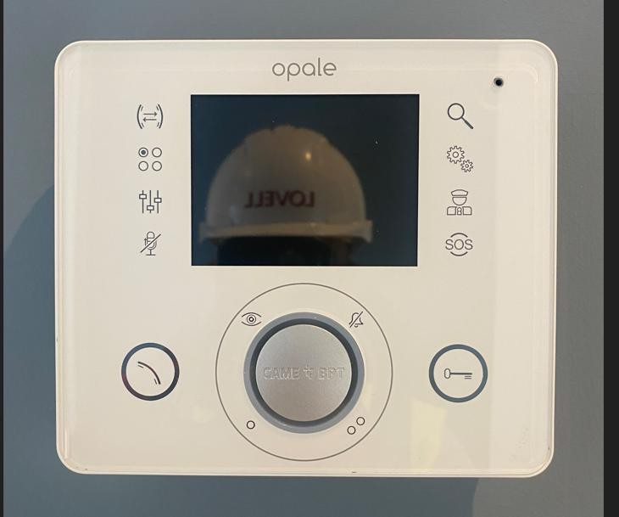
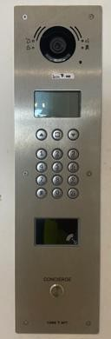

Fire Safety

If there is a fire in your flat, the smoke alarm will operate and where appropriate so will the sprinklers. You are to leave your flat without delay and ensure the front door to your flat is closed behind you.

Once in a safe location, preferably outside your building, call the fire Service on 999 giving your address.
Do not be concerned if there are new noises in the corridors outside your flat. The corridors are equipped with smoke vents, which will remove any smoke and keep it clear.

The fire strategy for your building has adopted a stay-put policy in order to minimise any inconvenience from false alarms and to keep you free from harm during a fire in another part of your building. There are additional fire safety precautions within your home to help keep you safe and therefore it is normally safer for you to remain in your flat if there is a fire in another part of the building.
The onsite staff and the fire service have all the necessary information to undertake firefighting activities and respond swiftly and appropriately to ensure your safety. However, if you have any concerns, or you would like to contact concierge please do so at the following email address: concierge@gallionsview.uk

You are free to leave your flat should you wish, but direction from the fire service should be followed for your own safety.
Your home has been provided with a fire alarm system, sprinklers, and fire-resistant walls, floors and fire doors and they are all very important components in keeping you safe if there is a fire in the building. Therefore, before any alterations or modifications are carried out to these parts of your home, we strongly advise that you seek professional advice and the permission of the landlord/ freeholder via your Housing Officer/ Property management Officer.

The Gallions 3B development includes the provision of an evacuation alert system.

Fire alarm operation

Sharky Heat Detector
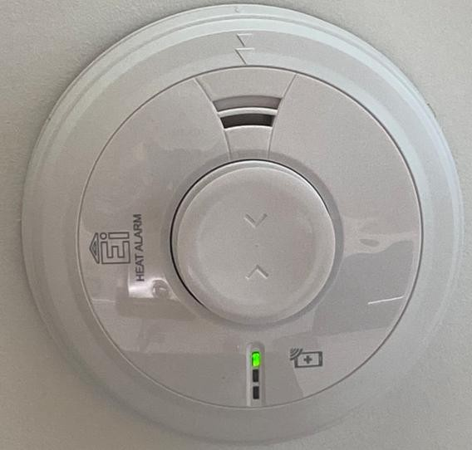

Optical Smoke Alarm
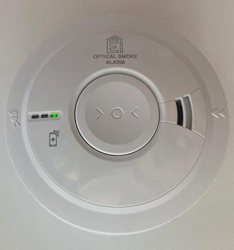

Balcony Sounder

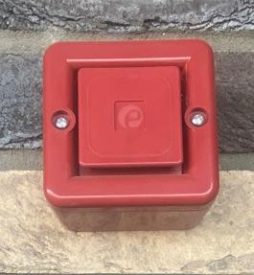

Evacuation Alarm
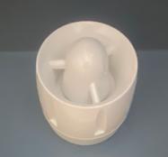

Do not paint your alarm, or allow water or dust to contaminate your alarm:
- Regularly check that the green mains indicator light on the cover is on
- If the alarm beeps and the red-light flashes at the same time the battery is depleted – ensure green mains power light is on
- Check the red light on the cover flashes every 40 seconds, to ensure that the detector has performed an automatic self-test.

- The red indicator will flash rapidly to show an alarm condition for the smoke detector
- In ‘Test’ mode the alarm will perform a self-test and emit the alarm sound
- When in ‘hush’ mode the alarm enters a ten-minute period instead of the normal 40 seconds to indicate the sensitivity is reduced, and will then automatically reset itself
- When interconnected to other mains powered alarms, an alarm on one detector will trigger all other interconnected alarms within one second (only the triggered alarm will flash a red indicator)

Fire Alarm Maintenance and testing
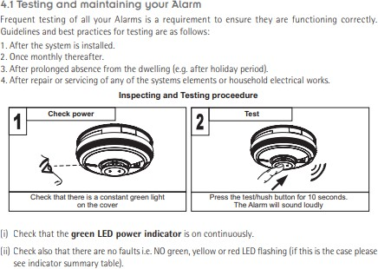

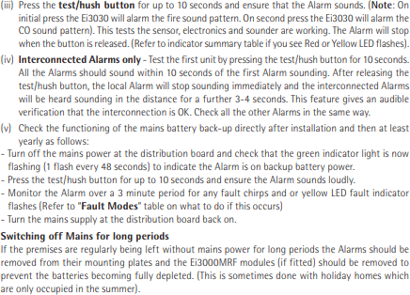

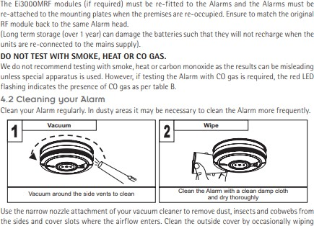

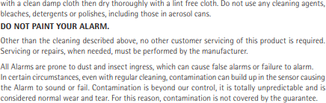

Fire doors

The front doors throughout the development are fire rated. The stairs are a protected area and internal doors onto the stairs are fire rated.

Sprinkler system

A sprinkler system has been installed within each dwelling. When a sprinkler head is activated (by a high temperature) the sprinkler will activate, and water will begin to flow.
The sprinkler system is maintained by the Gallions View management team. Any damage to the sprinkler head must be reported to Concierge immediately. Do not decorate over the sprinkler head.

Fire Safety Guide

The apartment that has a fire is immediately evacuated. Due to the level of compartmentation between each of the apartments and to reduce false alarms, the other apartments are to stay put unless advised otherwise by the Fire Services. Your home has been fitted with an emergency evacuation alarm, if this sounds, please evacuate your home following the fire escape route. Alterations or modifications to any part of your home could affect its ability to stop a fire spreading. Therefore, before any such work is carried out, we strongly advise that you seek professional advice and the permission of the Notting Hill Genesis via your Housing Officer / Property Management Officer. Please refer to the typical fire escape floor plan below which highlights fire emergency route in green through the stairwells, please ensure you are familiar with the fire escape route for your apartment block.

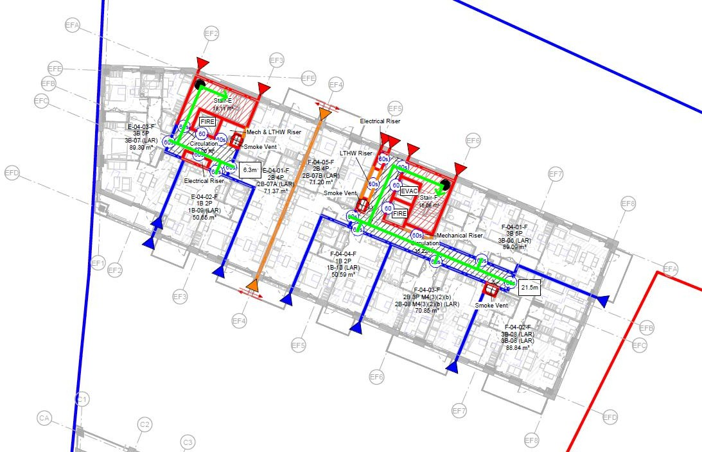

Contents Insurance

Residents are responsible for obtaining and maintaining insurance coverage for their personal property (for example, clothing, furnishings, carpets, appliances, etc.). Please arrange contents insurance for your possessions. We do not insure you for either the contents of your home or your personal possessions and cannot be responsible for these. It is strongly advisable that you arrange a comprehensive insurance policy covering you for fire, burglary, theft, storm, flood, and other risks as soon as you move in. Various items within your apartment (for example, kitchen fixtures and fittings, but not domestic appliances) are covered under the Landlord’s insurance, along with any contents of the communal areas. Vehicles and bicycles kept within the estate are the owner’s responsibility to insure them.

Local Information

Borough details
London Borough of Newham 328 Barking Road
East Ham London E6 2RT
Web: www.newham.gov.uk

Environmental Health and Bulk Refuse
London Borough of Newham 328 Barking Road
East Ham London E6 2RT
Tel: 020 8753 1100
Web: www.newham.gov.uk/rubbish-recycling-waste/bulky-household-waste-collections

 | Location | Details of Service
Tube Stations | Elizabeth Line | Elizabeth Line:  Westbound  -Stratford  Eastbound  -Stanmore
Tube Stations | Jubilee Line | Jubilee Line:  Westbound  -Abbey Lane  -Shenfield  Eastbound

 | Gallions Reach DLR Station | DLR  Platform 1 : Beckton Platform 12: Canning town
 | King George V DLR Station | DLR  Platform 1: Woolwich Arsenal DLR Station  Platform 2: DLR to Stratford International DLR Station
Bus Stops | Royal Docks Medical Centre Cyprus Station (Stop N) | 366  Redbridge, Falmouth Gardens 474  Canning Town, Hermit Road
Bus Stops | Cyprus Station (Stop Q) | 366  Beckton, Bus Station; East Ham  376  East Ham, Newham Town Hall  474  Manor Park
Bus Stops | Cyprus Station (Stop M) | 474  Canning Town, Hermit Road 366  Redbridge, Falmouth Gardens 376  Beckton, Bus Station
Bus Stops | East Ham Manor Way (Stop J) | 262  Stratford

376
Beckton, Bus Station
 | Savage Gardens (Stop K) | 366  Redbridge, Falmouth Gardens 474  Canning Town, Hermit Road
 | Savage Gardens (Stop L) | 366  Beckton, Bus Station 474  Manor Park
Hospitals | Newham University Hospital | Glen Rd, London E13 8SL
Hospitals | Queen Elizabeth Hospital | Stadium Rd, London SE18 4QH
Hospitals | Homerton University Hospital | Homerton Row, London E9 6SR
Parks | Royal Victoria Gardens | Albert Rd, London E16 2NL
Parks | New Beckton Park | Savage Gardens, London E6 5NB
Parks | Beckton District Park - South | Stansfeld Rd, London E6 5LT


Manufacturer’s Literature

MVHR and Cooling System unit
Intercom system
Heating Programmer
Heating Interface Unit
Consumer Unit
Welcome Letter
Smoke Alarms
EVAC Alarms

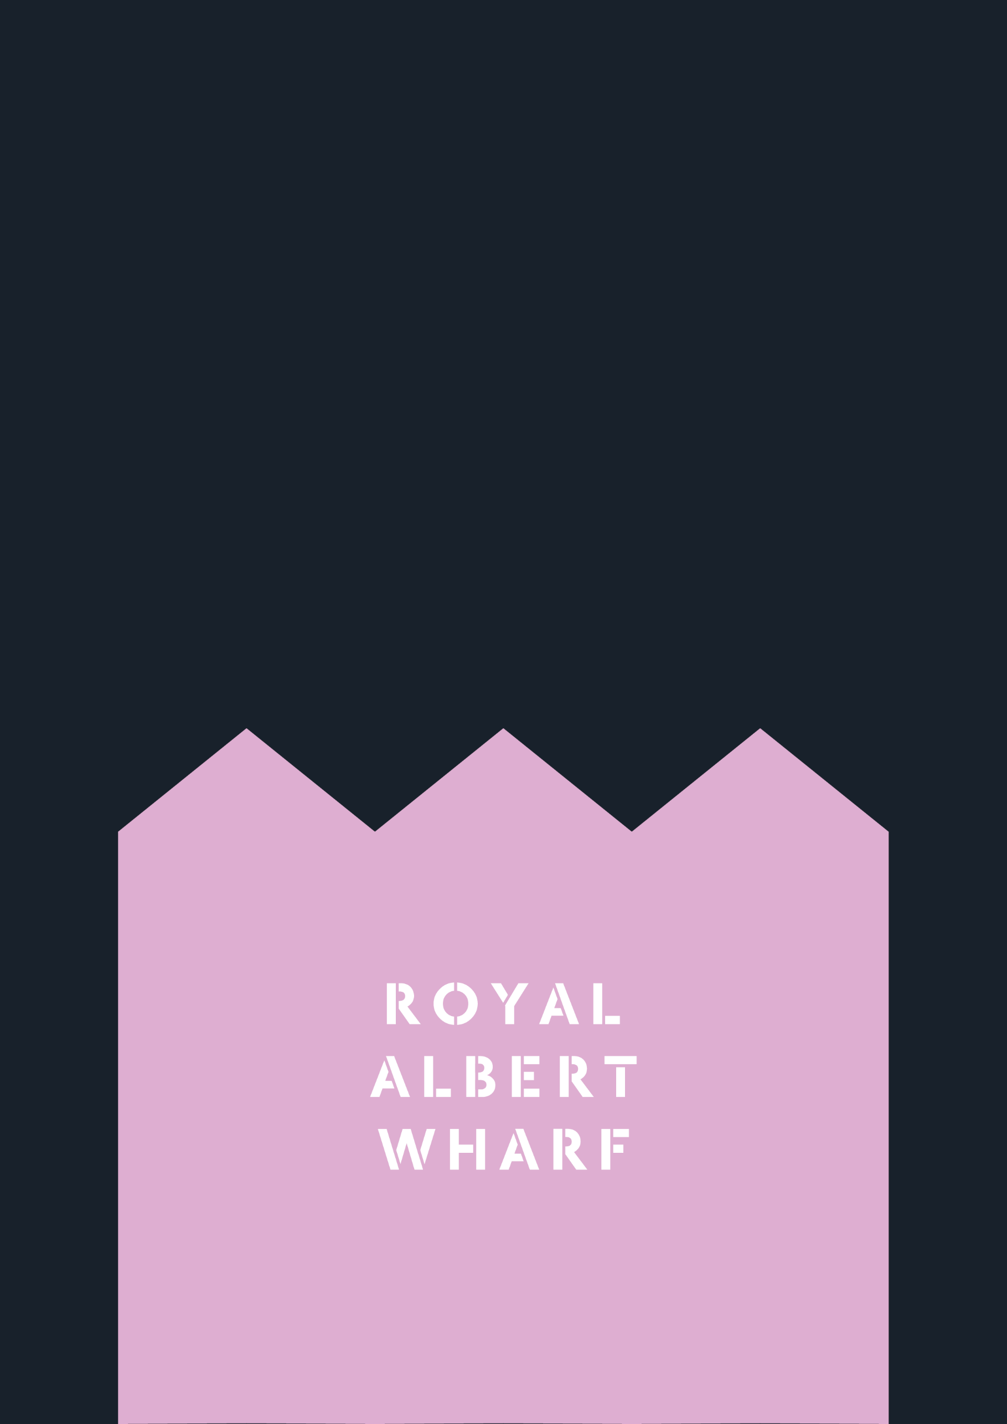

Thank You

